**Practical No. 1**

**Aim:** To study Big Data Analytics and Hadoop Architecture.

**Objectives:-**

1. Understand the concept of Big Data
2. Understand the concept of Hadoop.

**Theory:-**

**Q 1.** What do you know about the term “Big Data” and describe the application of the same**.**

**Ans** - Data which are significantly very large in size is called Big Data that are in Peta bytes i.e. 10^15 byte size.

There are 3 V’s in Big Data that explains its characteristics which are termed as :

1. **Velocity:** The data is increasing at a  very fast rate. It is estimated that the volume will double in every 2 years.
2. **Variety**: The variety of data can be explained by its form that can be structured as well unstructured. Log file, CCTV footage is called as unstructured data while the data which are in the form of tables and rows are called as structured data.
3. **Volume**: It specifies the amount of data which we deal with is of very large in size of Peta bytes.

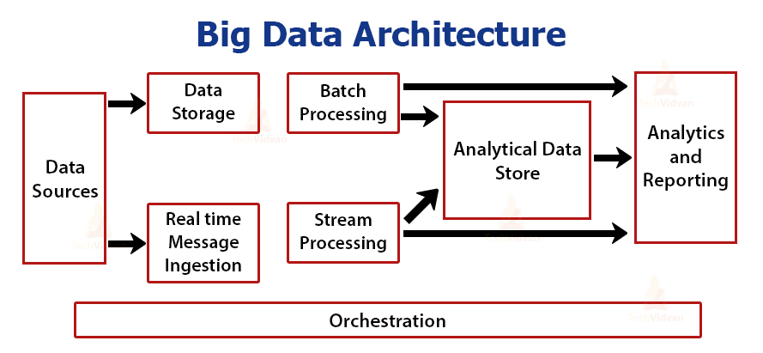

The architecture of Big Data is the foundation for Big Data Analytics. This large amount of data can be analyzed for business purposes and provide an environment wherein Big Data Analytical tools can extract vital Business related information from the ambiguous data forms.

The above architecture explains how the big data solutions, components and information will flow with respect to security details.

There are 4 layers through which the architecture can be analyzed.

**i). Big Data Source Layer:** It is the initial layer wherein the environment will manage the processing of data from the different management systems.

**ii). Management and Storage Layer:** This will serve as the conversion of data into specific format that can be used by the analytical tools for further processing.

**iii). Analysis Layer**: The extraction of useful information will occur in this layer.

**iv). Consumption Layer:** The presentation of the useful data to an output layer.

**Applications of Big Data:**

There are wide area of Big Data Applications such in Banking and Finance, Healthcare, Education, Government, Retail Industry, Transportation, Insurance, Media and Entertainment Sector, etc.

**Banking and Finance:** Big data has made banks more efficient for each industry. With the help of Big Data a company can opt an omnichannel approach that will enhance user experience by processing more than 30 transactions per second and collect all data onto a common platform for the purpose of future analysis.

**Education:** In the education sector, the data gathered from courses, students, faculty and results is huge. The process of segregation of the different modules and the process of providing a certain organization that will serve as the online or offline platform to analyze and use the required data only.

**Media and Entertainment Sector:** In the field of media and entertainment like Netflix, Amazon Prime , Spotify we do analysis on data collected from users and based on the choice of video, music used by them are analyzed and accordingly the next business strategy is used.

**HealthCare:** Using the help of Big Data tools, the data regarding the different patients' experience is recorded by the doctors for better treatment and accordingly the further strategy of the organization takes place.

**Q 2.** What are the challenges of using Hadoop?

Ans- Hadoop is an open source framework for Big Data that is used to store and access large amounts of datasets ranging from gigabytes to petabytes in size.

Hadoop allows clustering of multiple computers to analyze  large datasets in parallel more quickly.

**Challenges of using Hadoop:**

Some of the top challenges of using Hadoop are as follows:

1. Hadoop is a complex distributed system with low-level APIs

2. Specialized skills are required for using Hadoop, preventing most developers from effectively

building solutions

3. Business logic and infrastructure APIs have no clear separation, burdening app developers

4. Automated testing of end-to-end solutions is impractical or impossible

5. Hadoop is a diverse collection of many open source projects

6. Understanding multiple technologies and hand-coding integration between them

7. Significant effort is wasted on simple tasks like data ingestions and ETL

8. Moving from proof-of-concept to production is difficult and can take months or quarters

9. Hadoop is more than just offline storage and batch analytics

10. Different processing paradigms require data to be stored in specific ways

11. Real-time and batch ingestion requires deeply integrating several components

12. Common data patterns often require but don’t support data consistency and correctness

**Q.3 Explain how big data and Hadoop are related to each other.**

**Ans :** Big data and Hadoop are interrelated. In simple words, big data is massive amount of data that cannot be stored, processed, or analyzed using the traditional methods. Big data consists of vast volumes of various types of data which is generated at a high speed. To overcome the issue of storing, processing, and analyzing big data, Hadoop is used.

Hadoop is a framework that is used to store and process big data in a distributed and parallel way. In Hadoop, storing vast volumes of data becomes easy as the data is distributed across various machines, and data is also processed parallely and this saves time.

**Difference between Big Data vs. Hadoop**

1. Accessibility: One can use the Hadoop framework to process and access the data at a faster rate when it is compared to other tools, whereas it is tough to access the big data.

2. Storage: Apache Hadoop HDFS has the capability of storing big data, but on the other hand, Big Data is very difficult to be stored because it often comes in an unstructured and structured form.

3. Significance: Hadoop can process Big Data to make it more meaningful, but Big Data has no value on its own until it can be utilized to create some profit after processing the data.

4. Definition: Hadoop is a kind of framework that can handle the huge volume of Big Data and process it, whereas Big Data is just a large volume of the Data which can be in unstructured and structured data.

5. Developers: Big Data developers will just develop applications in Pig, Hive, Spark, Map Reduce, etc. whereas the Hadoop developers will be mainly responsible for the coding, which will be used to process the data.

6. Type: Big Data is a type of a problem that has no meaning or value to it unless it is processed, and Hadoop is a type of a solution that solves the complex processing of Huge Data.

7. Veracity: It means how trustworthiness the Data is. The Data that is processed by Hadoop can be used to process, analyze, and use for better decision-making. But on the other hand, Big Data cannot be relied on entirely to make any perfect decision because it has so many varieties of format and volume of data that makes it incomplete structured data to be able to process efficiently and understand. It makes Big Data not wholly reliable or trustworthiness to make a perfect decision.

**Q.4 How would you transform unstructured data into structured data?**

**Ans :** Step 1: Cleaning the Unstructured Data

Step 2: Check to see if it should be kept or deleted

Step 3: Choose the technology for data collection and storage based on

company requirements

Step 4: Entity Extraction

Step 5: Create a pattern

Step 6: Analyze the Data

Step 7: Understand what will be done with the analysis’ results

Step 8: Store the Data

Step 9: Implement project measurement

**Practical No: 2**

**Aim:** To study and usage of HDFS Commands.

**Objectives:**

To understand working of HDFS using Basic Commands.

**Theory:**

**HDFS Basic Commands:**

1. **pwd** :  The pwd command writes to standard output the full path name of your current directory (from the root directory).
2. **touchz**: It creates an empty file.
3. **-ls :**  It allows users to list files and directories from the Command Line Interface.
4. **-mkdir :** The mkdir stands for 'make directory'. With the help of mkdir command, you can create a new directory wherever you want in your system.
5. **–put :** HDFS Command to copy single source or multiple sources from local file system to the destination file system.
6. **-hadoop version:** That **command** is used to check the **Hadoop version**.
7. **–cat:**Reads a file on HDFS and prints the content of that file to the standard output.
8. **–rm:**To remove the file from HDFS.
9. **-get:**To copy files from hdfs to the linux file system.
10. **–help:**that displays help for given command or all commands if none is specified.
11. **–text:**  text takes the source file and outputs the file in the text format. It detects the encoding of the file and decodes it to plain text.
12. –fsck: HDFS fsck is used to check the health of the file system, to find missing files, over replicated, under replicated and corrupted blocks.
13. **–copyFromlocal:**To copy the file from a local file system to HDFS.
14. **–copyTolocal:** To copy the file from HDFS to local file system.
15. **–count:** To count the number of directories,files,and bytes under the paths that match the specified file pattern.

**Execution On Cloudera:**

[cloudera@quickstart ~]$ **hdfs dfs -mkdir /dir1**

[cloudera@quickstart ~]$ **hdfs dfs -touchz /dir1/sample**

[cloudera@quickstart ~]$ **hdfs dfs -text /dir1/sample**

[cloudera@quickstart ~]$ **ls**

cloudera-manager lib processfile1.txt

cm_api.py Music Public

Desktop parcels student_dat.txt

Documents Pictures student.txt

dom Pig student.txt~

Downloads pig_1666950577065.log temp21

eclipse pig_1666952614377.log Templates

enterprise-deployment.json pig_1666952896522.log Videos

express-deployment.json pig_1668140740255.log word.txt

kerberos processfile11.txt workspace

[cloudera@quickstart ~]$ **echo "Hello World" | hadoop fs -appendToFile - /dir1/sample**

[cloudera@quickstart ~]$ **hdfs dfs -cat /dir1/sample**

Hello World

[cloudera@quickstart ~]$ **hdfs dfs -text /dir1/sample**

Hello World

[cloudera@quickstart ~]$ **hdfs dfs -touchz /dir1/sample1.txt**

[cloudera@quickstart ~]$ **hadoop version**

Hadoop 2.6.0-cdh5.13.0

Subversion http://github.com/cloudera/hadoop -r 42e8860b182e55321bd5f5605264da4adc8882be

Compiled by jenkins on 2017-10-04T18:08Z

Compiled with protoc 2.5.0

From source with checksum 5e84c185f8a22158e2b0e4b8f85311

This command was run using /usr/lib/hadoop/hadoop-common-2.6.0-cdh5.13.0.jar

[cloudera@quickstart ~]$ **pwd**

/home/cloudera

[cloudera@quickstart ~]$ **mkdir temp**

[cloudera@quickstart ~]$ **ls**

cloudera-manager dom express-deployment.json parcels pig_1666952614377.log processfile1.txt student.txt~ Videos

cm_api.py Downloads kerberos Pictures pig_1666952896522.log Public temp word.txt

Desktop eclipse lib Pig pig_1668140740255.log student_dat.txt temp21 workspace

Documents enterprise-deployment.json Music pig_1666950577065.log processfile11.txt student.txt Templates

[cloudera@quickstart ~]$ **cd temp**

[cloudera@quickstart temp]$ **ls**

[cloudera@quickstart temp]$ **echo "welcome hadoop">wordcount.txt**

[cloudera@quickstart temp]$ **ifconfig**

eth0 Link encap:Ethernet HWaddr 08:00:27:B2:38:58

inet addr:10.0.2.15 Bcast:10.0.2.255 Mask:255.255.255.0

UP BROADCAST RUNNING MULTICAST MTU:1500 Metric:1

RX packets:16700 errors:0 dropped:0 overruns:0 frame:0

TX packets:11840 errors:0 dropped:0 overruns:0 carrier:0

collisions:0 txqueuelen:1000

RX bytes:10745959 (10.2 MiB) TX bytes:2125902 (2.0 MiB)

lo Link encap:Local Loopback

inet addr:127.0.0.1 Mask:255.0.0.0

UP LOOPBACK RUNNING MTU:65536 Metric:1

RX packets:65187268 errors:0 dropped:0 overruns:0 frame:0

TX packets:65187268 errors:0 dropped:0 overruns:0 carrier:0

collisions:0 txqueuelen:0

RX bytes:6213711827 (5.7 GiB) TX bytes:6213711827 (5.7 GiB)

1: lo: <LOOPBACK,UP,LOWER_UP> mtu 65536 qdisc noqueue state UNKNOWN

link/loopback 00:00:00:00:00:00 brd 00:00:00:00:00:00

inet 127.0.0.1/8 scope host lo

2: eth0: <BROADCAST,MULTICAST,UP,LOWER_UP> mtu 1500 qdisc pfifo_fast state UP qlen 1000

link/ether 08:00:27:b2:38:58 brd ff:ff:ff:ff:ff:ff

inet 10.0.2.15/24 brd 10.0.2.255 scope global eth0

[cloudera@quickstart temp]$ **hadoop**

Usage: hadoop [--config confdir] COMMAND

where COMMAND is one of:

fs run a generic filesystem user client

version print the version

jar <jar> run a jar file

checknative [-a|-h] check native hadoop and compression libraries availability

distcp <srcurl> <desturl> copy file or directories recursively

archive -archiveName NAME -p <parent path> <src>* <dest> create a hadoop archive

classpath prints the class path needed to get the

credential interact with credential providers

Hadoop jar and the required libraries

daemonlog get/set the log level for each daemon

s3guard manage data on S3

trace view and modify Hadoop tracing settings

or

CLASSNAME run the class named CLASSNAME

Most commands print help when invoked w/o parameters.

[cloudera@quickstart temp]$ **hadoop fs -ls /user**

Found 8 items

drwxr-xr-x - cloudera cloudera 0 2022-10-28 03:15 /user/cloudera

drwxr-xr-x - mapred hadoop 0 2017-10-23 09:15 /user/history

drwxrwxrwx - hive supergroup 0 2017-10-23 09:17 /user/hive

drwxrwxrwx - hue supergroup 0 2017-10-23 09:16 /user/hue

drwxrwxrwx - jenkins supergroup 0 2017-10-23 09:15 /user/jenkins

drwxrwxrwx - oozie supergroup 0 2017-10-23 09:16 /user/oozie

drwxrwxrwx - root supergroup 0 2017-10-23 09:16 /user/root

drwxr-xr-x - hdfs supergroup 0 2017-10-23 09:17 /user/spark

[cloudera@quickstart temp]$ **pwd**

/home/cloudera/temp

[cloudera@quickstart temp]$ **ls**

wordcount.txt

[cloudera@quickstart temp]$ **hdfs dfs -mkdir /user/cloudera/input1**

[cloudera@quickstart temp]$ **hdfs dfs -ls /user/cloudera/input1**

[cloudera@quickstart temp]$ **hdfs dfs -put /home/cloudera/temp/wordcount.txt /user/cloudera/input1**

[cloudera@quickstart temp]$ **hdfs dfs -ls /user/cloudera/input1**

Found 1 items

-rw-r--r-- 1 cloudera cloudera 15 2022-11-17 21:12 /user/cloudera/input1/wordcount.txt

[cloudera@quickstart temp]$ **hadoop fsck**

DEPRECATED: Use of this script to execute hdfs command is deprecated.

Instead use the hdfs command for it.

Usage: DFSck <path> [-list-corruptfileblocks | [-move | -delete | -openforwrite] [-files [-blocks [-locations | -racks]]]] [-maintenance]

<path> start checking from this path

-move move corrupted files to /lost+found

-delete delete corrupted files

-files print out files being checked

-openforwrite print out files opened for write

-includeSnapshots include snapshot data if the given path indicates a snapshottable directory or there are snapshottable directories under it

-list-corruptfileblocks print out list of missing blocks and files they belong to

-blocks print out block report

-locations print out locations for every block

-racks print out network topology for data-node locations

-maintenance print out maintenance state node details

-blockId print out which file this blockId belongs to, locations (nodes, racks) of this block, and other diagnostics info (under replicated, corrupted or not, etc)

Please Note:

1. By default fsck ignores files opened for write, use -openforwrite to report such files. They are usually tagged CORRUPT or HEALTHY depending on their block allocation status

2. Option -includeSnapshots should not be used for comparing stats, should be used only for HEALTH check, as this may contain duplicates if the same file present in both original fs tree and inside snapshots.

Generic options supported are

-conf <configuration file> specify an application configuration file

-D <property=value> use value for given property

-fs <local|namenode:port> specify a namenode

-jt <local|resourcemanager:port> specify a ResourceManager

-files <comma separated list of files> specify comma separated files to be copied to the map reduce cluster

-libjars <comma separated list of jars> specify comma separated jar files to include in the classpath.

-archives <comma separated list of archives> specify comma separated archives to be unarchived on the compute machines.

The general command line syntax is

bin/hadoop command [genericOptions] [commandOptions]

Generic options supported are

-conf <configuration file> specify an application configuration file

-D <property=value> use value for given property

-fs <local|namenode:port> specify a namenode

-jt <local|resourcemanager:port> specify a ResourceManager

-files <comma separated list of files> specify comma separated files to be copied to the map reduce cluster

-libjars <comma separated list of jars> specify comma separated jar files to include in the classpath.

-archives <comma separated list of archives> specify comma separated archives to be unarchived on the compute machines.

The general command line syntax is

bin/hadoop command [genericOptions] [commandOptions

[cloudera@quickstart temp]$ **fsck**

fsck from util-linux-ng 2.17.2

e2fsck 1.41.12 (17-May-2010)

/dev/mapper/vg_quickstart-lv_root is mounted.

WARNING!!! The filesystem is mounted. If you continue you ***WILL***

cause ***SEVERE*** filesystem damage.

Do you really want to continue (y/n)? **n**

check aborted.

e2fsck 1.41.12 (17-May-2010)

/dev/sda1 is mounted.

WARNING!!! The filesystem is mounted. If you continue you ***WILL***

cause ***SEVERE*** filesystem damage.

Do you really want to continue (y/n)? **n**

check aborted.

[cloudera@quickstart temp]$ **cat > /home/cloudera/file11.txt**

**Ramesh**

**Raju**

**Saniya**

**Vishal**

**Deepali**

^Z

[1]+ Stopped cat > /home/cloudera/file11.txt

[cloudera@quickstart temp]$ **cat /home/cloudera/file11.txt**

Ramesh

Raju

Saniya

Vishal

Deepali

[cloudera@quickstart temp]$ **hdfs dfs -ls**

Found 6 items

drwxr-xr-x - cloudera cloudera 0 2022-10-28 03:15 Pig_Data

drwxr-xr-x - cloudera cloudera 0 2022-11-17 21:15 dir11

drwxr-xr-x - cloudera cloudera 0 2022-09-22 21:27 input

drwxr-xr-x - cloudera cloudera 0 2022-11-17 21:12 input1

drwxr-xr-x - cloudera cloudera 0 2022-09-22 22:11 input2

drwxr-xr-x - cloudera cloudera 0 2022-09-22 21:21 pract2

[cloudera@quickstart temp]$ **hdfs dfs -mkdir /user/cloudera/dir12**

[cloudera@quickstart temp]$ **hdfs dfs -put /home/cloudera/file11.txt /user/cloudera/dir12**

[cloudera@quickstart temp]$ **hdfs dfs -mkdir /dir14**

[cloudera@quickstart temp]$ **cat > /home/cloudera/newfile.txt**

**Maths**

**Eng**

**Sci**

**Comp**

^Z

[2]+ Stopped cat > /home/cloudera/newfile.txt

[cloudera@quickstart temp]$ **hdfs dfs -copyFromLocal /home/cloudera/newfile.txt /dir14**

[cloudera@quickstart temp]$ **hdfs dfs -copyToLocal /dir14 /home/cloudera/newfile.txt**

copyToLocal: `/home/cloudera/newfile.txt': File exists

[cloudera@quickstart temp]$ **hdfs dfs -count /dir14**

1 1 19 /dir14

**Practical No. 3**

**Aim:** Write a wordCount program to demonstrate MapReduce paradigm.

**Objective:**

To understand and utilize MapReduce tool in the data analytic.

**Theory:**

**MapReduce**: MapReduce is a programming paradigm that enables massive scalability across hundreds or thousands of servers in a Hadoop cluster. As the processing component, MapReduce is the heart of Apache Hadoop. The term "MapReduce" refers to two separate and distinct tasks that Hadoop programs perform.

**Mapper**: Mapper is a function which process the input data. The mapper processes the data and creates several small chunks of data. The input to the mapper function is in the form of (key, value) pairs, even though the input to a MapReduce program is a file or directory (which is stored in the HDFS).

**Reducer:** Reducer in Hadoop MapReduce reduces a set of intermediate values which share a key to a smaller set of values. In MapReduce job execution flow, Reducer takes a set of an intermediate key-value pair produced by the mapper as the input.

**Question Resolved by MapReduce:-**

1. How to break a large program into smaller parts & run them in parallel?
2. How to assign task to machine?
3. How to do partition and distriutr data?
4. How to share intermediate result?
5. How to coordinate synchronization, scheduling and fault tolerance?

**JavaCode:-**

import java.io.IOException;

import java.util.StringTokenizer;

import org.apache.hadoop.conf.Configuration;

import org.apache.hadoop.fs.Path;

import org.apache.hadoop.io.IntWritable;

import org.apache.hadoop.io.Text;

import org.apache.hadoop.mapreduce.Job;

import org.apache.hadoop.mapreduce.Mapper;

import org.apache.hadoop.mapreduce.Reducer;

import org.apache.hadoop.mapreduce.lib.input.FileInputFormat;

import org.apache.hadoop.mapreduce.lib.output.FileOutputFormat;

public class WordCount {

public static class TokenizerMapper

extends Mapper<Object, Text, Text, IntWritable>{

private final static IntWritable one = new IntWritable(1);

private Text word = new Text();

public void map(Object key, Text value, Context context

) throws IOException, InterruptedException {

StringTokenizer itr = new StringTokenizer(value.toString());

while (itr.hasMoreTokens()) {

word.set(itr.nextToken());

context.write(word, one);

}

}

}

public static class IntSumReducer

extends Reducer<Text,IntWritable,Text,IntWritable> {

private IntWritable result = new IntWritable();

public void reduce(Text key, Iterable<IntWritable> values,

Context context

) throws IOException, InterruptedException {

int sum = 0;

for (IntWritable val : values) {

sum += val.get();

}

result.set(sum);

context.write(key, result);

}

}

public static void main(String[] args) throws Exception {

Configuration conf = new Configuration();

Job job = Job.getInstance(conf, "word count");

job.setJarByClass(WordCount.class);

job.setMapperClass(TokenizerMapper.class);

job.setCombinerClass(IntSumReducer.class);

job.setReducerClass(IntSumReducer.class);

job.setOutputKeyClass(Text.class);

job.setOutputValueClass(IntWritable.class);

FileInputFormat.addInputPath(job, new Path(args[0]));

FileOutputFormat.setOutputPath(job, new Path(args[1]));

System.exit(job.waitForCompletion(true) ? 0 : 1);

}

}

**Execution on Cloudera:**

[cloudera@quickstart ~]$ **cat > /home/cloudera/Processfile33.txt**

AIML

IOT

IS

AIML

IS

IOT

BDAV

MATHS

^C

[cloudera@quickstart ~]$ **cat /home/cloudera/Processfile33.txt**

AIML

IOT

IS

AIML

IS

IOT

BDAV

MATHS

[cloudera@quickstart ~]$ **hdfs dfs -mkdir /inputfile33**

[cloudera@quickstart ~]$ **hdfs dfs -put /home/cloudera/Processfile33.txt /inputfile33**

[cloudera@quickstart ~]$ **hdfs dfs -cat /inputfile33/Processfile33.txt**

AIML

IOT

IS

AIML

IS

IOT

BDAV

MATHS

[cloudera@quickstart ~]$ **hadoop jar /home/cloudera/WordCount.jar WordCount /inputfile33/Processfile33.txt /out33**

22/10/22 04:33:16 INFO client.RMProxy: Connecting to ResourceManager at /0.0.0.0:8032

22/10/22 04:33:21 WARN mapreduce.JobResourceUploader: Hadoop command-line option parsing not performed. Implement the Tool interface and execute your application with ToolRunner to remedy this.

22/10/22 04:33:23 INFO input.FileInputFormat: Total input paths to process : 1

22/10/22 04:33:23 INFO mapreduce.JobSubmitter: number of splits:1

22/10/22 04:33:27 INFO mapreduce.JobSubmitter: Submitting tokens for job: job_1666426057642_0001

22/10/22 04:33:33 INFO impl.YarnClientImpl: Submitted application application_1666426057642_0001

22/10/22 04:33:35 INFO mapreduce.Job: The url to track the job: http://quickstart.cloudera:8088/proxy/application_1666426057642_0001/

22/10/22 04:33:35 INFO mapreduce.Job: Running job: job_1666426057642_0001

22/10/22 04:34:50 INFO mapreduce.Job: Job job_1666426057642_0001 running in uber mode : false

22/10/22 04:34:50 INFO mapreduce.Job:  map 0% reduce 0%

22/10/22 04:35:41 INFO mapreduce.Job:  map 100% reduce 0%

22/10/22 04:36:24 INFO mapreduce.Job:  map 100% reduce 100%

22/10/22 04:36:28 INFO mapreduce.Job: Job job_1666426057642_0001 completed successfully

22/10/22 04:36:30 INFO mapreduce.Job: Counters: 49

    File System Counters

        FILE: Number of bytes read=59

        FILE: Number of bytes written=286823

        FILE: Number of read operations=0

        FILE: Number of large read operations=0

        FILE: Number of write operations=0

        HDFS: Number of bytes read=161

        HDFS: Number of bytes written=33

        HDFS: Number of read operations=6

        HDFS: Number of large read operations=0

        HDFS: Number of write operations=2

    Job Counters

        Launched map tasks=1

        Launched reduce tasks=1

        Data-local map tasks=1

        Total time spent by all maps in occupied slots (ms)=41845

        Total time spent by all reduces in occupied slots (ms)=41002

        Total time spent by all map tasks (ms)=41845

        Total time spent by all reduce tasks (ms)=41002

        Total vcore-milliseconds taken by all map tasks=41845

        Total vcore-milliseconds taken by all reduce tasks=41002

        Total megabyte-milliseconds taken by all map tasks=42849280

        Total megabyte-milliseconds taken by all reduce tasks=41986048

    Map-Reduce Framework

        Map input records=8

        Map output records=8

        Map output bytes=67

        Map output materialized bytes=59

        Input split bytes=126

        Combine input records=8

        Combine output records=5

        Reduce input groups=5

        Reduce shuffle bytes=59

        Reduce input records=5

        Reduce output records=5

        Spilled Records=10

        Shuffled Maps =1

        Failed Shuffles=0

        Merged Map outputs=1

        GC time elapsed (ms)=876

        CPU time spent (ms)=7300

        Physical memory (bytes) snapshot=348278784

        Virtual memory (bytes) snapshot=3015077888

        Total committed heap usage (bytes)=226365440

    Shuffle Errors

        BAD_ID=0

        CONNECTION=0

        IO_ERROR=0

        WRONG_LENGTH=0

        WRONG_MAP=0

        WRONG_REDUCE=0

    File Input Format Counters

        Bytes Read=35

    File Output Format Counters

        Bytes Written=33

[cloudera@quickstart ~]$ **hdfs dfs -ls /out33**

Found 2 items

-rw-r--r--   1 cloudera supergroup          0 2022-10-22 04:36 /out33/_SUCCESS

-rw-r--r--   1 cloudera supergroup         33 2022-10-22 04:36 /out33/part-r-00000

[cloudera@quickstart ~]$ **hdfs dfs -cat /out33/part-r-00000**

AIML    2

BDAV    1

IOT 2

IS  2

MATHS   1

**Practical No. 4**

**Aim: Study of Installation of Mongo DB**

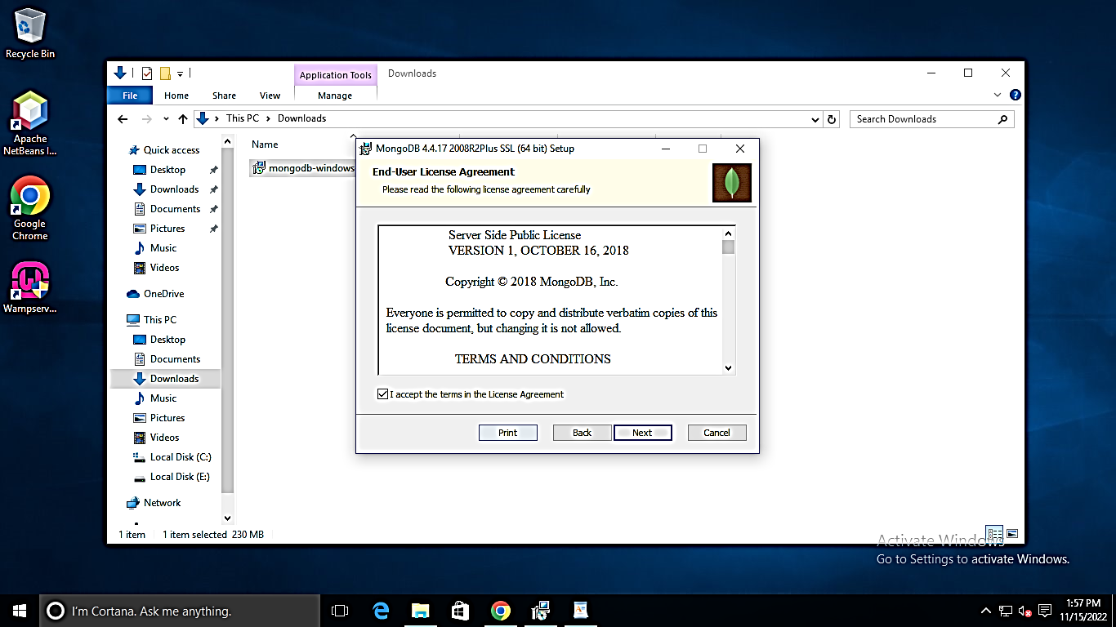 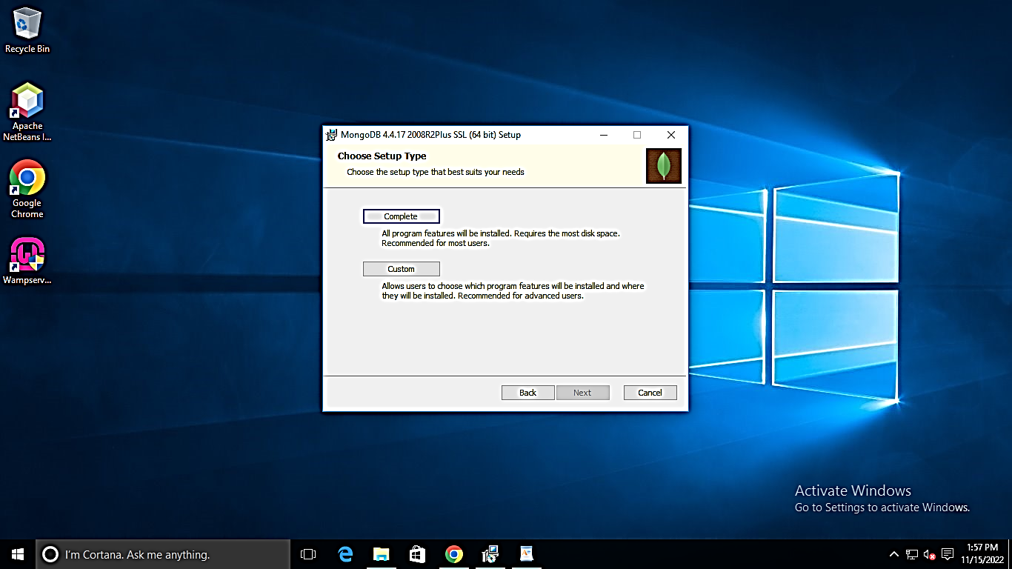

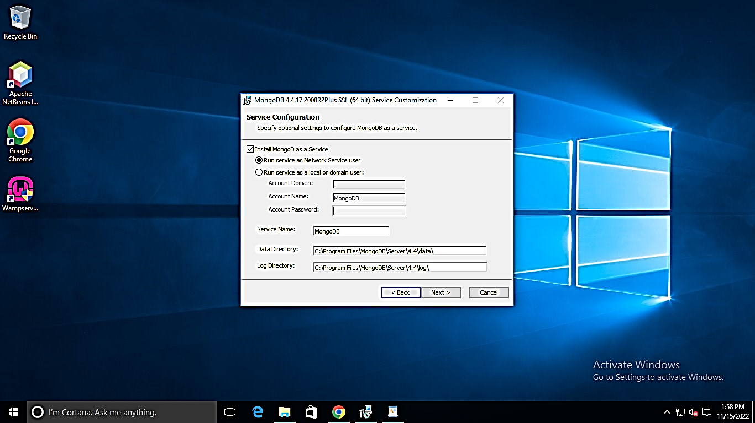 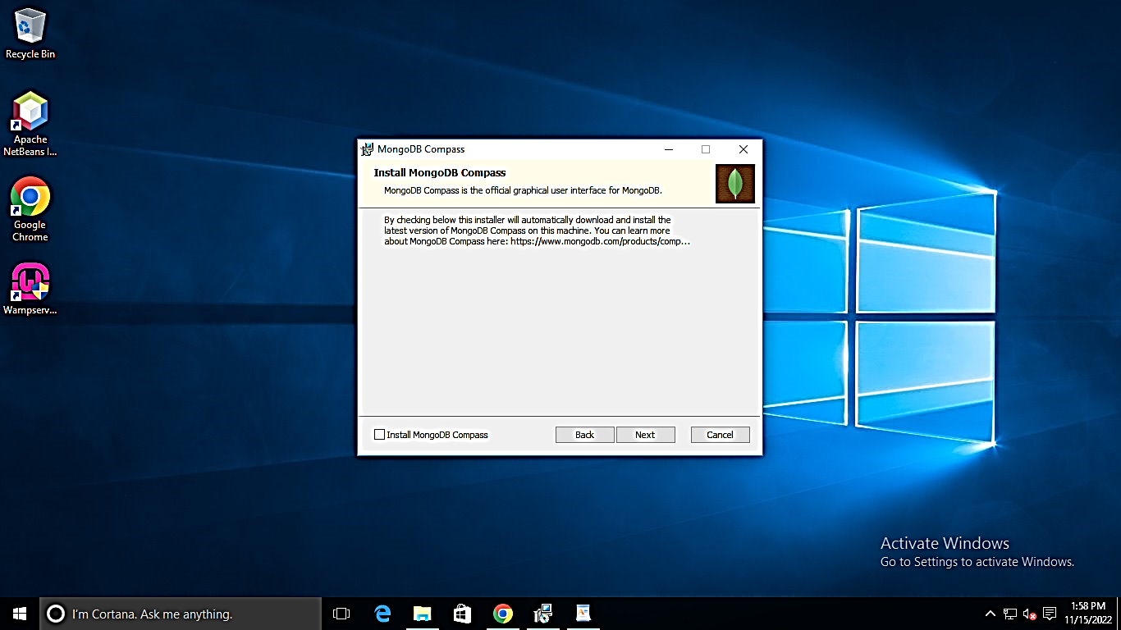

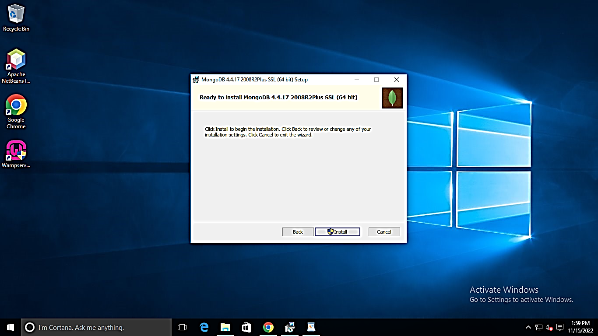 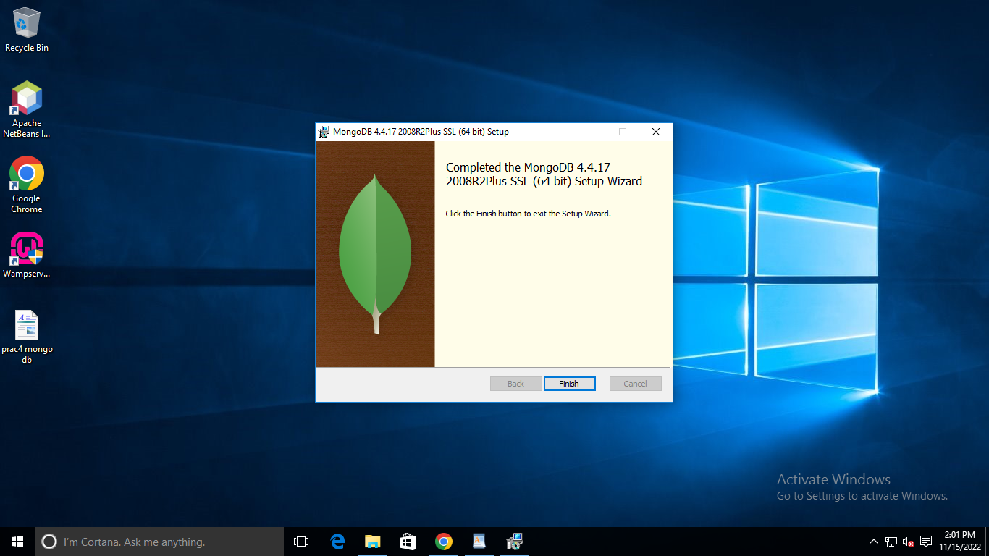

**Practical No. 5**

**Aim: Create A Sample Database:**

**Sample data creation of Mongo db.**

**Terminal screen:**

C:\Users\TEMP.DESKTOP-7VKNIDQ.007>cd ..

C:\Users>cd C:\Program Files\MongoDB\Server\4.4\bin

C:\Program Files\MongoDB\Server\4.4\bin>mongo

MongoDB shell version v4.4.17

connecting to: mongodb://127.0.0.1:27017/?compressors=disabled&gssapiServiceName=mongodb

Implicit session: session { "id" : UUID("72aface3-dce0-4ef0-9b06-1ce415dacf38") }

MongoDB server version: 4.4.17

Welcome to the MongoDB shell.

For interactive help, type "help".

For more comprehensive documentation, see

        https://docs.mongodb.com/

Questions? Try the MongoDB Developer Community Forums

        https://community.mongodb.com

---

The server generated these startup warnings when booting:

        2022-11-11T14:04:41.453+05:30: Access control is not enabled for the database. Read and write access to data and configuration is unrestricted

---

---

        Enable MongoDB's free cloud-based monitoring service, which will then receive and display

        metrics about your deployment (disk utilization, CPU, operation statistics, etc).

        The monitoring data will be available on a MongoDB website with a unique URL accessible to you

        and anyone you share the URL with. MongoDB may use this information to make product

        improvements and to suggest MongoDB products and deployment options to you.

        To enable free monitoring, run the following command: db.enableFreeMonitoring()

        To permanently disable this reminder, run the following command: db.disableFreeMonitoring()

---

> sample database creation-----write doc.

... ^C

> use MyDb

switched to db MyDb

> db

MyDb

> show dbs;

admin   0.000GB

config  0.000GB

local   0.000GB

**Practical No. 6**

**Aim: Query the Sample db with:**

1. **Create Collection**
2. **Insert document**
3. **Query document**
4. **Delete document**
5. **Indexing**

**Collection Name: Student**

**//I. Create Collection**

//sample database creation

> use MyDb

switched to db MyDb

> db

MyDb

> show dbs;

admin   0.000GB

config  0.000GB

local   0.000GB

> create collection:----write doc.

... ^C

> db.createCollection("Students")

{ "ok" : 1 }

**/II. Insert document**

> db.Students.insert({_id:1, StudName:"Arshad",Grade:"A", Hobbies:"Internet Surfing")};

uncaught exception: SyntaxError: missing } after property list :

@(shell):1:82

> db.Students.insert({_id:1, StudName:"Arshad",Grade:"A", Hobbies:"Internet Surfing"});

WriteResult({ "nInserted" : 1 })

> db.Students.insert({_id:5, StudName:"Stark",Grade:"A", Hobbies:"Advisory"});

WriteResult({ "nInserted" : 1 })

> db.Students.insert({_id:2, StudName:"Peter",Grade:"B", Hobbies:"Web Shotting"});

WriteResult({ "nInserted" : 1 })

> db.Students.insert({_id:3, StudName:"Ultron",Grade:"B", Hobbies:"Robotics"});

WriteResult({ "nInserted" : 1 })

> db.Students.insert({_id:4, StudName:"Ethan",Grade:"A", Hobbies:"Sky Diving"});

WriteResult({ "nInserted" : 1 })

//III. Query Document

> db.Students.fin();

uncaught exception: TypeError: db.Students.fin is not a function :

@(shell):1:1

> db.Students.find();

{ "_id" : 1, "StudName" : "Arshad", "Grade" : "A", "Hobbies" : "Internet Surfing" }

{ "_id" : 5, "StudName" : "Stark", "Grade" : "A", "Hobbies" : "Advisory" }

{ "_id" : 2, "StudName" : "Peter", "Grade" : "B", "Hobbies" : "Web Shotting" }

{ "_id" : 3, "StudName" : "Ultron", "Grade" : "B", "Hobbies" : "Robotics" }

{ "_id" : 4, "StudName" : "Ethan", "Grade" : "A", "Hobbies" : "Sky Diving" }

> db.Students.find().preety();

uncaught exception: TypeError: db.Students.find(...).preety is not a function :

@(shell):1:1

> db.Students.find().pretty();

{

        "_id" : 1,

        "StudName" : "Arshad",

        "Grade" : "A",

        "Hobbies" : "Internet Surfing"

}

{ "_id" : 5, "StudName" : "Stark", "Grade" : "A", "Hobbies" : "Advisory" }

{

        "_id" : 2,

        "StudName" : "Peter",

        "Grade" : "B",

        "Hobbies" : "Web Shotting"

}

{ "_id" : 3, "StudName" : "Ultron", "Grade" : "B", "Hobbies" : "Robotics" }

{

        "_id" : 4,

        "StudName" : "Ethan",

        "Grade" : "A",

        "Hobbies" : "Sky Diving"

}

> db.Students.find().pretty();

{

        "_id" : 1,

        "StudName" : "Arshad",

        "Grade" : "A",

        "Hobbies" : "Internet Surfing"

}

{ "_id" : 5, "StudName" : "Stark", "Grade" : "A", "Hobbies" : "Advisory" }

{

        "_id" : 2,

        "StudName" : "Peter",

        "Grade" : "B",

        "Hobbies" : "Web Shotting"

}

{ "_id" : 3, "StudName" : "Ultron", "Grade" : "B", "Hobbies" : "Robotics" }

{

        "_id" : 4,

        "StudName" : "Ethan",

        "Grade" : "A",

        "Hobbies" : "Sky Diving"

}

**// Update Document**

> db.Students.Update({_id:1, StudName:"Arshad", Grade:"A",},{$set:{Hobbies:"App_Development"}}, {upsert:true});

uncaught exception: TypeError: db.Students.Update is not a function :

@(shell):1:1

> db.Students.update({_id:1, StudName:"Arshad", Grade:"A",},{$set:{Hobbies:"App_Development"}}, {upsert:true});

WriteResult({ "nMatched" : 1, "nUpserted" : 0, "nModified" : 1 })

> db.Students.find();

{ "_id" : 1, "StudName" : "Arshad", "Grade" : "A", "Hobbies" : "App_Development" }

{ "_id" : 5, "StudName" : "Stark", "Grade" : "A", "Hobbies" : "Advisory" }

{ "_id" : 2, "StudName" : "Peter", "Grade" : "B", "Hobbies" : "Web Shotting" }

{ "_id" : 3, "StudName" : "Ultron", "Grade" : "B", "Hobbies" : "Robotics" }

{ "_id" : 4, "StudName" : "Ethan", "Grade" : "A", "Hobbies" : "Sky Diving" }

>

C:\Program Files\MongoDB\Server\4.4\bin>

C:\Program Files\MongoDB\Server\4.4\bin>

C:\Program Files\MongoDB\Server\4.4\bin>use MyDB

'use' is not recognized as an internal or external command,

operable program or batch file.

C:\Program Files\MongoDB\Server\4.4\bin>mongo

MongoDB shell version v4.4.17

connecting to: mongodb://127.0.0.1:27017/?compressors=disabled&gssapiServiceName=mongodb

Implicit session: session { "id" : UUID("0e18e7fa-ba3d-4fa7-8597-15d0bc081c38") }

MongoDB server version: 4.4.17

---

The server generated these startup warnings when booting:

        2022-11-11T14:04:41.453+05:30: Access control is not enabled for the database. Read and write access to data and configuration is unrestricted

---

---

        Enable MongoDB's free cloud-based monitoring service, which will then receive and display

        metrics about your deployment (disk utilization, CPU, operation statistics, etc).

        The monitoring data will be available on a MongoDB website with a unique URL accessible to you

        and anyone you share the URL with. MongoDB may use this information to make product

        improvements and to suggest MongoDB products and deployment options to you.

        To enable free monitoring, run the following command: db.enableFreeMonitoring()

        To permanently disable this reminder, run the following command: db.disableFreeMonitoring()

---

> use MyDB'

switched to db MyDB'

> db

MyDB'

> use MyDB

switched to db MyDB

> db

MyDB

> db.Students.find();

>

> db.Students.find().pretty();

> use MyDb

switched to db MyDb

> db

MyDb

> db.Students.find();

{ "_id" : 1, "StudName" : "Arshad", "Grade" : "A", "Hobbies" : "App_Development" }

{ "_id" : 5, "StudName" : "Stark", "Grade" : "A", "Hobbies" : "Advisory" }

{ "_id" : 2, "StudName" : "Peter", "Grade" : "B", "Hobbies" : "Web Shotting" }

{ "_id" : 3, "StudName" : "Ultron", "Grade" : "B", "Hobbies" : "Robotics" }

{ "_id" : 4, "StudName" : "Ethan", "Grade" : "A", "Hobbies" : "Sky Diving" }

> db.Students.find().pretty();

{

        "_id" : 1,

        "StudName" : "Arshad",

        "Grade" : "A",

        "Hobbies" : "App_Development"

}

{ "_id" : 5, "StudName" : "Stark", "Grade" : "A", "Hobbies" : "Advisory" }

{

        "_id" : 2,

        "StudName" : "Peter",

        "Grade" : "B",

        "Hobbies" : "Web Shotting"

}

{ "_id" : 3, "StudName" : "Ultron", "Grade" : "B", "Hobbies" : "Robotics" }

{

        "_id" : 4,

        "StudName" : "Ethan",

        "Grade" : "A",

        "Hobbies" : "Sky Diving"

}

**// IV. Delete Document**

> db.Students.update({_id:1,},{$unset:{Hobbies:"App_Development"}});

WriteResult({ "nMatched" : 1, "nUpserted" : 0, "nModified" : 1 })

> db.Students.find().pretty();

{ "_id" : 1, "StudName" : "Arshad", "Grade" : "A" }

{ "_id" : 5, "StudName" : "Stark", "Grade" : "A", "Hobbies" : "Advisory" }

{

        "_id" : 2,

        "StudName" : "Peter",

        "Grade" : "B",

        "Hobbies" : "Web Shotting"

}

{ "_id" : 3, "StudName" : "Ultron", "Grade" : "B", "Hobbies" : "Robotics" }

{

        "_id" : 4,

        "StudName" : "Ethan",

        "Grade" : "A",

        "Hobbies" : "Sky Diving"

}

> use Students

switched to db Students

> db.createCollection("Studentsgrades")

{ "ok" : 1 }

>

>

> db.Studentsgrades.insertMany({

... ^C

> db.Studentsgrades.insertMany([

... {name:"Steve", Subject:"Language Monitoring", score:100},

... {name:"Tony", Subject:"Mathematics", score:95}

... ]);

{

        "acknowledged" : true,

        "insertedIds" : [

                ObjectId("636e16199069b19306859c41"),

                ObjectId("636e16199069b19306859c42")

        ]

}

> db.Studentsgrades.find();

{ "_id" : ObjectId("636e16199069b19306859c41"), "name" : "Steve", "Subject" : "Language Monitoring", "score" : 100 }

{ "_id" : ObjectId("636e16199069b19306859c42"), "name" : "Tony", "Subject" : "Mathematics", "score" : 95 }

> db.Studentsgrades.find().pretty();

{

        "_id" : ObjectId("636e16199069b19306859c41"),

        "name" : "Steve",

        "Subject" : "Language Monitoring",

        "score" : 100

}

{

        "_id" : ObjectId("636e16199069b19306859c42"),

        "name" : "Tony",

        "Subject" : "Mathematics",

        "score" : 95

}

**//V. Indexing Document**

> db.Studentsgrades.createIndex({name:1}{name:"Student name index"});

uncaught exception: SyntaxError: missing ) after argument list :

@(shell):1:38

> db.Studentsgrades.createIndex({{name:1}{name:"Student name index"}});

uncaught exception: SyntaxError: expected property name, got '{' :

@(shell):1:31

> db.Studentsgrades.createIndex({name:1}{name:"Student name index"});

uncaught exception: SyntaxError: missing ) after argument list :

@(shell):1:38

> db.Studentsgrades.createIndex({name:1},{name:"Student name index"});

{

        "createdCollectionAutomatically" : false,

        "numIndexesBefore" : 1,

        "numIndexesAfter" : 2,

        "ok" : 1

}

> db.Studentsgrades.find();

{ "_id" : ObjectId("636e16199069b19306859c41"), "name" : "Steve", "Subject" : "Language Monitoring", "score" : 100 }

{ "_id" : ObjectId("636e16199069b19306859c42"), "name" : "Tony", "Subject" : "Mathematics", "score" : 95 }

> db.Studentsgrades.getIndexes();

[

        {

                "v" : 2,

                "key" : {

                        "_id" : 1

                },

                "name" : "_id_"

        },

        {

                "v" : 2,

                "key" : {

                        "name" : 1

                },

                "name" : "Student name index"

        }

]

> db.Studentsgrades.dropIndex({name:1});

{ "nIndexesWas" : 2, "ok" : 1 }

> db.Studentsgrades.getIndexes();

[ { "v" : 2, "key" : { "_id" : 1 }, "name" : "_id_" } ]

> db.Studentsgrades.find();

{ "_id" : ObjectId("636e16199069b19306859c41"), "name" : "Steve", "Subject" : "Language Monitoring", "score" : 100 }

{ "_id" : ObjectId("636e16199069b19306859c42"), "name" : "Tony", "Subject" : "Mathematics", "score" : 95 }

>

**Collection Name: Person**

**//I. Create Collection**

> db.createCollection("Person");

{ "ok" : 1 }

**/II. Insert document**

> db.Person.insert({_id:1, PersonName:"Tony", Grade:"A", Salary:"20000"});

WriteResult({ "nInserted" : 1 })

> db.Person.insert({_id:2, PersonName:"Chris", Grade:"B", Salary:"10000"});

WriteResult({ "nInserted" : 1 })

> db.Person.insert({_id:2, PersonName:"Peter", Grade:"A", Salary:"50000"});

WriteResult({

        "nInserted" : 0,

        "writeError" : {

                "code" : 11000,

                "errmsg" : "E11000 duplicate key error collection: myDb.Person index: _id_ dup key: { _id: 2.0 }"

        }

})

> db.Person.insert({_id:3, PersonName:"Peter", Grade:"A", Salary:"50000"});

WriteResult({ "nInserted" : 1 })

> db.Person.insert({_id:4, PersonName:"Watson", Grade:"C", Salary:"15000"});

WriteResult({ "nInserted" : 1 })

**//III. Query Document**

> db.Person.find();

{ "_id" : 1, "PersonName" : "Tony", "Grade" : "A", "Salary" : "20000" }

{ "_id" : 2, "PersonName" : "Chris", "Grade" : "B", "Salary" : "10000" }

{ "_id" : 3, "PersonName" : "Peter", "Grade" : "A", "Salary" : "50000" }

{ "_id" : 4, "PersonName" : "Watson", "Grade" : "C", "Salary" : "15000" }

> db.Person.find().pretty();

{ "_id" : 1, "PersonName" : "Tony", "Grade" : "A", "Salary" : "20000" }

{ "_id" : 2, "PersonName" : "Chris", "Grade" : "B", "Salary" : "10000" }

{ "_id" : 3, "PersonName" : "Peter", "Grade" : "A", "Salary" : "50000" }

{ "_id" : 4, "PersonName" : "Watson", "Grade" : "C", "Salary" : "15000" }

> db.Person.Ipdate({_id:1, PersonName:"Tony", Grade:"A",},{$set:{Salary:"25000"}},{upsert:true});

uncaught exception: TypeError: db.Person.Ipdate is not a function :

@(shell):1:1

> db.Person.Update({_id:1, PersonName:"Tony", Grade:"A",},{$set:{Salary:"25000"}},{upsert:true});

uncaught exception: TypeError: db.Person.Update is not a function :

@(shell):1:1

> db.Person.update({_id:1, PersonName:"Tony", Grade:"A",},{$set:{Salary:"25000"}},{upsert:true});

WriteResult({ "nMatched" : 1, "nUpserted" : 0, "nModified" : 1 })

> db.Person.find().pretty();

{ "_id" : 1, "PersonName" : "Tony", "Grade" : "A", "Salary" : "25000" }

{ "_id" : 2, "PersonName" : "Chris", "Grade" : "B", "Salary" : "10000" }

{ "_id" : 3, "PersonName" : "Peter", "Grade" : "A", "Salary" : "50000" }

{ "_id" : 4, "PersonName" : "Watson", "Grade" : "C", "Salary" : "15000" }

// IV. Delete Document

> db.Person.update({_id:1,},{$unset:{Salary:"25000"}});

WriteResult({ "nMatched" : 1, "nUpserted" : 0, "nModified" : 1 })

> db.Person.find().pretty();

{ "_id" : 1, "PersonName" : "Tony", "Grade" : "A" }

{ "_id" : 2, "PersonName" : "Chris", "Grade" : "B", "Salary" : "10000" }

{ "_id" : 3, "PersonName" : "Peter", "Grade" : "A", "Salary" : "50000" }

{ "_id" : 4, "PersonName" : "Watson", "Grade" : "C", "Salary" : "15000" }

**//V. Indexing Document**

> db.Person.createIndex({PersonName:1})

{

        "createdCollectionAutomatically" : false,

        "numIndexesBefore" : 1,

        "numIndexesAfter" : 2,

        "ok" : 1

}

> db.Person.find().pretty();

{ "_id" : 1, "PersonName" : "Tony", "Grade" : "A" }

{ "_id" : 2, "PersonName" : "Chris", "Grade" : "B", "Salary" : "10000" }

{ "_id" : 3, "PersonName" : "Peter", "Grade" : "A", "Salary" : "50000" }

{ "_id" : 4, "PersonName" : "Watson", "Grade" : "C", "Salary" : "15000" }

> db.Person.find().find({},{_id:0}).sort({PersonName:1)}

uncaught exception: SyntaxError: missing } after property list :

@(shell):1:52

> db.Person.find().find({},{_id:0}).sort({PersonName:1})

uncaught exception: TypeError: db.Person.find(...).find is not a function :

@(shell):1:1

> db.Person.find({},{_id:0}).sort({PersonName:1})

{ "PersonName" : "Chris", "Grade" : "B", "Salary" : "10000" }

{ "PersonName" : "Peter", "Grade" : "A", "Salary" : "50000" }

{ "PersonName" : "Tony", "Grade" : "A" }

{ "PersonName" : "Watson", "Grade" : "C", "Salary" : "15000" }

> db.Person.find().getIndexes();

uncaught exception: TypeError: db.Person.find(...).getIndexes is not a function :

@(shell):1:1

> db.Person.getIndexes();

[

        {

                "v" : 2,

                "key" : {

                        "_id" : 1

                },

                "name" : "_id_"

        },

        {

                "v" : 2,

                "key" : {

                        "PersonName" : 1

                },

                "name" : "PersonName_1"

        }

]

> db.Person.dropIndex({Person:1});

{

        "ok" : 0,

        "errmsg" : "can't find index with key: { Person: 1.0 }",

        "code" : 27,

        "codeName" : "IndexNotFound"

}

> db.Person.dropIndex({PersonName:1});

{ "nIndexesWas" : 2, "ok" : 1 }

> db.Person.getIndexes();

[ { "v" : 2, "key" : { "_id" : 1 }, "name" : "_id_" } ]

> db.Person.find();

{ "_id" : 1, "PersonName" : "Tony", "Grade" : "A" }

{ "_id" : 2, "PersonName" : "Chris", "Grade" : "B", "Salary" : "10000" }

{ "_id" : 3, "PersonName" : "Peter", "Grade" : "A", "Salary" : "50000" }

{ "_id" : 4, "PersonName" : "Watson", "Grade" : "C", "Salary" : "15000" }

>

**Collection Name: Friends**

**//I. Create Collection**

> db.createCollection("Friends");

{ "ok" : 1 }

**//II. Insert**

> db.Friends.insert({_id:1, FrndName:"Ethan", Grade:"B", Occupation:"Employee"});

WriteResult({ "nInserted" : 1 })

> db.Friends.insert({_id:2, FrndName:"Harry", Grade:"A", Occupation:"Student"});

WriteResult({ "nInserted" : 1 })

> db.Friends.insert({_id:3, FrndName:"Sonu", Grade:"B", Occupation:"Freelancer"});

WriteResult({ "nInserted" : 1 })

> db.Friends.insert({_id:4, FrndName:"James", Grade:"C", Occupation:"Spy"});

WriteResult({ "nInserted" : 1 })

> db.Friends.find();

{ "_id" : 1, "FrndName" : "Ethan", "Grade" : "B", "Occupation" : "Employee" }

{ "_id" : 2, "FrndName" : "Harry", "Grade" : "A", "Occupation" : "Student" }

{ "_id" : 3, "FrndName" : "Sonu", "Grade" : "B", "Occupation" : "Freelancer" }

{ "_id" : 4, "FrndName" : "James", "Grade" : "C", "Occupation" : "Spy" }

> db.Friends.find().pretty();

{

        "_id" : 1,

        "FrndName" : "Ethan",

        "Grade" : "B",

        "Occupation" : "Employee"

}

{

        "_id" : 2,

        "FrndName" : "Harry",

        "Grade" : "A",

        "Occupation" : "Student"

}

{

        "_id" : 3,

        "FrndName" : "Sonu",

        "Grade" : "B",

        "Occupation" : "Freelancer"

}

{ "_id" : 4, "FrndName" : "James", "Grade" : "C", "Occupation" : "Spy" }

> db.Friends.update({_id:3, FrndName:"Sonu",Grade:"B",},{$set:{occupation:"Employee"}},{upsert:true});

WriteResult({ "nMatched" : 1, "nUpserted" : 0, "nModified" : 1 })

> db.Friends.find();

{ "_id" : 1, "FrndName" : "Ethan", "Grade" : "B", "Occupation" : "Employee" }

{ "_id" : 2, "FrndName" : "Harry", "Grade" : "A", "Occupation" : "Student" }

{ "_id" : 3, "FrndName" : "Sonu", "Grade" : "B", "Occupation" : "Freelancer", "occupation" : "Employee" }

{ "_id" : 4, "FrndName" : "James", "Grade" : "C", "Occupation" : "Spy" }

> db.Friends.update({_id:3, FrndName:"Sonu",Grade:"B",},{$unset:{occupation:"Employee"}});

WriteResult({ "nMatched" : 1, "nUpserted" : 0, "nModified" : 1 })

> db.Friends.find();

{ "_id" : 1, "FrndName" : "Ethan", "Grade" : "B", "Occupation" : "Employee" }

{ "_id" : 2, "FrndName" : "Harry", "Grade" : "A", "Occupation" : "Student" }

{ "_id" : 3, "FrndName" : "Sonu", "Grade" : "B", "Occupation" : "Freelancer" }

{ "_id" : 4, "FrndName" : "James", "Grade" : "C", "Occupation" : "Spy" }

> db.Friends.createIndex({FrndName:1})

{

        "createdCollectionAutomatically" : false,

        "numIndexesBefore" : 1,

        "numIndexesAfter" : 2,

        "ok" : 1

}

> db.Friends.find();

{ "_id" : 1, "FrndName" : "Ethan", "Grade" : "B", "Occupation" : "Employee" }

{ "_id" : 2, "FrndName" : "Harry", "Grade" : "A", "Occupation" : "Student" }

{ "_id" : 3, "FrndName" : "Sonu", "Grade" : "B", "Occupation" : "Freelancer" }

{ "_id" : 4, "FrndName" : "James", "Grade" : "C", "Occupation" : "Spy" }

> db.Friends.find({},{_id:1}).sort({FrndName:1})

{ "_id" : 1 }

{ "_id" : 2 }

{ "_id" : 4 }

{ "_id" : 3 }

> db.Friends.find.getIndex();

uncaught exception: TypeError: db.Friends.find.getIndex is not a function :

@(shell):1:1

> db.Friends.find.getIndexes();

uncaught exception: TypeError: db.Friends.find.getIndexes is not a function :

@(shell):1:1

> db.Friends.find().getIndexes();

uncaught exception: TypeError: db.Friends.find(...).getIndexes is not a function :

@(shell):1:1

> db.Friends.getIndexes();

[

        {

                "v" : 2,

                "key" : {

                        "_id" : 1

                },

                "name" : "_id_"

        },

        {

                "v" : 2,

                "key" : {

                        "FrndName" : 1

                },

                "name" : "FrndName_1"

        }

]

> db.Friends.dropIndex({FrndName:1});

{ "nIndexesWas" : 2, "ok" : 1 }

> db.Friends.getIndexes();

[ { "v" : 2, "key" : { "_id" : 1 }, "name" : "_id_" } ]

> db.Friends.find();

{ "_id" : 1, "FrndName" : "Ethan", "Grade" : "B", "Occupation" : "Employee" }

{ "_id" : 2, "FrndName" : "Harry", "Grade" : "A", "Occupation" : "Student" }

{ "_id" : 3, "FrndName" : "Sonu", "Grade" : "B", "Occupation" : "Freelancer" }

{ "_id" : 4, "FrndName" : "James", "Grade" : "C", "Occupation" : "Spy" }

**Collection Name: Customers**

> db.createCollection("Customers");

{ "ok" : 1 }

> db.Customers.insert(_id:1, CustName:"Logan", Grade:"A",Profession:"Working"});

uncaught exception: SyntaxError: missing ) after argument list :

@(shell):1:23

> db.Customers.insert({_id:1, CustName:"Logan", Grade:"A",Profession:"Working"});

WriteResult({ "nInserted" : 1 })

> db.Customers.insert({_id:2, CustName:"Clint", Grade:"A",Profession:"SecretService"});

WriteResult({ "nInserted" : 1 })

> db.Customers.insert({_id:3, CustName:"Nick", Grade:"B",Profession:"CEO"});

WriteResult({ "nInserted" : 1 })

> db.Customers.find.pretty();

uncaught exception: TypeError: db.Customers.find.pretty is not a function :

@(shell):1:1

> db.Customers.find().pretty();

{

        "_id" : 1,

        "CustName" : "Logan",

        "Grade" : "A",

        "Profession" : "Working"

}

{

        "_id" : 2,

        "CustName" : "Clint",

        "Grade" : "A",

        "Profession" : "SecretService"

}

{ "_id" : 3, "CustName" : "Nick", "Grade" : "B", "Profession" : "CEO" }

> db.Customers.find();

{ "_id" : 1, "CustName" : "Logan", "Grade" : "A", "Profession" : "Working" }

{ "_id" : 2, "CustName" : "Clint", "Grade" : "A", "Profession" : "SecretService" }

{ "_id" : 3, "CustName" : "Nick", "Grade" : "B", "Profession" : "CEO" }

> db.Customers.update({_id:1, CustName:"Nick,Grade:"B",},{$set:{Profession:"Boss"}},{upsert:true});

uncaught exception: SyntaxError: missing } after property list :

@(shell):1:50

> db.Customers.update({_id:3, CustName:"Nick",Grade:"B",},{$set:{Profession:"Boss"}},{upsert:true});

WriteResult({ "nMatched" : 1, "nUpserted" : 0, "nModified" : 1 })

> db.Customers.find();

{ "_id" : 1, "CustName" : "Logan", "Grade" : "A", "Profession" : "Working" }

{ "_id" : 2, "CustName" : "Clint", "Grade" : "A", "Profession" : "SecretService" }

{ "_id" : 3, "CustName" : "Nick", "Grade" : "B", "Profession" : "Boss" }

> db.Customers.update({_id:3, CustName:"Nick",Grade:"B",},{$unset:{Profession:"Boss"});

... db.Customers.update({_id:3, CustName:"Nick",Grade:"B",},{$set:{Profession:"Boss"}},{upsert:true});^C

> db.Customers.update({_id:3, CustName:"Nick",Grade:"B",},{$unset:{Profession:"Boss"}});

WriteResult({ "nMatched" : 1, "nUpserted" : 0, "nModified" : 1 })

> db.Customers.find();

{ "_id" : 1, "CustName" : "Logan", "Grade" : "A", "Profession" : "Working" }

{ "_id" : 2, "CustName" : "Clint", "Grade" : "A", "Profession" : "SecretService" }

{ "_id" : 3, "CustName" : "Nick", "Grade" : "B" }

> db.Customers.createIndex({CustName:1})

{

        "createdCollectionAutomatically" : false,

        "numIndexesBefore" : 1,

        "numIndexesAfter" : 2,

        "ok" : 1

}

> db.Customers.find();

{ "_id" : 1, "CustName" : "Logan", "Grade" : "A", "Profession" : "Working" }

{ "_id" : 2, "CustName" : "Clint", "Grade" : "A", "Profession" : "SecretService" }

{ "_id" : 3, "CustName" : "Nick", "Grade" : "B" }

> db.Customers.find({},{_id:1}).sort({CustName:1});

{ "_id" : 2 }

{ "_id" : 1 }

{ "_id" : 3 }

> db.Customers.getIndexes();

[

        {

                "v" : 2,

                "key" : {

                        "_id" : 1

                },

                "name" : "_id_"

        },

        {

                "v" : 2,

                "key" : {

                        "CustName" : 1

                },

                "name" : "CustName_1"

        }

]

> db.Customer.dropIndex({CustName:1});

{

        "ok" : 0,

        "errmsg" : "ns not found myDb.Customer",

        "code" : 26,

        "codeName" : "NamespaceNotFound"

}

> db.Customers.dropIndex({CustName:1});

{ "nIndexesWas" : 2, "ok" : 1 }

> db.Customers.getIndexes();

[ { "v" : 2, "key" : { "_id" : 1 }, "name" : "_id_" } ]

> db.Customers.find();

{ "_id" : 1, "CustName" : "Logan", "Grade" : "A", "Profession" : "Working" }

{ "_id" : 2, "CustName" : "Clint", "Grade" : "A", "Profession" : "SecretService" }

{ "_id" : 3, "CustName" : "Nick", "Grade" : "B" }

**Practical No: 7**

**Aim: To study and usage of HIVE Commands.**

* + **Hive Data Types**
  + **Create Database & Table in Hive**
  + **Hive Partitioning**
  + **Hive Built In Operations**
  + **Hive Built in Functions**
  + **Hive Views and Indexes**
  + **HIveQL : Select Where, Select OrderBy, Select GroupBy, Select Joins**

**Objective:** To Understand Hadoop Ecosystem Projects Hive & Its Programming Modules.

**Start the Hive:- hive**

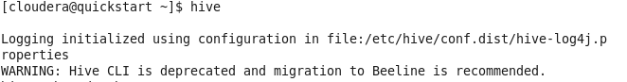

**To display databases:-**

**Show Databases;**

1. **Hive Data Types**

Primitive types:

* TINYINT
* SMALLINT
* INT
* BIGINT
* BOOLEAN
* FLOAT
* DOUBLE
* BIGDECIMAL (Only available starting with Hive [0.10.0)](https://issues.apache.org/jira/browse/HIVE-2693)
* STRING
* BINARY (Only available starting with Hive [0.8.0)](https://issues.apache.org/jira/browse/HIVE-2380)
* TIMESTAMP (Only available starting with Hive [0.8.0)](https://issues.apache.org/jira/browse/HIVE-2272)

Complex types:

* arrays: ARRAY<data_type>
* maps: MAP<primitive_type, data_type>
* structs: STRUCT<col_name : data_type [COMMENT col_comment], ...>
* union: UNIONTYPE<data_type, data_type, ...>

1. **To create new database:-**

**create database databsename;**

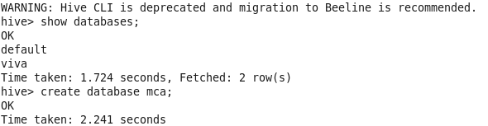

**Create table employee and department under database mca.**

**Create table mca.emp1(empcode INT,empfname STRING,emplname STRING,job STRING,manager STRING,hiredate STRING,salary INT,comm INT,deptcode INT)row format delimited fields terminated by ‘,’;**



**Create table mca.dept1(deptcode INT,deptname STRING,location STRING)row format delimited fields terminated by ‘,’;**



1. **List the tables that are created under mca database**

**use mca;**

**show tables;**

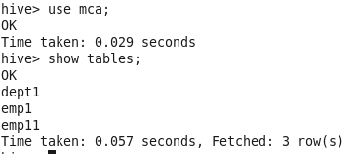

1. **Load data in the tables employee and department using employee.txt and dept.txt file.**

**Load data local inpath ‘/home/cloudera/employee.txt’ into table emp1;**

**Load data local inpath ‘/home/cloudera/dept.txt’ into table dept1;**

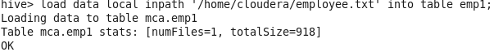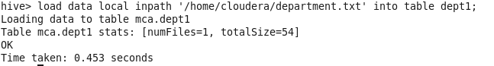

1. **List all the records from the table employee and department.**

**Select * from emp1;**

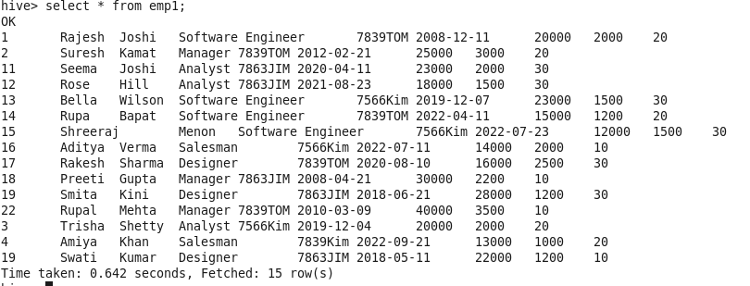

**Select * from dept1;**

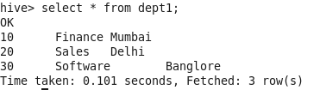

1. **Get the table structure**

**desc emp1;**

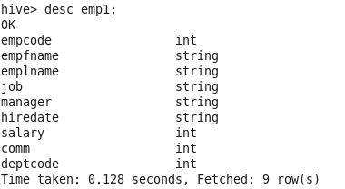

**desc dept1;**

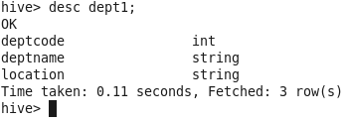

**Perform following operations on employee table**

**7 a) Prepare list of all the jobs and their respective number of employees working for that job**

**select job,count(empfname) from emp1 group by job;**

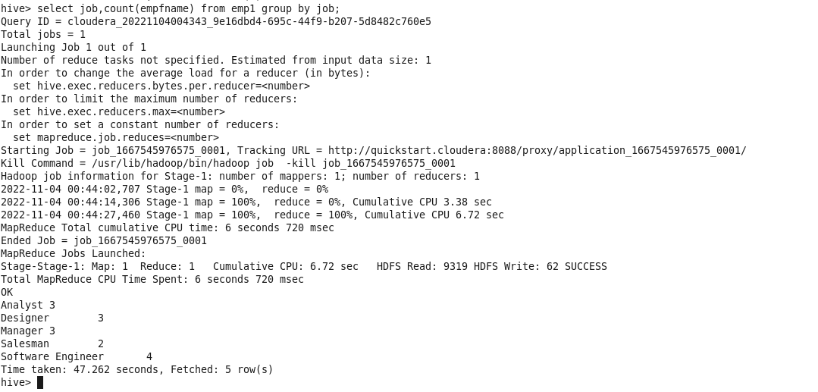

**b) Display all the managers in order where the one who served the most appears first**

**select empfname,emplname,manager,hiredate from emp1 order by hiredate;**

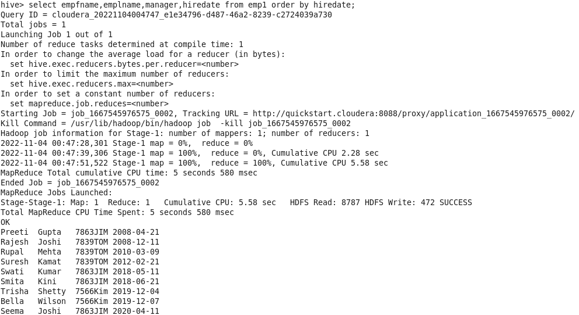

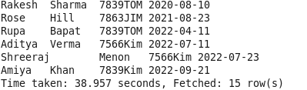

**c) Display the full name and salary for an analyst working in deptno 30**

**select empfname,emplname,salary,job,deptcode from emp1 where job=”Analyst” and deptcode=30**

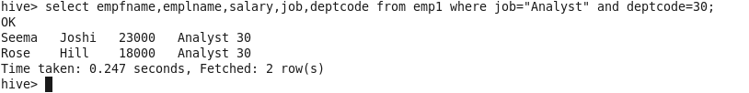

**d) Display the details of employee having salary greater than 25000**

**select * from emp1 where salary>=25000;**

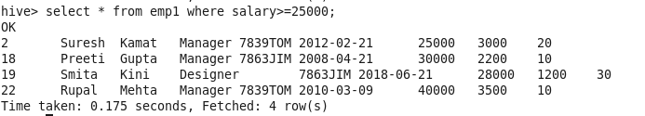

**e) Display maximum salary of an employee**

**select MAX(salary) from emp1;**

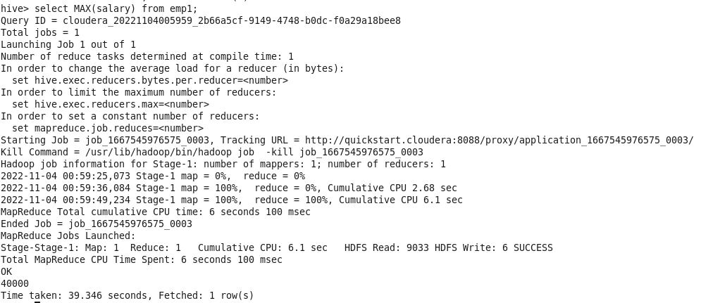

**f) Display name of each employee in UPPERCASE**

**select upper(concat(empfname,’ ‘,emplname)) as Name from emp1;**

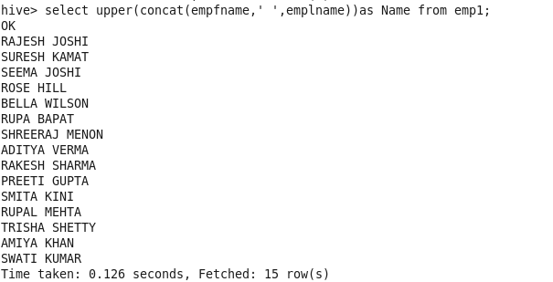

**g) Display the sum of employee salaries job wise**

**select job,sum(salary) from emp1 group by job;**

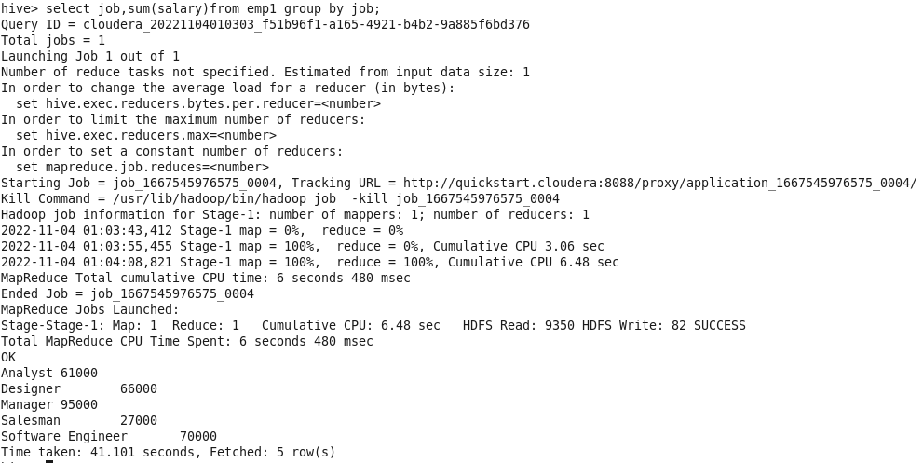

**h) Display the sum of employee salaries dept wise having sum greater than 30000**

**select job,sum(salary) from emp1 group by job having sum(salary)>=30000;**

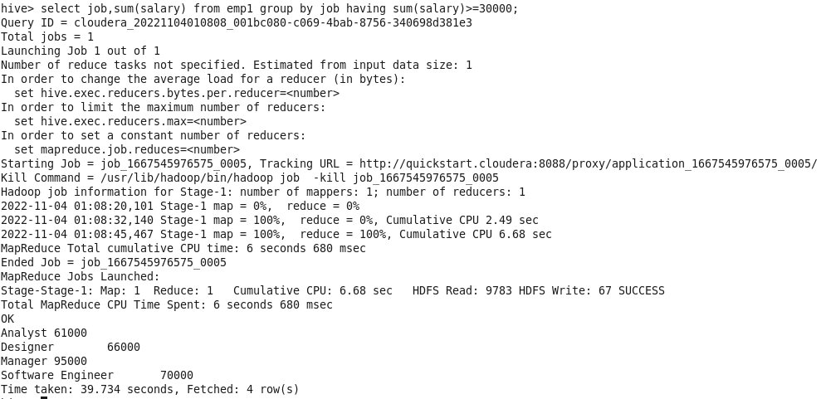

**i) Display the employee data in ascending order of salary**

**Select * from emp1 order by salary;**

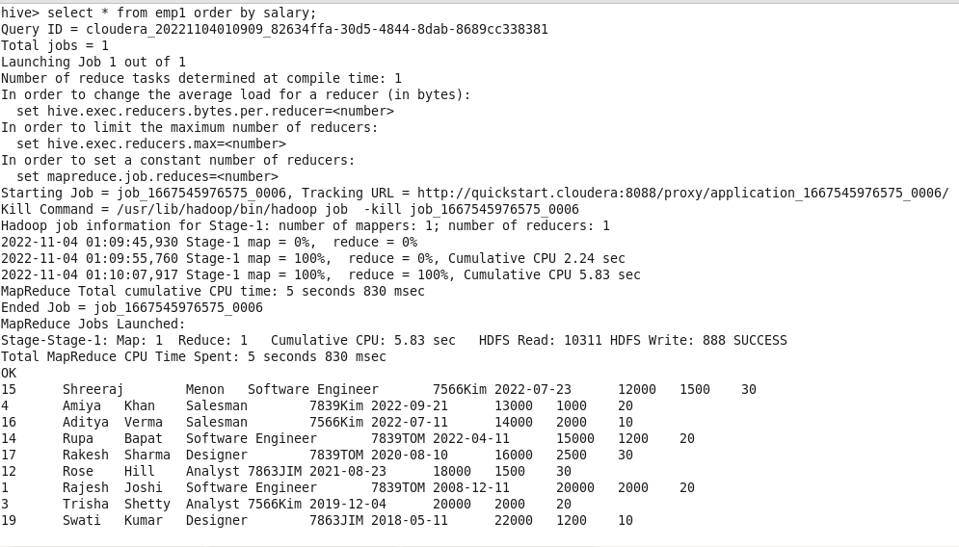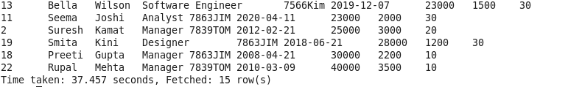

**j) Display the employee data in descending order of salary and ascending order of employee name**

**select * from emp1 e order by e.salary DESC,e.empfname ASC;**

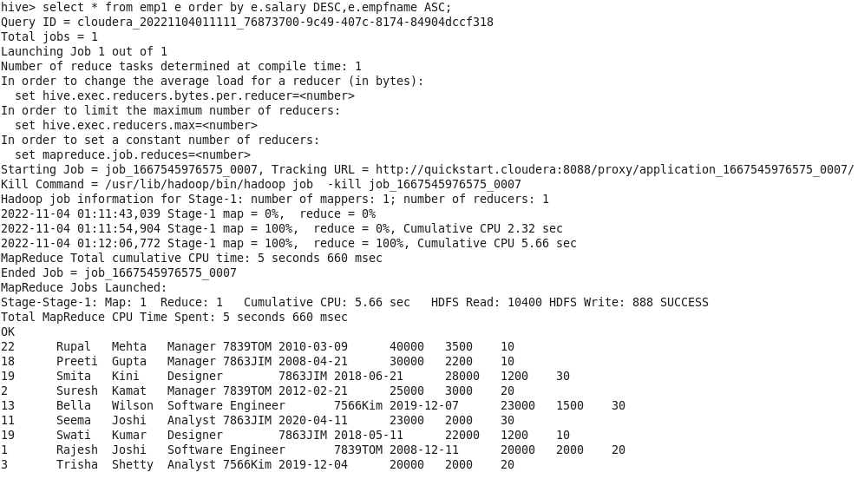

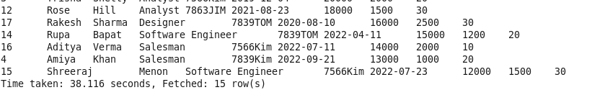

**8) Perform following joins between employee and dept table using key deptcode**

**a)Left Join**

**select * from emp1 LEFT JOIN dept1 on emp1.deptcode=dept1.deptcode;**

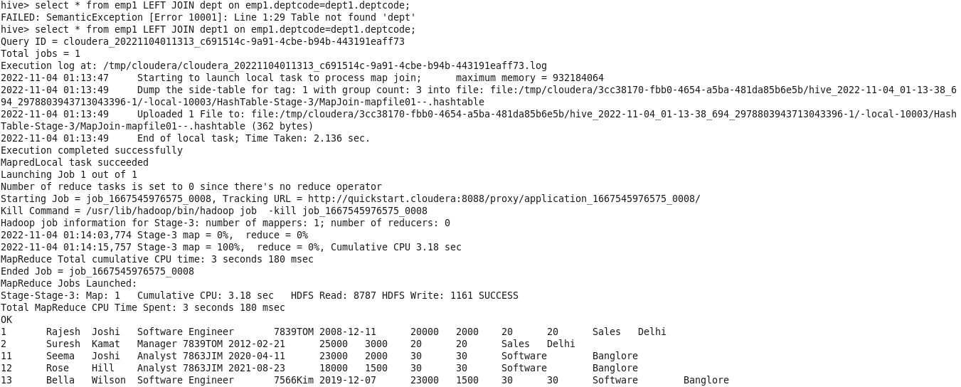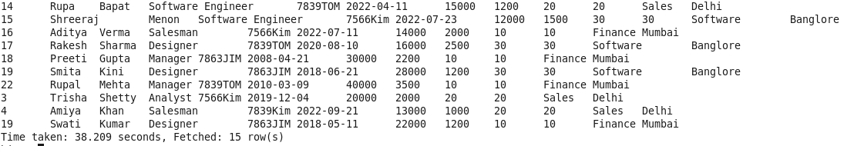

**b) Right Join**

**select * from emp1 RIGHT JOIN dept1 on emp1.deptcode=dept1.deptcode;**

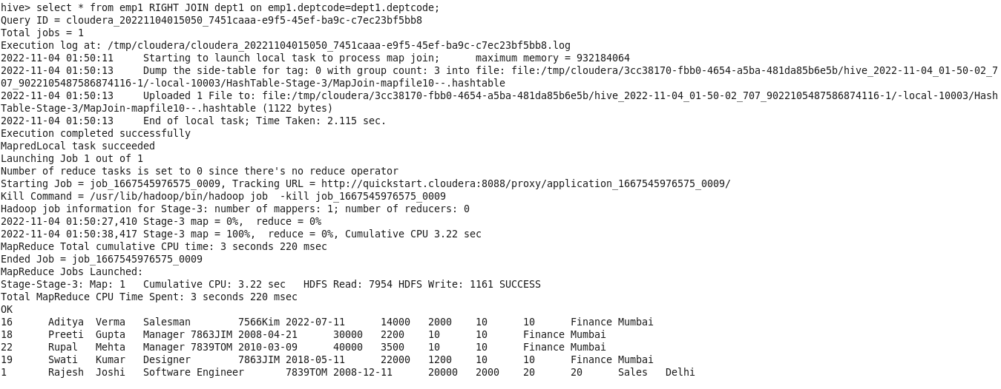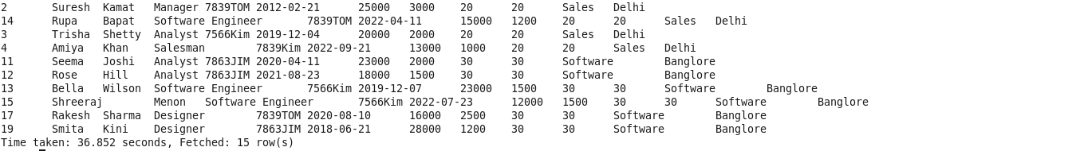

**c) Full Join**

**select * from emp1 FULL JOIN dept1 on emp1.deptcode=dept1.deptcode;**

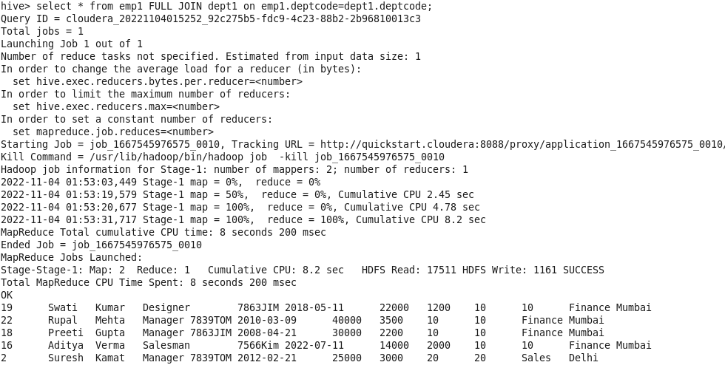

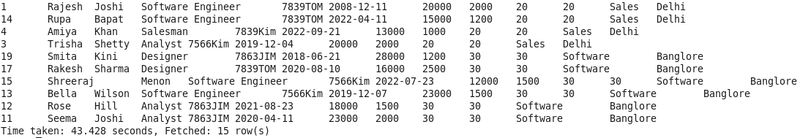

**d) Inner Join**

**select * from emp1 JOIN dept1 on emp1.deptcode=dept1.deptcode;**

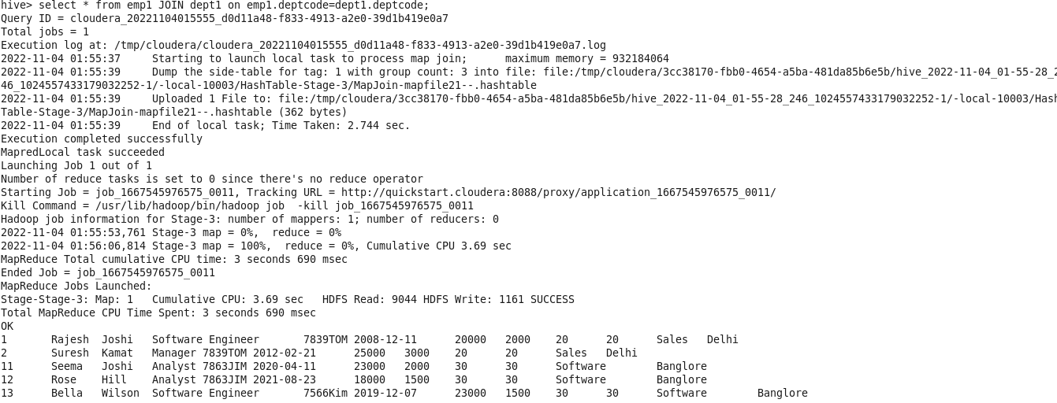

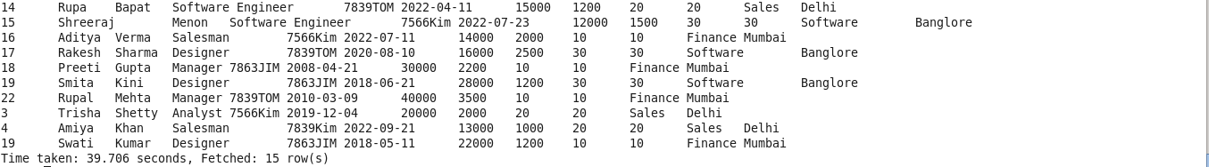

**9) create view on employee table for employee whose salary greater then 20000 and then drop the view**

**create view sal as select * from emp1 where salary>20000;**



**Select * from sal;**

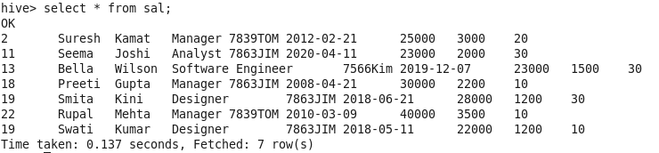

**Drop view sal;**

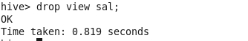

**10) create index on employee table than drop that index.**

**create index empindex1 on table emp1(empfname,emplname)as ‘org.apache.hadoop.hive.ql.index.compact.CompactIndexHandler’ with deferred rebuild;**



**Show index on emp1;**



**Drop index empindex1 on emp1;**

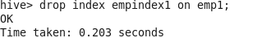

**Show index on emp1;**

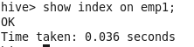

**11) Hive Partitioning**

Create table student with fields (roll INT,studfname STRING,studlname STRING,course STRING)

Create a partitioned table student_course based on course and demonstrate static and dynamic partitioning

**STATIC PARTITIONING**

In static or manual partitioning, it is required to pass the values of partitioned columns manually while loading the data into the table. Hence, the data file doesn't contain the partitioned columns

**Create table student1(roll int,studfname string,studlname string)partitioned by (course string) row format delimited fields terminated by ‘,’;**



**Describe student1;**

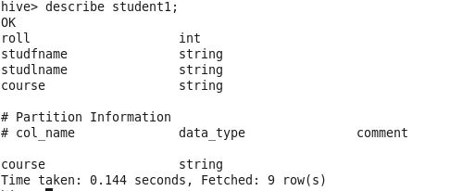

**Load data local inpath’/home/cloudera/studentdata.txt’ into table student1 partition(course=”Java”);**

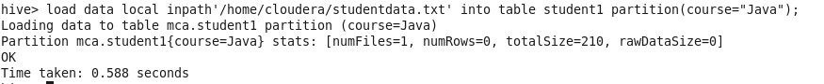

**Load data local inpath’/home/cloudera/studentdata.txt’ into table student1 partition(course=”IOT”);**

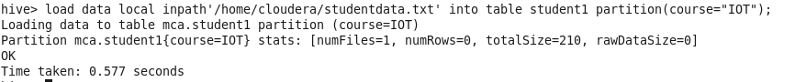

**Select * from student1;**

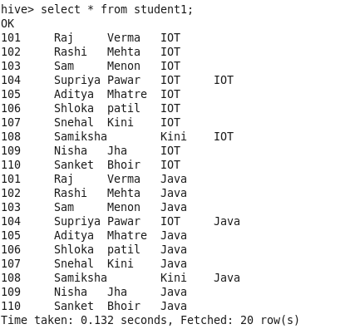

**Describe student1;**

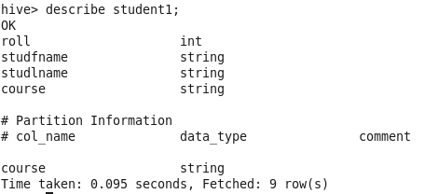

**DYNAMIC PARTITIONING**

**Create table student11(roll INT,studfname STRING,studlname STRING,course STRING) row format delimited fields terminated by’,’;**



**load data local inpath’/home/cloudera/studentdata.txt’ into table student11;**

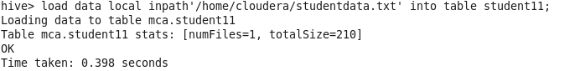

**Select * from student11;**

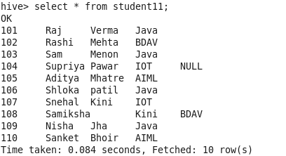



**Create table student_course(roll int,studfname string,studlname string)partitioned by (course string) row format delimited fields terminated by ‘,’;**



**describe student_course;**

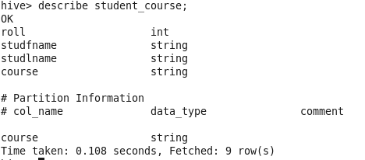

**insert into student_course partition(course)select roll,studfname,studlname,course from student11;**

--If error come (Dynamic partition strict mode)

hive> SET hive.exec.dynamic.partition=true;

hive> SET hive.exec.dynamic.partition.mode=non-strict;

hive> SET hive.enforce.bucketing =true;​

then re run query

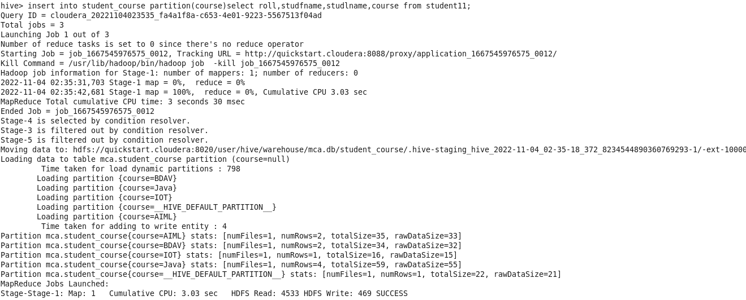



**select * from student_course;**

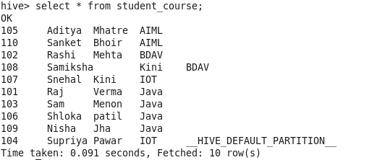

**Data Text files.**

**Student.txt**

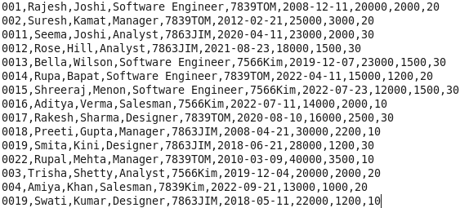

**Department.txt**

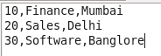

**Studentdata.txt**

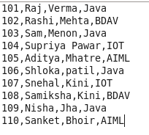

**Practical No. 8**

**Aim: Study of Pig:-**

* 1. **Pig Latin Basic**

**Ans:** Pig Latin is the language used to analyze data in Hadoop using Apache Pig. In this chapter, we are going to discuss the basics of Pig Latin such as Pig Latin statements, data types, general and relational operators, and Pig Latin UDF’s.

## Pig Latin – Statements

While processing data using Pig Latin, **statements** are the basic constructs.

* These statements work with **relations**. They include **expressions** and **schemas**.
* Every statement ends with a semicolon (;).
* We will perform various operations using operators provided by Pig Latin, through statements.
* Except LOAD and STORE, while performing all other operations, Pig Latin statements take a relation as input and produce another relation as output.
* As soon as you enter a **Load** statement in the Grunt shell, its semantic checking will be carried out. To see the contents of the schema, you need to use the **Dump** operator. Only after performing the **dump** operation, the MapReduce job for loading the data into the file system will be carried out.

### **Example**

Given below is a Pig Latin statement, which loads data to Apache Pig.

grunt> Student_data = LOAD 'student_data.txt' USING PigStorage(',')as

( id:int, firstname:chararray, lastname:chararray, phone:chararray, city:

* 1. **Pig Data Types**

**Ans:** Given below table describes the Pig Latin data types.

|  |  |  |
| --- | --- | --- |
| **S.N.** | **Data Type** | **Description & Example** |
| 1 | int | Represents a signed 32-bit integer.  **Example** : 8 |
| 2 | long | Represents a signed 64-bit integer.  **Example** : 5L |
| 3 | float | Represents a signed 32-bit floating point.  **Example** : 5.5F |
| 4 | double | Represents a 64-bit floating point.  **Example** : 10.5 |
| 5 | chararray | Represents a character array (string) in Unicode UTF-8 format.  **Example** : ‘tutorials point’ |
| 6 | Bytearray | Represents a Byte array (blob). |
| 7 | Boolean | Represents a Boolean value.  **Example** : true/ false. |
| 8 | Datetime | Represents a date-time.  **Example** : 1970-01-01T00:00:00.000+00:00 |
| 9 | Biginteger | Represents a Java BigInteger.  **Example** : 60708090709 |
| 10 | Bigdecimal | Represents a Java BigDecimal  **Example** : 185.98376256272893883 |
| **Complex Types** | | |
| 11 | Tuple | A tuple is an ordered set of fields.  **Example** : (raja, 30) |
| 12 | Bag | A bag is a collection of tuples.  **Example** : {(raju,30),(Mohhammad,45)} |
| 13 | Map | A Map is a set of key-value pairs.  **Example** : [ ‘name’#’Raju’, ‘age’#30] |

**Cloudera Terminal Screen:**

* 1. **Download the data**

[cloudera@quickstart ~]$ **cat > /home/cloudera/student.txt**

1,Ram,25,9856321456,airoli

2,Ramesh,24,9856321458,thane

3,Samir,26,8965231478,Virar

4,Sneha,23,8745693214,Vasai

5,Shruti,21,8965471236,Miraroad

^Z

[1]+  Stopped                 cat > /home/cloudera/student.txt

[cloudera@quickstart ~]$ **cat student.txt**

1,Ram,25,9856321456,airoli

2,Ramesh,24,9856321458,thane

3,Samir,26,8965231478,Virar

4,Sneha,23,8745693214,Vasai

5,Shruti,21,8965471236,Miraroad

[cloudera@quickstart ~]$

## Create your script

* 1. **Save and Execute the script**

## Executing Pig Script in Batch mode

While executing Apache Pig statements in batch mode, follow the steps given below.

### **Step 1**

Write all the required Pig Latin statements in a single file. We can write all the Pig Latin statements and commands in a single file and save it as **.pig** file.

### **Step 2**

Execute the Apache Pig script. You can execute the Pig script from the shell (Linux) as shown below.

|  |  |
| --- | --- |
| **Local mode** | **MapReduce mode** |
| $ pig -x local **Sample_script.pig** | $ pig -x mapreduce **Sample_script.pig** |

**Cloudera Terminal:**

[cloudera@quickstart ~]$ **pig -x local;**

2022-11-24 00:41:02,451 [main] INFO  org.apache.hadoop.conf.Configuration.deprecation - mapred.job.tracker is deprecated. Instead, use mapreduce.jobtracker.address

2022-11-24 00:41:02,457 [main] INFO  org.apache.hadoop.conf.Configuration.deprecation - io.bytes.per.checksum is deprecated. Instead, use dfs.bytes-per-checksum

grunt> **student_data = Load '/home/cloudera/student.txt' USING PigStorage (',') as (id:int,name:chararray,age:int,contact:long,address:chararray);**

* 1. **Pig Operations: Diagnostic Operations, Grouping and Joining, Combining and Splitting, Filtering, Sorting.**

**//Grouping and Joining**

grunt> **student_agegroup = Group student_data by age;**

grunt> **Dump student_agegroup;**

2022-11-24 00:41:54,162 [main] INFO  org.apache.pig.tools.pigstats.ScriptState - Pig features used in the script: GROUP_BY

2022-11-24 00:41:54,290 [main] INFO  org.apache.pig.newplan.logical.optimizer.LogicalPlanOptimizer - {RULES_ENABLED=[AddForEach, ColumnMapKeyPrune, DuplicateForEachColumnRewrite, GroupByConstParallelSetter, ImplicitSplitInserter, LimitOptimizer, LoadTypeCastInserter, MergeFilter, MergeForEach, NewPartitionFilterOptimizer, PushDownForEachFlatten, PushUpFilter, SplitFilter, StreamTypeCastInserter], RULES_DISABLED=[FilterLogicExpressionSimplifier, PartitionFilterOptimizer]}

2022-11-24 00:41:58,718 [LocalJobRunner Map Task Executor #0] INFO  org.apache.hadoop.mapred.MapTask - Processing split: Number of splits :1

Total Length = 144

Input split[0]:

   Length = 144

  Locations:

-----------------------

HadoopVersion   PigVersion  UserId  StartedAt   FinishedAt  Features

2.6.0-cdh5.13.0 0.12.0-cdh5.13.0    cloudera    2022-11-24 00:41:54 2022-11-24 00:42:10 GROUP_BY

Success!

Job Stats (time in seconds):

JobId   Alias   Feature Outputs

job_local447114441_0001 student_agegroup,student_data   GROUP_BY    file:/tmp/temp-770698414/tmp985266601,

Input(s):

Successfully read records from: "/home/cloudera/student.txt"

Output(s):

Successfully stored records in: "file:/tmp/temp-770698414/tmp985266601"

Job DAG:

job_local447114441_0001

2022-11-24 00:42:16,494 [main] INFO  org.apache.pig.backend.hadoop.executionengine.util.MapRedUtil - Total input paths to process : 1

(21,{(5,Shruti,21,8965471236,Miraroad)})

(23,{(4,Sneha,23,8745693214,Vasai)})

(24,{(2,Ramesh,24,9856321458,thane)})

(25,{(1,Ram,25,9856321456,airoli)})

(26,{(3,Samir,26,8965231478,Virar)})

grunt>

cloudera@quickstart ~]$ **touch customer.txt**

[cloudera@quickstart ~]$ **vi customer.txt**

[3]+ Stopped vim customer.txt

[cloudera@quickstart ~]$ **cat customer.txt**

[cloudera@quickstart ~]$ **cat > /home/cloudera/customer.txt**

1,Ramesh,32,Mumbai,20000.00

2,Ram,33,Hydrabad,30000.00

^Z

[4]+ Stopped cat > /home/cloudera/customer.txt

[cloudera@quickstart ~]$ **cat > /home/cloudera/order.txt**

102,2009-08-10,00:00:00,3,3000

101,2010-03-11,00:00:00,3,1500

^Z

[5]+ Stopped cat > /home/cloudera/order.txt

[cloudera@quickstart ~]$ **pig -x local;**

grunt> **customers = Load '/home/cloudera/customer.txt' USING PigStorage (',') as (id:int,name:chararray,age:int,address:chararray,salary:int);**

grunt> **orders = Load '/home/cloudera/order.txt' USING PigStorage (',') as (oid:int,date:chararray,custid:int,amount:int);**

grunt> **customers_orders = JOIN customers by id,orders by custid;**

grunt> **dump customers_orders;**

grunt> **customers_orders_leftouter = JOIN customers by id LEFT OUTER,orders by custid;**

grunt> **dump customers_orders_leftouter;**

Success!

Job Stats (time in seconds):

JobId Alias Feature Outputs

job_local1289991738_0002 customers,customers_orders_leftouter,orders HASH_JOIN file:/tmp/temp2144833409/tmp-1967226646,

Input(s):

Successfully read records from: "/home/cloudera/customer.txt"

Successfully read records from: "/home/cloudera/order.txt"

Output(s):

Successfully stored records in: "file:/tmp/temp2144833409/tmp-1967226646"

Job DAG:

job_local1289991738_0002

2022-11-23 20:54:01,254 [main] INFO org.apache.pig.backend.hadoop.executionengine.mapReduceLayer.MapReduceLauncher - Success!

2022-11-23 20:54:01,255 [main] INFO org.apache.hadoop.conf.Configuration.deprecation - fs.default.name is deprecated. Instead, use fs.defaultFS

2022-11-23 20:54:01,255 [main] INFO org.apache.hadoop.conf.Configuration.deprecation - mapred.job.tracker is deprecated. Instead, use mapreduce.jobtracker.address

2022-11-23 20:54:01,257 [main] INFO org.apache.hadoop.conf.Configuration.deprecation - io.bytes.per.checksum is deprecated. Instead, use dfs.bytes-per-checksum

2022-11-23 20:54:01,257 [main] WARN org.apache.pig.data.SchemaTupleBackend - SchemaTupleBackend has already been initialized

2022-11-23 20:54:01,304 [main] INFO org.apache.hadoop.mapreduce.lib.input.FileInputFormat - Total input paths to process : 1

2022-11-23 20:54:01,304 [main] INFO org.apache.pig.backend.hadoop.executionengine.util.MapRedUtil - Total input paths to process : 1

(1,Ramesh,32,Mumbai,20000,,,,)

(2,Ram,33,Hydrabad,30000,,,,)

grunt> **customers_orders_rightouter = JOIN customers by id RIGHT,orders by custid;**

grunt> **dump customers_orders_rightouter;**

HadoopVersion PigVersion UserId StartedAt FinishedAt Features

2.6.0-cdh5.13.0 0.12.0-cdh5.13.0 cloudera 2022-11-23 20:55:47 2022-11-23 20:56:00 HASH_JOIN

Success!

Job Stats (time in seconds):

JobId Alias Feature Outputs

job_local1122836933_0003 customers,customers_orders_rightouter,orders HASH_JOIN file:/tmp/temp2144833409/tmp-1782501056,

Input(s):

Successfully read records from: "/home/cloudera/order.txt"

Successfully read records from: "/home/cloudera/customer.txt"

Output(s):

Successfully stored records in: "file:/tmp/temp2144833409/tmp-1782501056"

Job DAG:

job_local1122836933_0003

2022-11-23 20:56:06,372 [main] INFO org.apache.pig.backend.hadoop.executionengine.mapReduceLayer.MapReduceLauncher - Success!

2022-11-23 20:56:06,374 [main] INFO org.apache.hadoop.conf.Configuration.deprecation - fs.default.name is deprecated. Instead, use fs.defaultFS

2022-11-23 20:56:06,374 [main] INFO org.apache.hadoop.conf.Configuration.deprecation - mapred.job.tracker is deprecated. Instead, use mapreduce.jobtracker.address

2022-11-23 20:56:06,375 [main] INFO org.apache.hadoop.conf.Configuration.deprecation - io.bytes.per.checksum is deprecated. Instead, use dfs.bytes-per-checksum

2022-11-23 20:56:06,376 [main] WARN org.apache.pig.data.SchemaTupleBackend - SchemaTupleBackend has already been initialized

2022-11-23 20:56:06,399 [main] INFO org.apache.hadoop.mapreduce.lib.input.FileInputFormat - Total input paths to process : 1

2022-11-23 20:56:06,399 [main] INFO org.apache.pig.backend.hadoop.executionengine.util.MapRedUtil - Total input paths to process : 1

(,,,,,101,2010-03-11,,3)

(,,,,,102,2009-08-10,,3)

[cloudera@quickstart ~]$ **touch emp.txt**

[cloudera@quickstart ~]$ **cat > /home/cloudera/emp.txt**

Manish,pal,1

Meena,rao,2

Prashant,gupta,3

Rushabh,pawar,4

Viraj,pitale,5

^Z

[7]+ Stopped cat > /home/cloudera/emp.txt

[cloudera@quickstart ~]$ **hdfs dfs -put emp.txt /user/cloudera/**

[cloudera@quickstart ~]$ **hdfs dfs -ls**

Found 1 items

-rw-r--r-- 1 cloudera cloudera 73 2022-11-23 21:00 emp.txt

[cloudera@quickstart ~]$ **pig**

grunt> **fs -cat /user/cloudera/emp.txt;**

Manish,pal,1

Meena,rao,2

Prashant,gupta,3

Rushabh,pawar,4

Viraj,pitale,5

grunt> **B = Load '/user/cloudera/emp.txt' USING PigStorage (',') as (Fname:chararray,Lname:chararray,id:int);**

grunt> **dump B;**

Input(s):

Successfully read 5 records (445 bytes) from: "/user/cloudera/emp.txt"

Output(s):

Successfully stored 5 records (107 bytes) in: "hdfs://quickstart.cloudera:8020/tmp/temp1898886882/tmp257753236"

Counters:

Total records written : 5

Total bytes written : 107

Spillable Memory Manager spill count : 0

Total bags proactively spilled: 0

Total records proactively spilled: 0

Job DAG:

job_1669264024719_0001

2022-11-23 21:05:46,413 [main] INFO org.apache.pig.backend.hadoop.executionengine.mapReduceLayer.MapReduceLauncher - Success!

2022-11-23 21:05:46,419 [main] INFO org.apache.hadoop.conf.Configuration.deprecation - fs.default.name is deprecated. Instead, use fs.defaultFS

2022-11-23 21:05:46,419 [main] INFO org.apache.hadoop.conf.Configuration.deprecation - mapred.job.tracker is deprecated. Instead, use mapreduce.jobtracker.address

2022-11-23 21:05:46,421 [main] INFO org.apache.pig.data.SchemaTupleBackend - Key [pig.schematuple] was not set... will not generate code.

2022-11-23 21:05:46,477 [main] INFO org.apache.hadoop.mapreduce.lib.input.FileInputFormat - Total input paths to process : 1

2022-11-23 21:05:46,477 [main] INFO org.apache.pig.backend.hadoop.executionengine.util.MapRedUtil - Total input paths to process : 1

(Manish,pal,1)

(Meena,rao,2)

(Prashant,gupta,3)

(Rushabh,pawar,4)

(Viraj,pitale,5)

//below command will not show the record of pawar.

grunt> **filterrowdata = filter B by Lname!='pawar';**

grunt> **dump filterrowdata;**

Input(s):

Successfully read 5 records (445 bytes) from: "/user/cloudera/emp.txt"

Output(s):

Successfully stored 4 records (86 bytes) in: "hdfs://quickstart.cloudera:8020/tmp/temp1898886882/tmp1236244344"

Counters:

Total records written : 4

Total bytes written : 86

Spillable Memory Manager spill count : 0

Total bags proactively spilled: 0

Total records proactively spilled: 0

Job DAG:

job_1669264024719_0002

2022-11-23 21:07:56,435 [main] INFO org.apache.pig.backend.hadoop.executionengine.mapReduceLayer.MapReduceLauncher - Success!

2022-11-23 21:07:56,436 [main] INFO org.apache.hadoop.conf.Configuration.deprecation - fs.default.name is deprecated. Instead, use fs.defaultFS

2022-11-23 21:07:56,436 [main] INFO org.apache.hadoop.conf.Configuration.deprecation - mapred.job.tracker is deprecated. Instead, use mapreduce.jobtracker.address

2022-11-23 21:07:56,438 [main] INFO org.apache.pig.data.SchemaTupleBackend - Key [pig.schematuple] was not set... will not generate code.

2022-11-23 21:07:56,457 [main] INFO org.apache.hadoop.mapreduce.lib.input.FileInputFormat - Total input paths to process : 1

2022-11-23 21:07:56,457 [main] INFO org.apache.pig.backend.hadoop.executionengine.util.MapRedUtil - Total input paths to process : 1

(Manish,pal,1)

(Meena,rao,2)

(Prashant,gupta,3)

(Viraj,pitale,5)

**//Filtering**

grunt> **filterdata = foreach B generate Fname,Lname;**

grunt> **dump filterdata;**

Input(s):

Successfully read 5 records (445 bytes) from: "/user/cloudera/emp.txt"

Output(s):

Successfully stored 5 records (98 bytes) in: "hdfs://quickstart.cloudera:8020/tmp/temp1898886882/tmp812709621"

Counters:

Total records written : 5

Total bytes written : 98

Spillable Memory Manager spill count : 0

Total bags proactively spilled: 0

Total records proactively spilled: 0

Job DAG:

job_1669264024719_0003

2022-11-23 21:10:40,497 [main] INFO org.apache.pig.backend.hadoop.executionengine.mapReduceLayer.MapReduceLauncher - Success!

2022-11-23 21:10:40,498 [main] INFO org.apache.hadoop.conf.Configuration.deprecation - fs.default.name is deprecated. Instead, use fs.defaultFS

2022-11-23 21:10:40,498 [main] INFO org.apache.hadoop.conf.Configuration.deprecation - mapred.job.tracker is deprecated. Instead, use mapreduce.jobtracker.address

2022-11-23 21:10:40,499 [main] INFO org.apache.pig.data.SchemaTupleBackend - Key [pig.schematuple] was not set... will not generate code.

2022-11-23 21:10:40,510 [main] INFO org.apache.hadoop.mapreduce.lib.input.FileInputFormat - Total input paths to process : 1

2022-11-23 21:10:40,511 [main] INFO org.apache.pig.backend.hadoop.executionengine.util.MapRedUtil - Total input paths to process : 1

(Manish,pal)

(Meena,rao)

(Prashant,gupta)

(Rushabh,pawar)

(Viraj,pitale)

**// Sorting**

grunt> **orderbydata = ORDER B BY Fname DESC;**

grunt> **dump orderbydata;**

(Viraj,pitale,5)

(Rushabh,pawar,4)

(Prashant,gupta,3)

(Meena,rao,2)

(Manish,pal,1)

UNION oerator

grunt> **emp_data = Load '/user/cloudera/emp.txt' USING PigStorage (',') as (Fname:chararray,Lname:chararray,id:int);**

grunt> **dump emp_data;**

Input(s):

Successfully read 5 records (445 bytes) from: "/user/cloudera/emp.txt"

Output(s):

Successfully stored 5 records (107 bytes) in: "hdfs://quickstart.cloudera:8020/tmp/temp-120282841/tmp-333419804"

Counters:

Total records written : 5

Total bytes written : 107

Spillable Memory Manager spill count : 0

Total bags proactively spilled: 0

Total records proactively spilled: 0

Job DAG:

job_1669264024719_0008

2022-11-23 21:19:57,938 [main] INFO org.apache.pig.backend.hadoop.executionengine.mapReduceLayer.MapReduceLauncher - Success!

2022-11-23 21:19:57,940 [main] INFO org.apache.hadoop.conf.Configuration.deprecation - fs.default.name is deprecated. Instead, use fs.defaultFS

2022-11-23 21:19:57,940 [main] INFO org.apache.hadoop.conf.Configuration.deprecation - mapred.job.tracker is deprecated. Instead, use mapreduce.jobtracker.address

2022-11-23 21:19:57,941 [main] INFO org.apache.pig.data.SchemaTupleBackend - Key [pig.schematuple] was not set... will not generate code.

2022-11-23 21:19:57,985 [main] INFO org.apache.hadoop.mapreduce.lib.input.FileInputFormat - Total input paths to process : 1

2022-11-23 21:19:57,985 [main] INFO org.apache.pig.backend.hadoop.executionengine.util.MapRedUtil - Total input paths to process : 1

(Manish,pal,1)

(Meena,rao,2)

(Prashant,gupta,3)

(Rushabh,pawar,4)

(Viraj,pitale,5)

[cloudera@quickstart ~]$ **cat > /home/cloudera/stud.txt**

Raj,sharma,101

Ramesh,pathak,102

Seema,verma,103

^Z

[9]+ Stopped cat > /home/cloudera/stud.txt

[cloudera@quickstart ~]$ **cat stud.txt**

Raj,sharma,101

Ramesh,pathak,102

Seema,verma,103

[cloudera@quickstart ~]$ **touch stud1.txt;**

[cloudera@quickstart ~]$ **cat > /home/cloudera/stud1.txt**

Raj,sharma,101

Ramesh,pathak,102

Seema,verma,103

^Z

[11]+ Stopped cat > /home/cloudera/stud1.txt

[cloudera@quickstart ~]$ **cat stud1.txt**

Raj,sharma,101

Ramesh,pathak,102

Seema,verma,103

[cloudera@quickstart ~]$ **hdfs dfs -put stud1.txt /user/cloudera/**

[cloudera@quickstart ~]$ **hdfs dfs -ls**

Found 2 items

-rw-r--r-- 1 cloudera cloudera 73 2022-11-23 21:00 emp.txt

-rw-r--r-- 1 cloudera cloudera

[cloudera@quickstart ~]$ **pig**

grunt> **fs -cat /user/cloudera/stud1.txt;**

Raj,sharma,101

Ramesh,pathak,102

Seema,verma,103

grunt> **stud_data = Load '/user/cloudera/stud1.txt' USING PigStorage (',') as (Fname:chararray,Lname:chararray,id:int);**

grunt> **dump stud_data;**

Input(s):

Successfully read 3 records (423 bytes) from: "/user/cloudera/stud1.txt"

Output(s):

Successfully stored 3 records (68 bytes) in: "hdfs://quickstart.cloudera:8020/tmp/temp-389547853/tmp-395179122"

Counters:

Total records written : 3

Total bytes written : 68

Spillable Memory Manager spill count : 0

Total bags proactively spilled: 0

Total records proactively spilled: 0

Job DAG:

job_1669264024719_0013

2022-11-23 21:53:36,258 [main] INFO org.apache.pig.backend.hadoop.executionengine.mapReduceLayer.MapReduceLauncher - Success!

2022-11-23 21:53:36,264 [main] INFO org.apache.hadoop.conf.Configuration.deprecation - fs.default.name is deprecated. Instead, use fs.defaultFS

2022-11-23 21:53:36,264 [main] INFO org.apache.hadoop.conf.Configuration.deprecation - mapred.job.tracker is deprecated. Instead, use mapreduce.jobtracker.address

2022-11-23 21:53:36,265 [main] INFO org.apache.pig.data.SchemaTupleBackend - Key [pig.schematuple] was not set... will not generate code.

2022-11-23 21:53:36,303 [main] INFO org.apache.hadoop.mapreduce.lib.input.FileInputFormat - Total input paths to process : 1

2022-11-23 21:53:36,304 [main] INFO org.apache.pig.backend.hadoop.executionengine.util.MapRedUtil - Total input paths to process : 1

(Raj,sharma,101)

(Ramesh,pathak,102)

(Seema,verma,103)

grunt> **load_emp = Load '/user/cloudera/emp.txt' USING PigStorage (',') as (Fname:chararray,Lname:chararray,id:int);**

grunt> **dump load_emp;**

Input(s):

Successfully read 5 records (445 bytes) from: "/user/cloudera/emp.txt"

Output(s):

Successfully stored 5 records (107 bytes) in: "hdfs://quickstart.cloudera:8020/tmp/temp-389547853/tmp1727300527"

Counters:

Total records written : 5

Total bytes written : 107

Spillable Memory Manager spill count : 0

Total bags proactively spilled: 0

Total records proactively spilled: 0

Job DAG:

job_1669264024719_0014

2022-11-23 21:58:16,867 [main] INFO org.apache.pig.backend.hadoop.executionengine.mapReduceLayer.MapReduceLauncher - Success!

2022-11-23 21:58:16,867 [main] INFO org.apache.hadoop.conf.Configuration.deprecation - fs.default.name is deprecated. Instead, use fs.defaultFS

2022-11-23 21:58:16,879 [main] INFO org.apache.hadoop.mapreduce.lib.input.FileInputFormat - Total input paths to process : 1

2022-11-23 21:58:16,879 [main] INFO org.apache.pig.backend.hadoop.executionengine.util.MapRedUtil - Total input paths to process : 1

(Manish,pal,1)

(Meena,rao,2)

(Prashant,gupta,3)

(Rushabh,pawar,4)

(Viraj,pitale,5)

grunt> **union_data = UNION load_emp,stud_data;**

grunt> **dump union_data;**

Output(s):

Successfully stored 8 records (175 bytes) in: "hdfs://quickstart.cloudera:8020/tmp/temp-389547853/tmp-510031842"

Counters:

Total records written : 8

Total bytes written : 175

Spillable Memory Manager spill count : 0

Total bags proactively spilled: 0

Total records proactively spilled: 0

Job DAG:

job_1669264024719_0015

2022-11-23 22:00:10,714 [main] INFO org.apache.pig.backend.hadoop.executionengine.mapReduceLayer.MapReduceLauncher - Success!

2022-11-23 22:00:10,714 [main] INFO org.apache.hadoop.conf.Configuration.deprecation - fs.default.name is deprecated. Instead, use fs.defaultFS

2022-11-23 22:00:10,714 [main] INFO org.apache.hadoop.conf.Configuration.deprecation -

2022-11-23 22:00:10,732 [main] INFO org.apache.pig.backend.hadoop.executionengine.util.MapRedUtil - Total input paths to process : 2

(Manish,pal,1)

(Meena,rao,2)

(Prashant,gupta,3)

(Rushabh,pawar,4)

(Viraj,pitale,5)

(Raj,sharma,101)

(Ramesh,pathak,102)

(Seema,verma,103)

Splitting_data

[12]+ Stopped pig

**Practical No. 9**

**Aim: Study and Usage of Spark Commands.**

* 1. **Downloading Data Set and Processing it Spark.**

**Terminal Screen:**

**C:\>spark-shell**

22/11/22 11:35:36 WARN Shell: Did not find winutils.exe: java.io.FileNotFoundException: Hadoop bin directory does not exist: C:\spark-3.3.1-bin-hadoop3\spark-3.3.1-bin-hadoop3\bin\bin -see https://wiki.apache.org/hadoop/WindowsProblems

Setting default log level to "WARN".

To adjust logging level use sc.setLogLevel(newLevel). For SparkR, use setLogLevel(newLevel).

22/11/22 11:35:42 WARN NativeCodeLoader: Unable to load native-hadoop library for your platform... using builtin-java classes where applicable

Spark context Web UI available at http://DESKTOP-7VKNIDQ:4040

Spark context available as 'sc' (master = local[*], app id = local-1669097143545).

Spark session available as 'spark'.

Welcome to

____ __

/ __/__ ___ _____/ /__

_\ \/ _ \/ _ `/ __/ '_/

/___/ .__/\_,_/_/ /_/\_\ version 3.3.1

/_/

Using Scala version 2.12.15 (Java HotSpot(TM) 64-Bit Server VM, Java 15.0.2)

Type in expressions to have them evaluated.

Type :help for more information.

scala>

22/11/22 11:35:58 WARN ProcfsMetricsGetter:

Exception when trying to compute pagesize, as a result reporting of ProcessTree metrics is stopped

* 1. **Word Count in Apache Spark.**

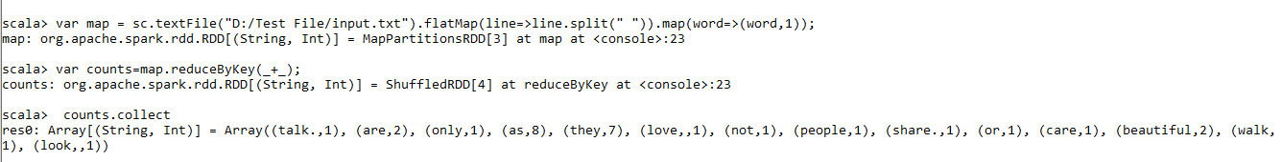

**scala> var map = sc.textFile("D:/Test File/input.txt").flatMap(line=>line.split(" ")).map(word=>(word,1));**

map: org.apache.spark.rdd.RDD[(String, Int)] = MapPartitionsRDD[3] at map at <console>:23

**scala> var counts=map.reduceByKey(_+_);**

counts: org.apache.spark.rdd.RDD[(String, Int)] = ShuffledRDD[4] at reduceByKey at <console>:23

**scala> counts.collect**

res0: Array[(String, Int)] = Array((talk.,1), (are,2), (only,1), (as,8), (they,7), (love,,1), (not,1), (people,1), (share.,1), (or,1), (care,1), (beautiful,2), (walk,1), (look,,1))

**input.txt: -**

people are not as beautiful as they look,

as they walk or as they talk.

they are only as beautiful as they love,

as they care as they share.

**Terminal Screen:**

**scala> spark.read.csv("D:/Test File/student.csv");**

res1: org.apache.spark.sql.DataFrame = [_c0: string, _c1: string ... 3 more fields]

**scala> .show**

+--------+------------+---------+------+-----+

| _c0| _c1| _c2| _c3| _c4|

+--------+------------+---------+------+-----+

|Roll No.| Stud_name| Stream| Year|Grade|

| 1| Amit Lad| Comp Eng| First| A|

| 2| Ram Krishna| MBA|Second| B|

| 3| Sham Shah| BCA| Third| O|

| 4| Gita Kumar| MCA| First| C|

| 5|Sayali Patil|Civil Eng|Second| A|

+--------+------------+---------+------+-----+

**PRACTICAL NO 10**

**Aim: Visualization Using Tableau**

**Assignment 1: Analysis operations**

**Q 1:** **Find the customer with the highest overall profit. What is his/her profit ratio?**

**Ans:**

**Step 1:** Open the superstore subset Excel data set

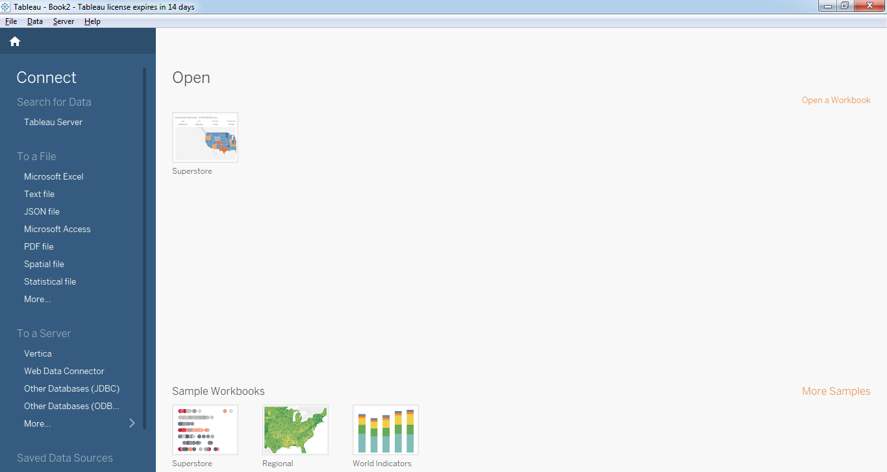

**Step 2:** Drag Orders sheet to sheet area

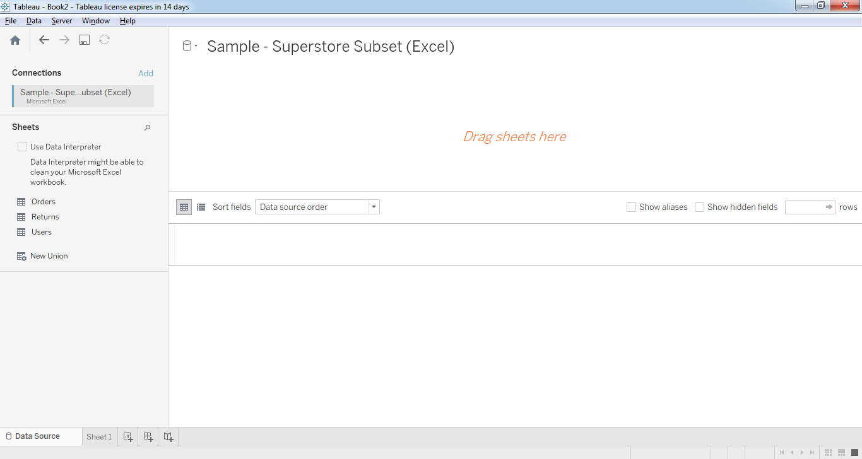

Step 3: Go to sheet 1 and add Customer name as rows and profit as column

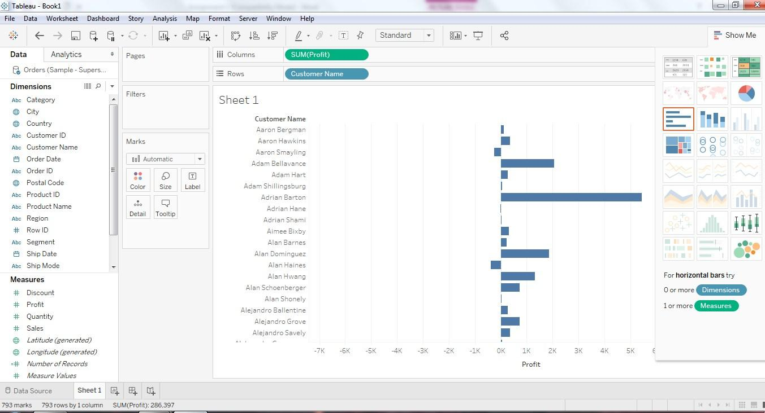

**Step 4**: Sort the data by clicking on Profit label on bottom



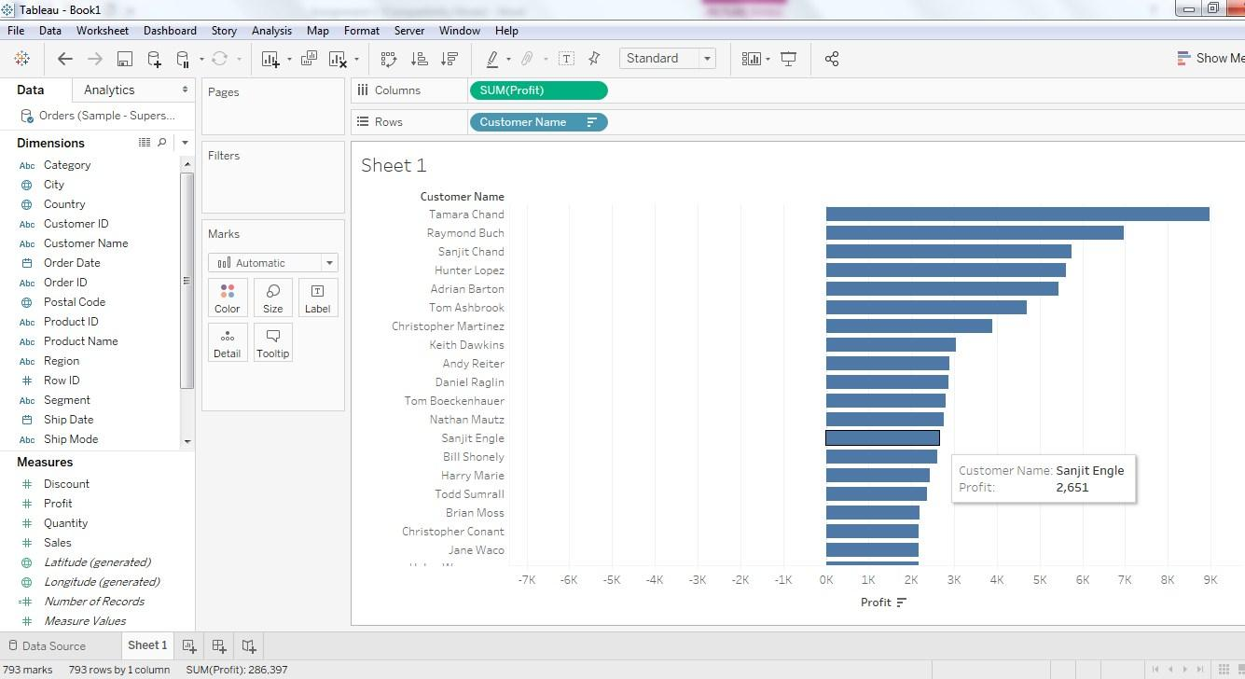

**Step 5:** To calculate profit Ratio

**(Sum([Profit])/Sum([Sales]))**

This formula needs to be entered as tooltip or label

Click on Analysis>Create Calculated Field and enter the formula\

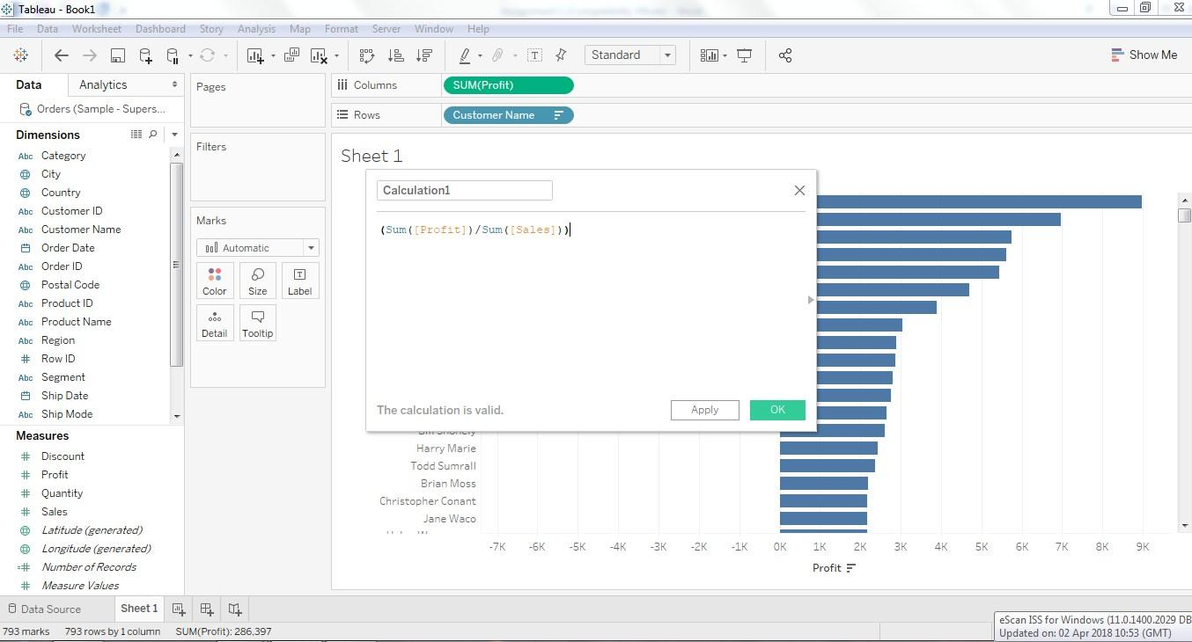

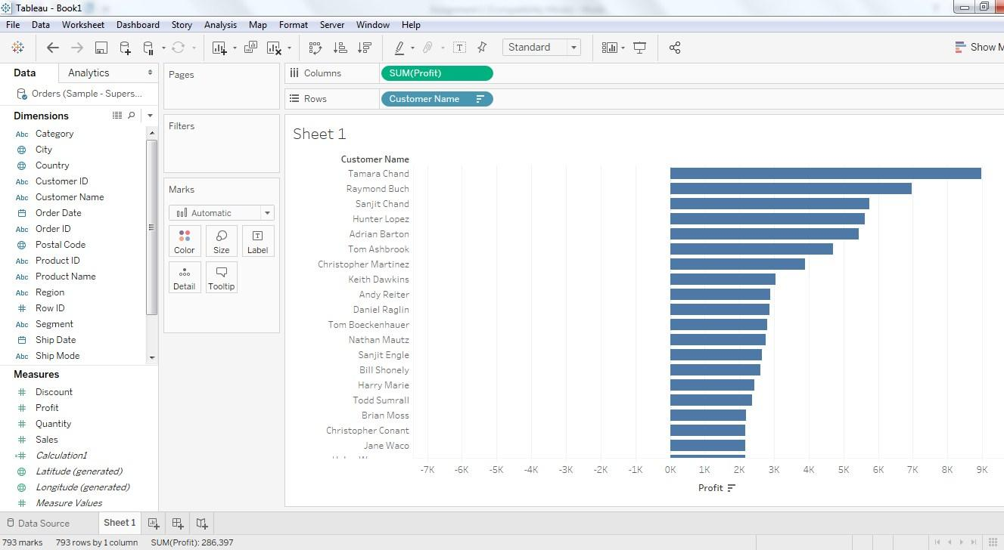

You can see Calculation1 in measures. Drag it to Marks area.

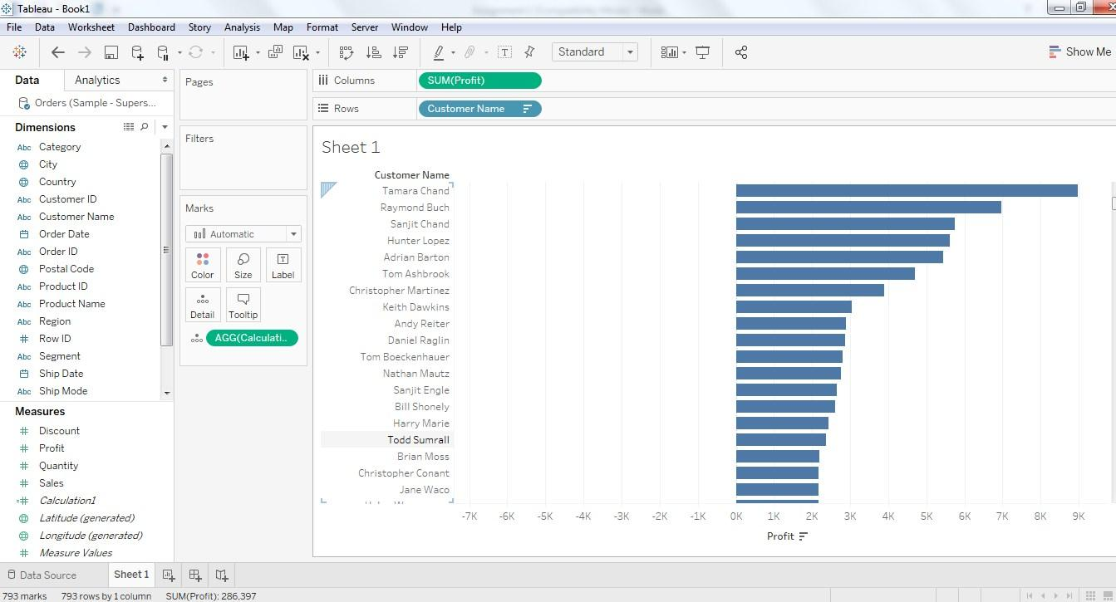

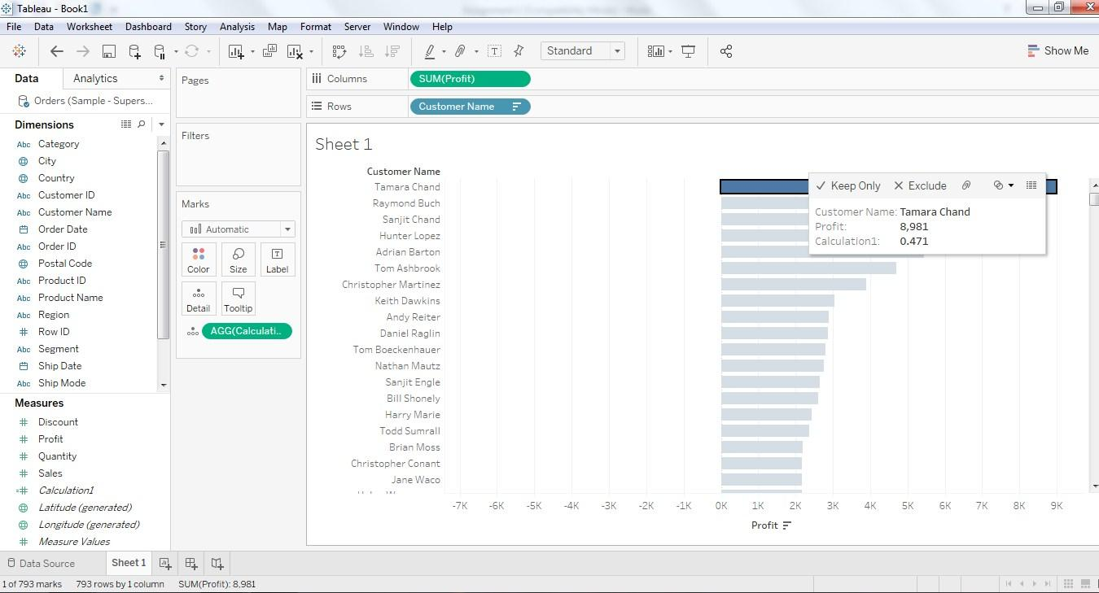

Final answer is: **Note: Your answer might be different… As Data set values are different**

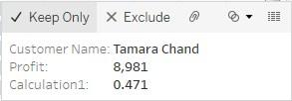

**Q2: Which state has the highest Sales (Sum)? What is the total Sales for that state?**

**Ans: Add State/provinance in Rows**

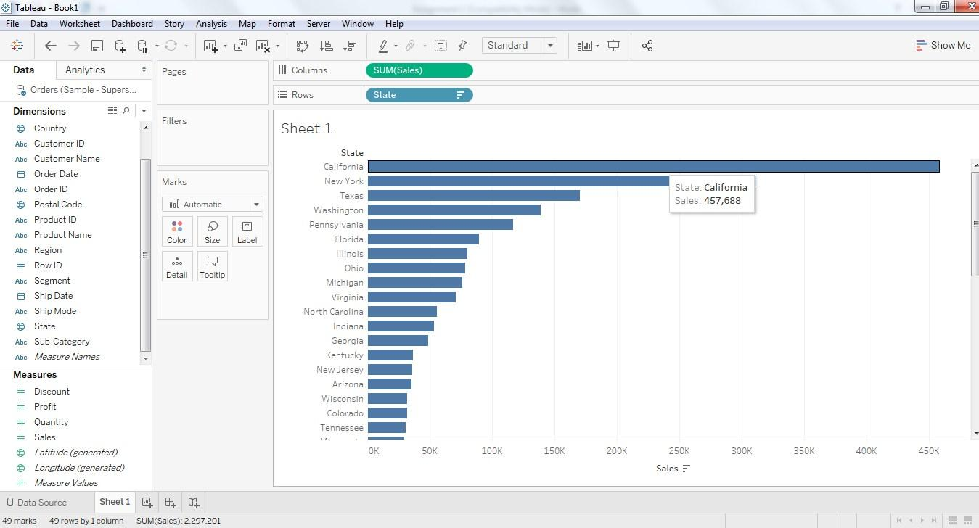

**Q 3: Which customer segment has both the highest order quantity and average discount rate?**

**What is the order quantity and average discount rate for that state?**

**Add Customer segment in columns**

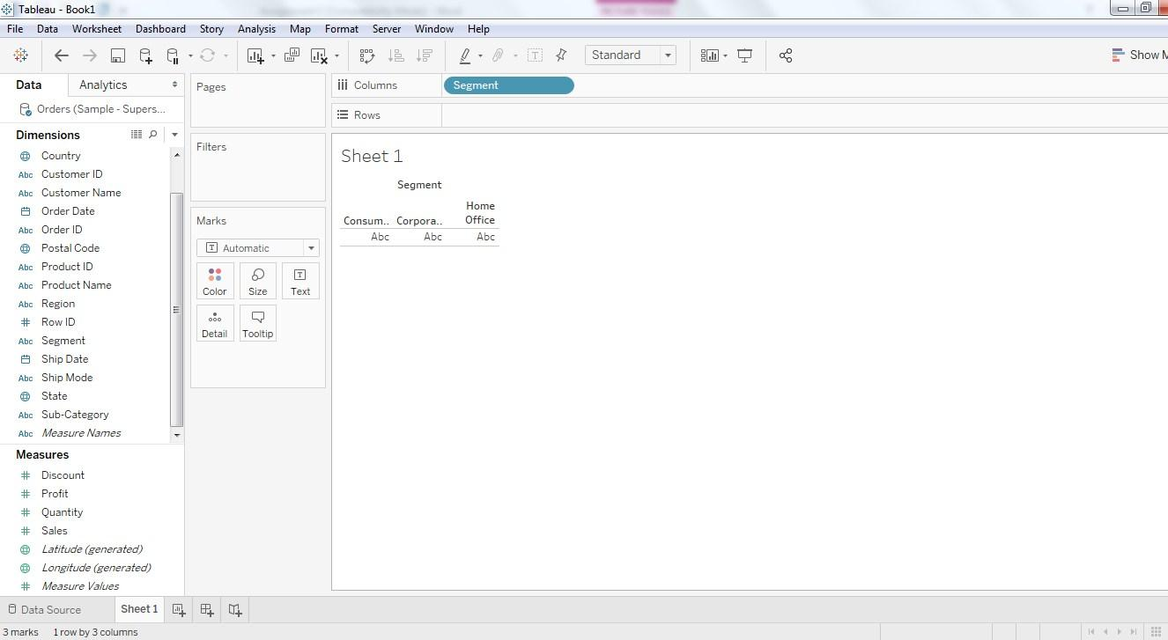

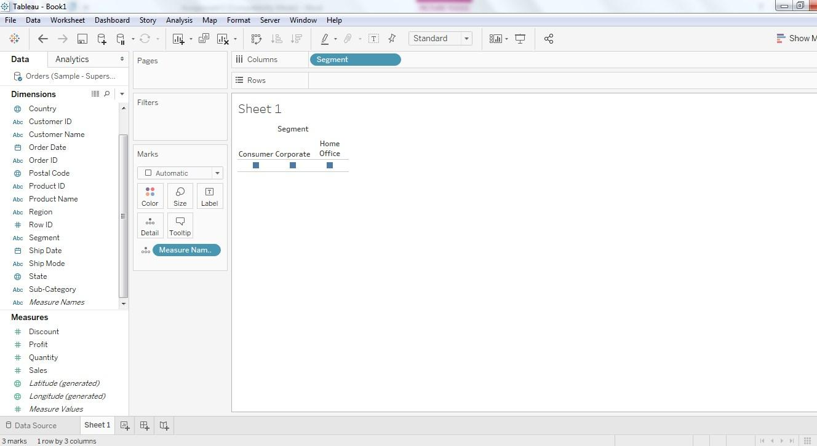

Check Discount and quantity. Rest fields are unchecked (According to question check the appropriate field)

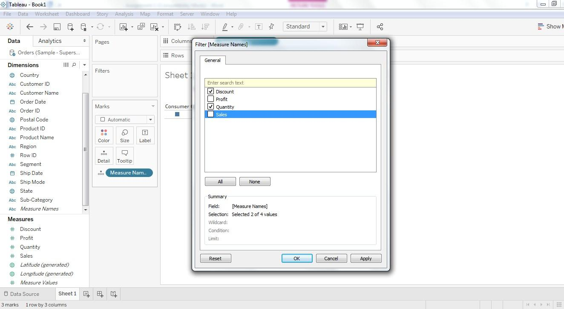

Right click on dimensions to remove it from rows and columns

Select Measure Values As Rows, Segment as Columns

You Can Change Graph by Clicking on dropdown list. Here I have selected line graph

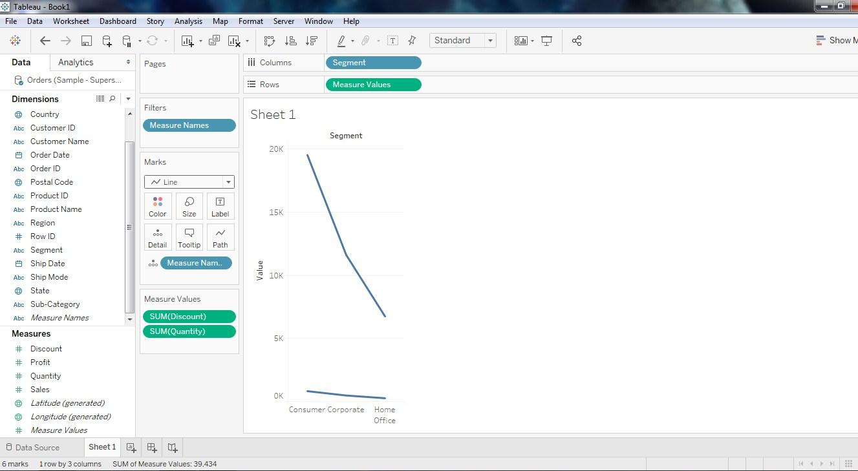

\

**Q 4: Which Product Category has the highest total Sales? Which Product Category has the worst Profit? Name the Product Category and $ amount for each.**

**Ans**

1. Bar Chart displaying total Sales for each Product Category (Change the graph style)

Remove the previous columns and rows by right clicking on it. Add new fields.

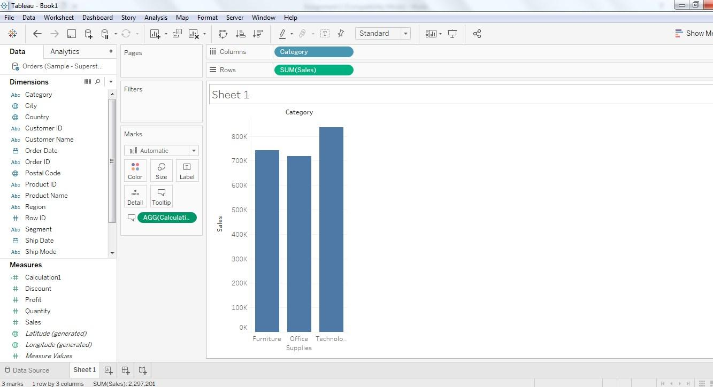

**b. Add a color scale indicating Profit**

Add Sum(Sales) and Sum(Profit) by clicking on icon you can change the marking system.

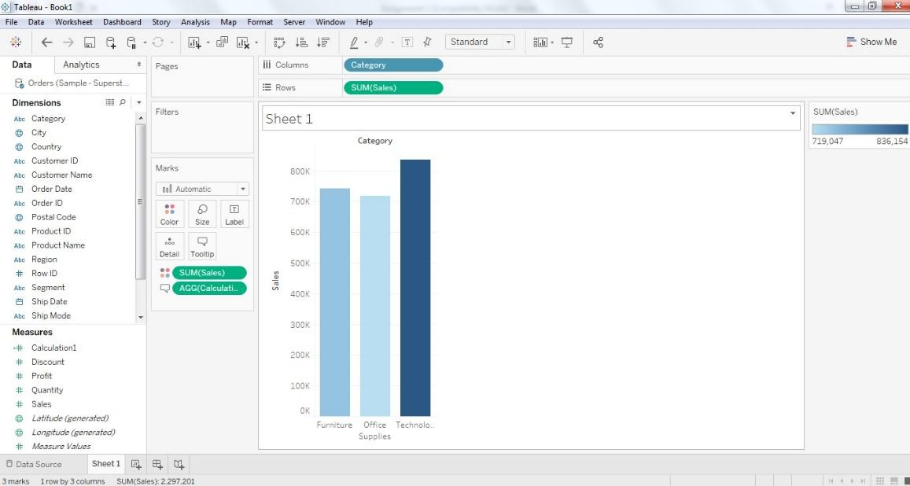

1. Each Product Category labeled with total Sales and Each Product Category labeled with Profit

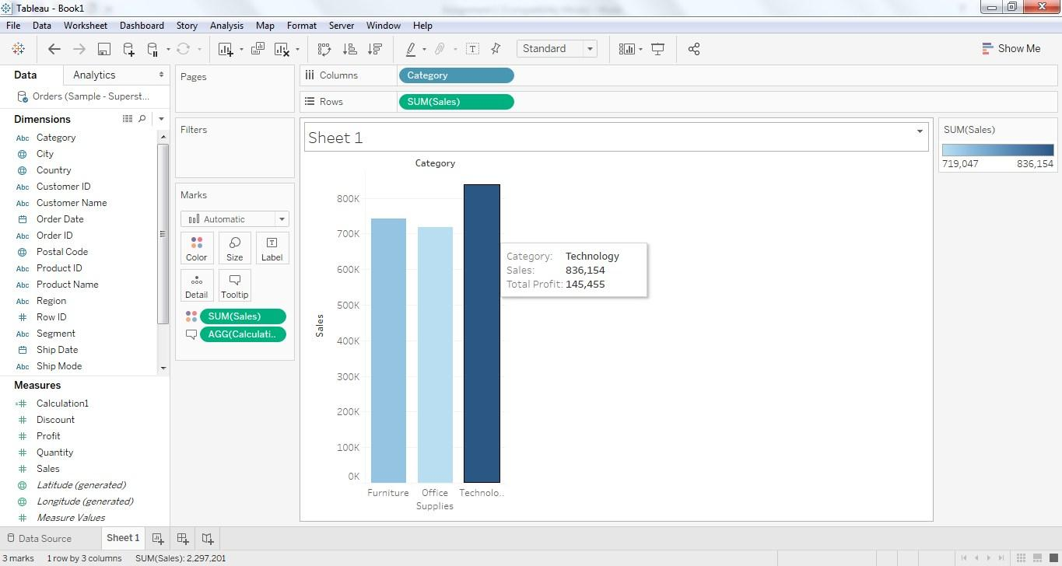

**Q 5: Use the same visualization created for Question #4.What was the Profit on Technology (Product Category) in Boca Raton (City) ?**

Add dimension City to filter. Select the city as per question. Click🡪apply🡪ok.

This will give you profit for Boca Raton City.

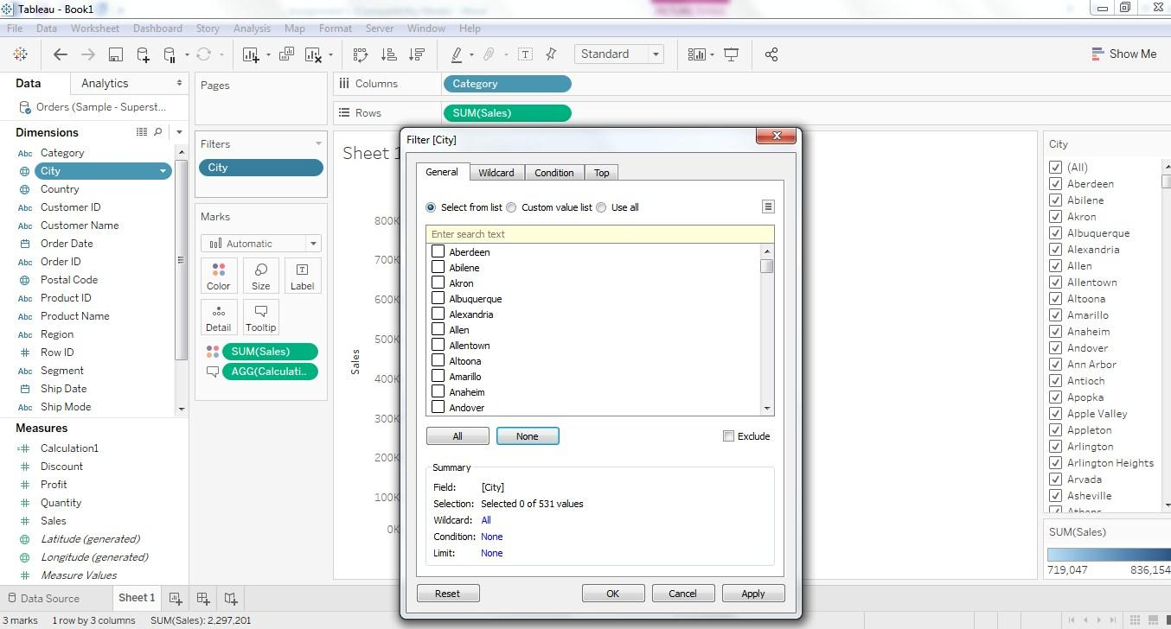

**Select the city to show a single bar for the city**

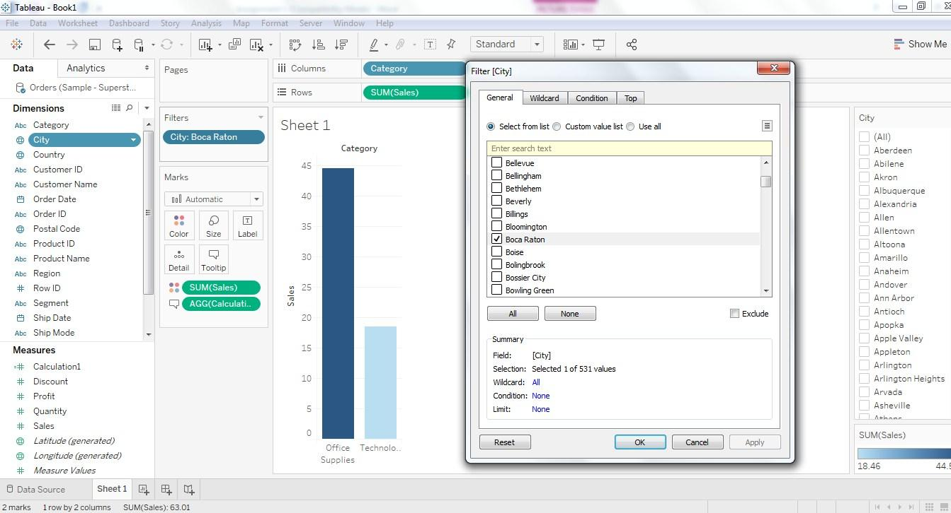

**Apply a filter for Technology. Same as above add Category dimension to filter on technology.**

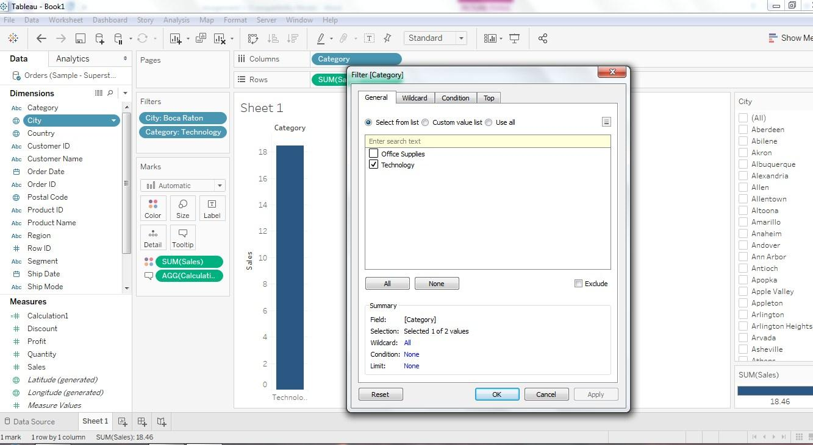

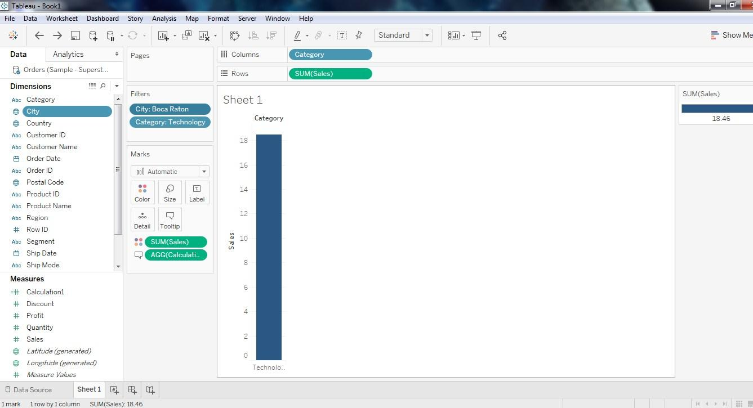

**6: Which Product Department has the highest Shipping Costs? Name the Department and cost.**

1. Packed bubble chart showing each Product Department as a colored bubble.

From right side (show me)select packed bubble chart.

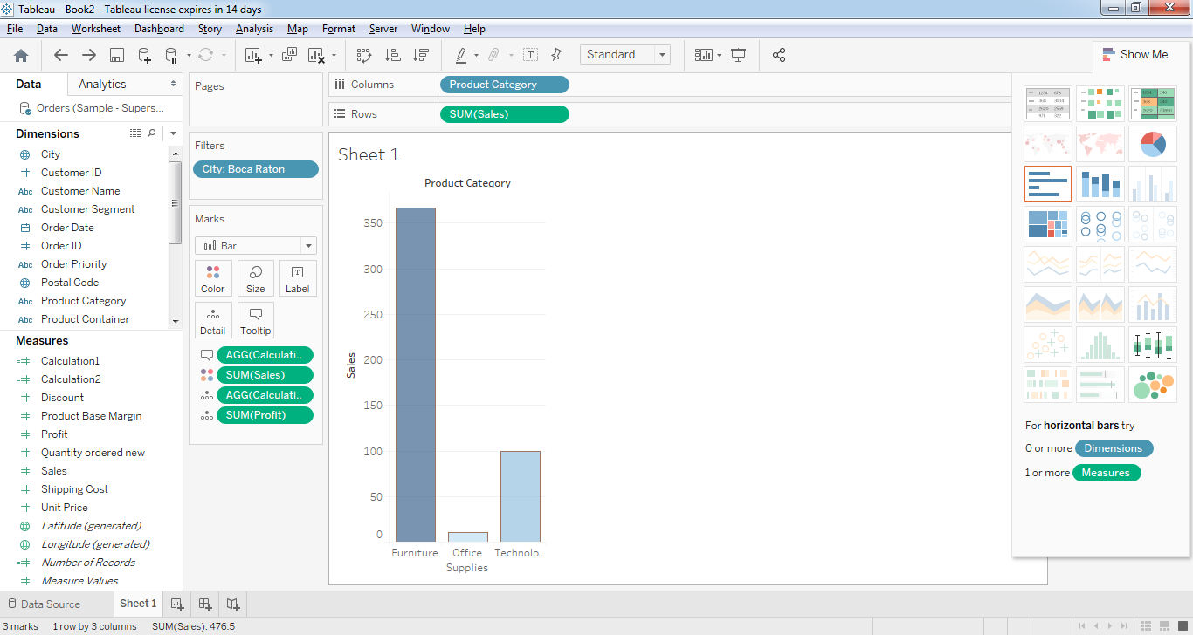

1. **Use Shipping Cost to display the size of each bubble (select Sum(Sales), Sum(Shipping Cost) and Product Category. (Product category as Color and toooltip)**

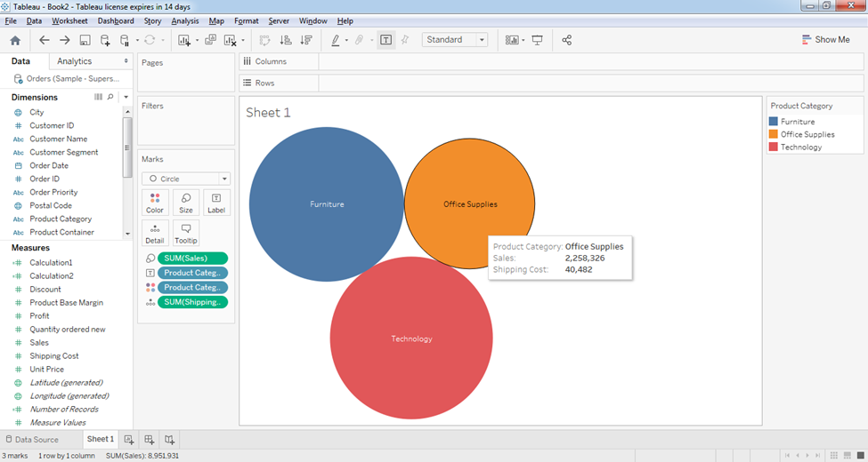

**Assignment 2: Preparing Maps**

**Data Set for this Lab Sample- Superstore**

**Q 1: Prepare a Geographic map to show sales in each state and city.**

Ans:

**a) Connect to dataset**

**b) Join sheets**

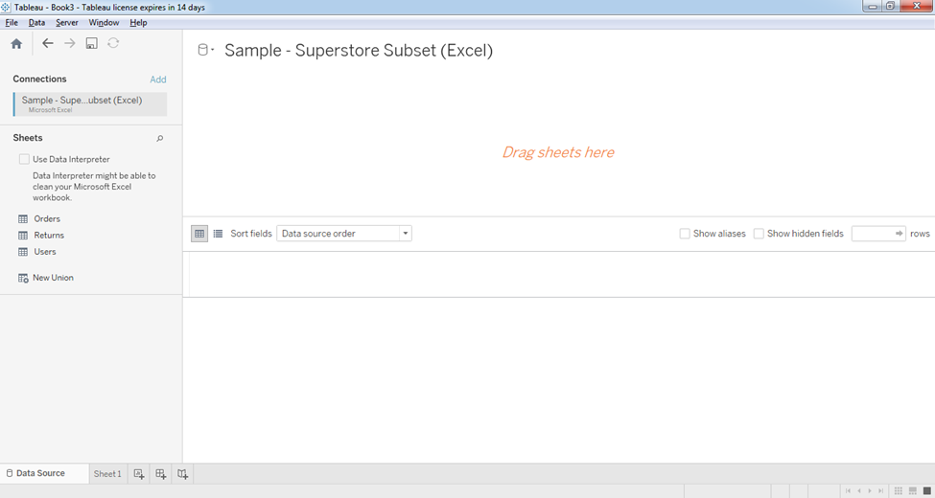

**c. Create a Geographic Hierarchy**

In the Data pane, right-click the geographic field ie Country or State or province, and then select Hierarchy > Create Hierarchy.

In the Create Hierarchy dialog box that opens, give the hierarchy a name, such as Mapping Items, and then click OK.

At the bottom of the Dimensions section, the Mapping Items hierarchy is created with the State field.

In the Data pane, drag the City field to the hierarchy and place it below the State field.

Do same for Postal Code fields.

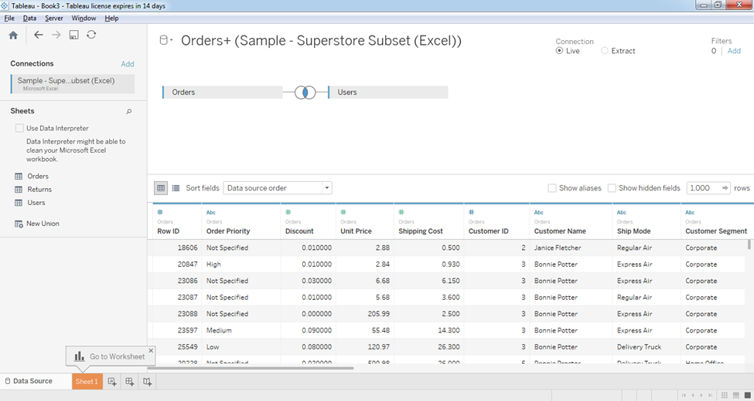

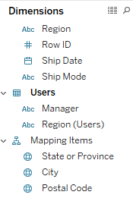

**d. Build a basic map**

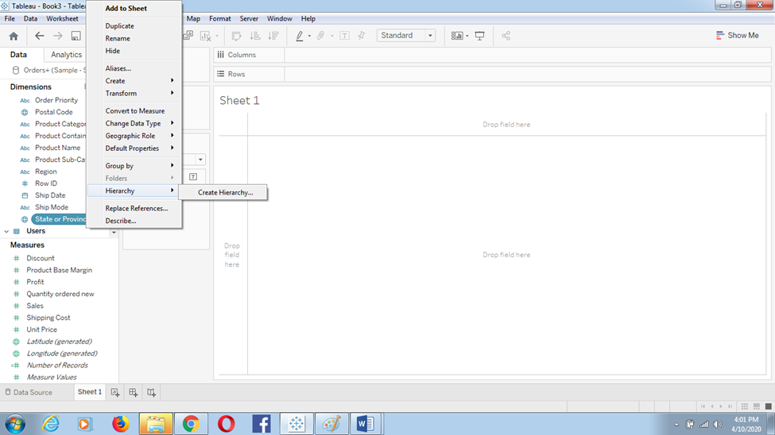

**1) In the Data pane, double-click State.**

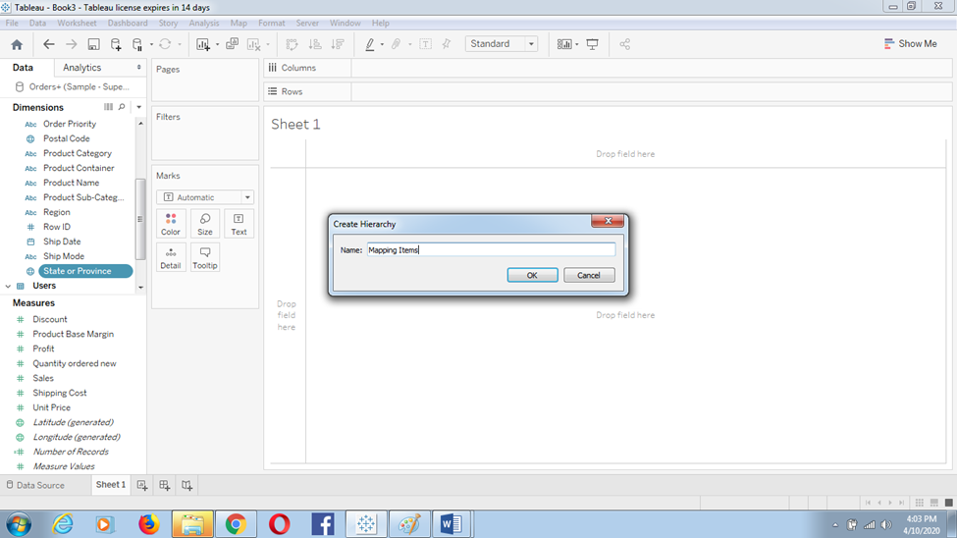

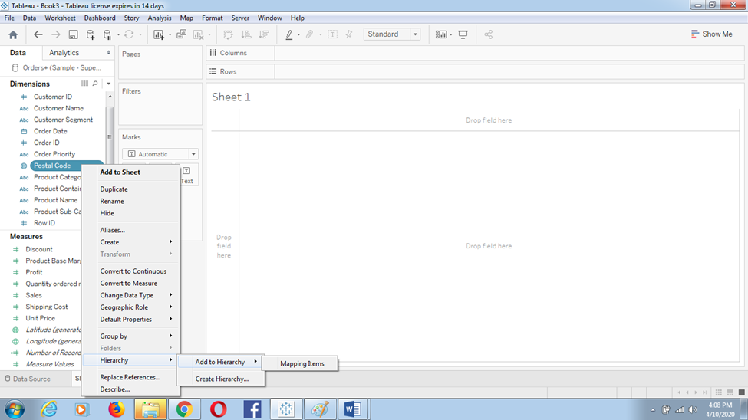

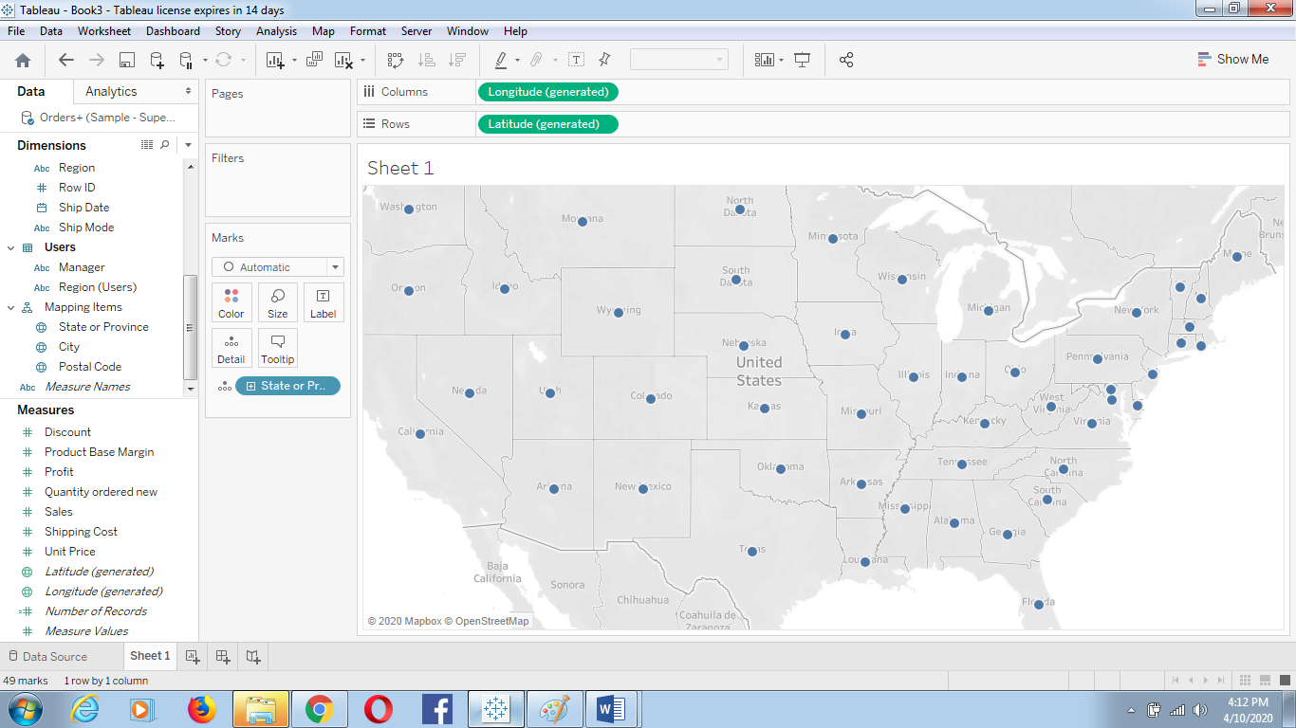

2) On the Marks card, click the + icon on the State field.

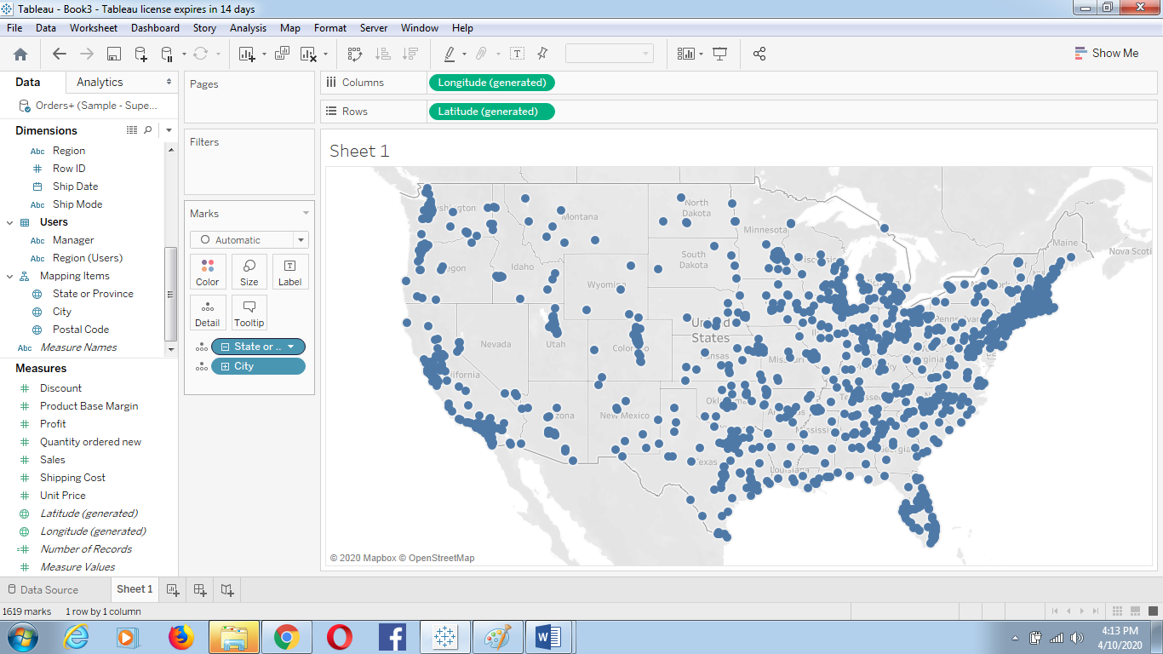

**e. Add visual detail**

Add color

Minimize to state

From Measures, drag Sales to Marks card.

Change the Sale appearance as **Color**

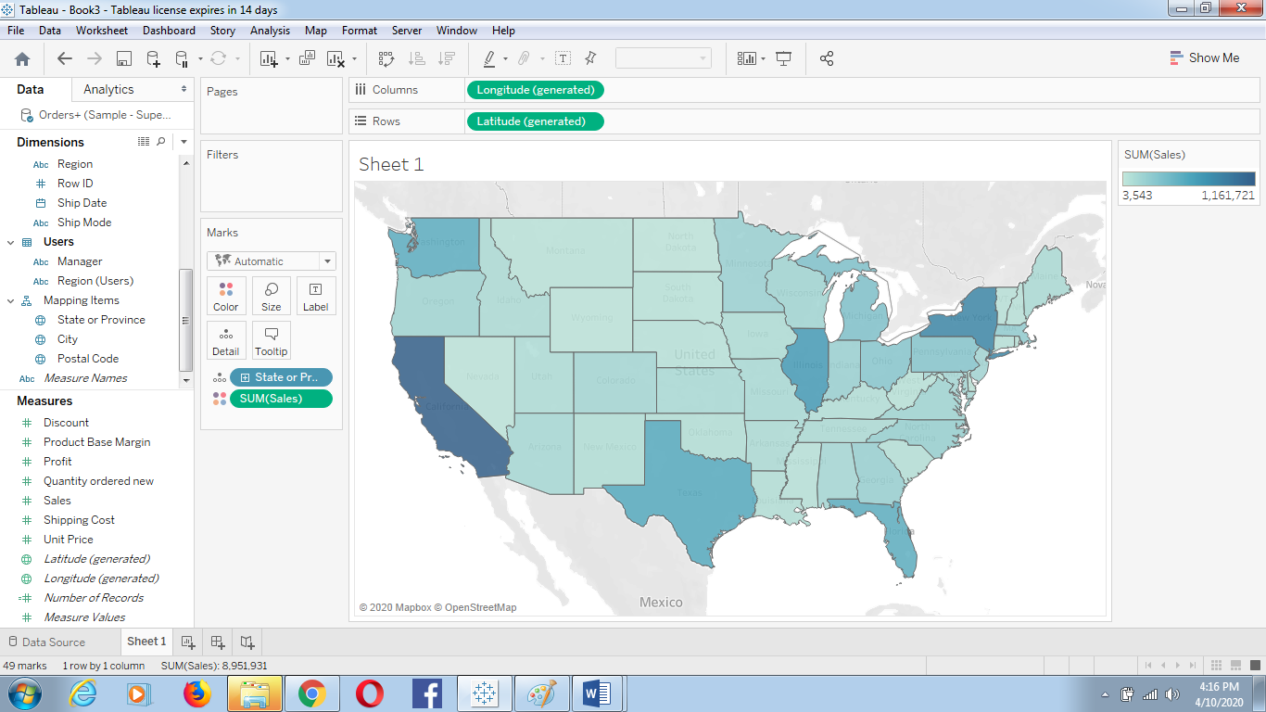

**Add labels**

From Measures, drag Sales to Label on the Marks card.

Each state is labeled with sum of sales.

The numbers need a little bit of formatting, however.

In the Data pane, right-click Sales and select Default Properties > Number Format.

In the Default Number Format dialog box that opens, select Number (Custom), and then do the following:

For Decimal Places, enter 0.

For Units, select Thousands (K).

Click OK.

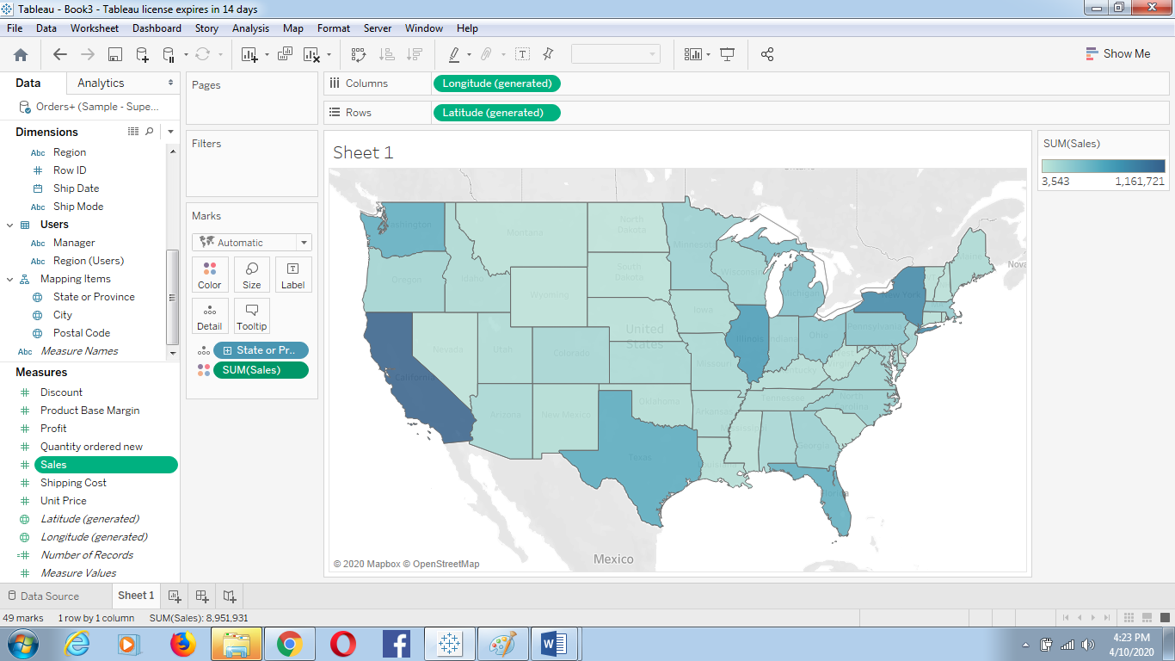

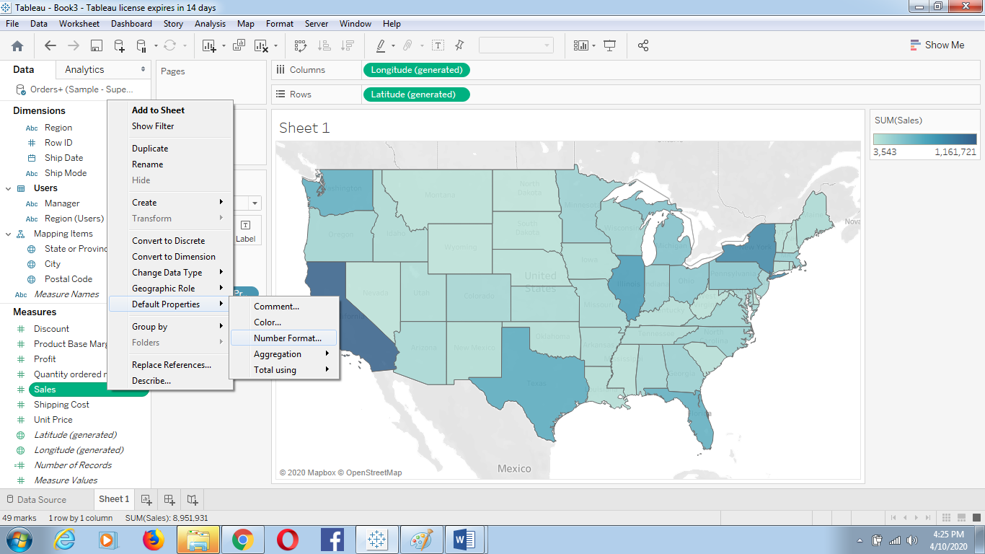

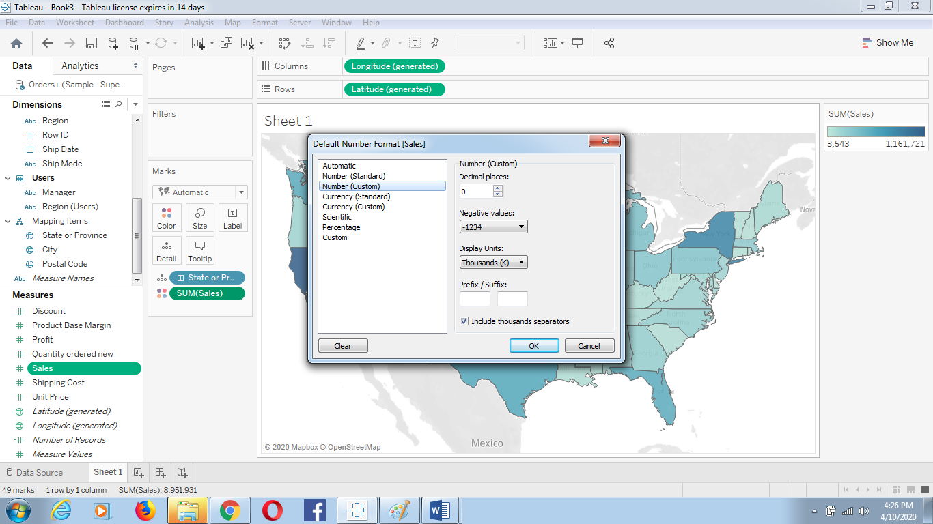

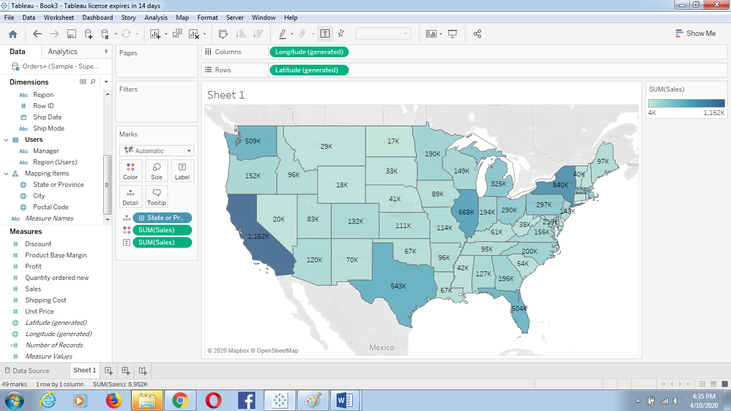

Q 2: Show Profit Ratio of each state as tooltip on map

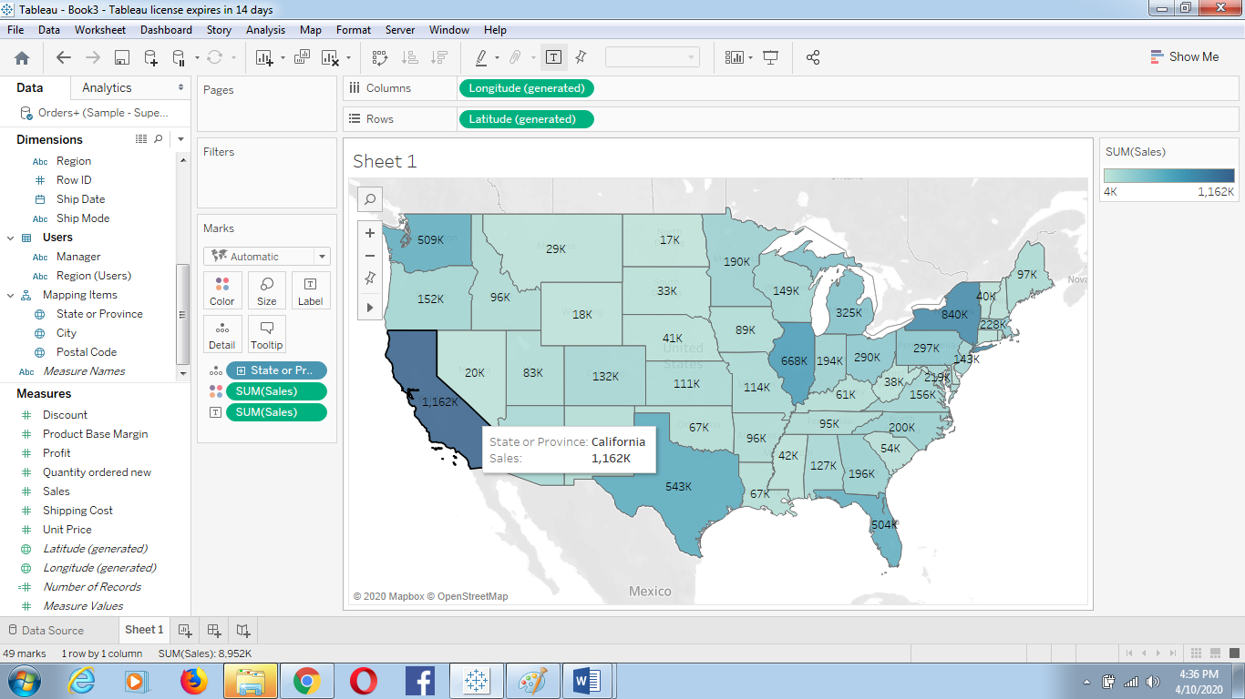

Show Profit Ratio of each city as tooltip on map

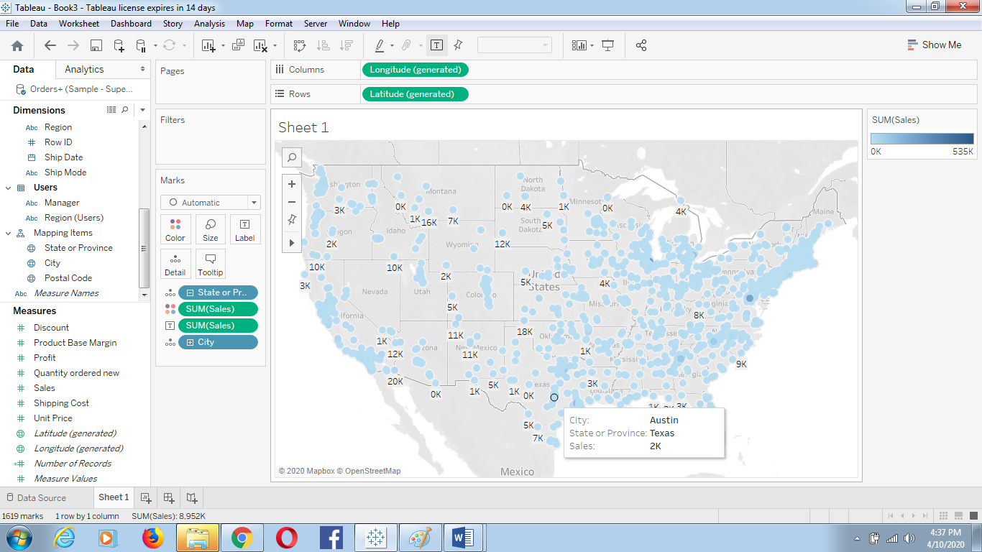

**Q 3: Show Profit ratio for Grip Envelop products (Add product name in filter)**

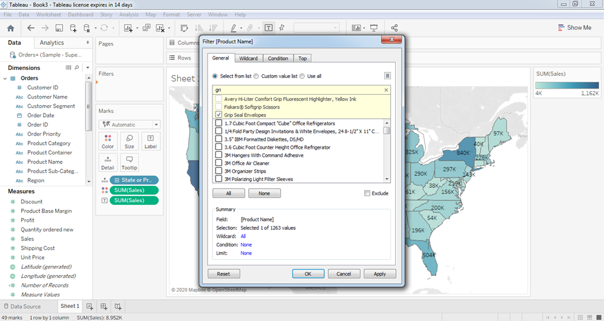

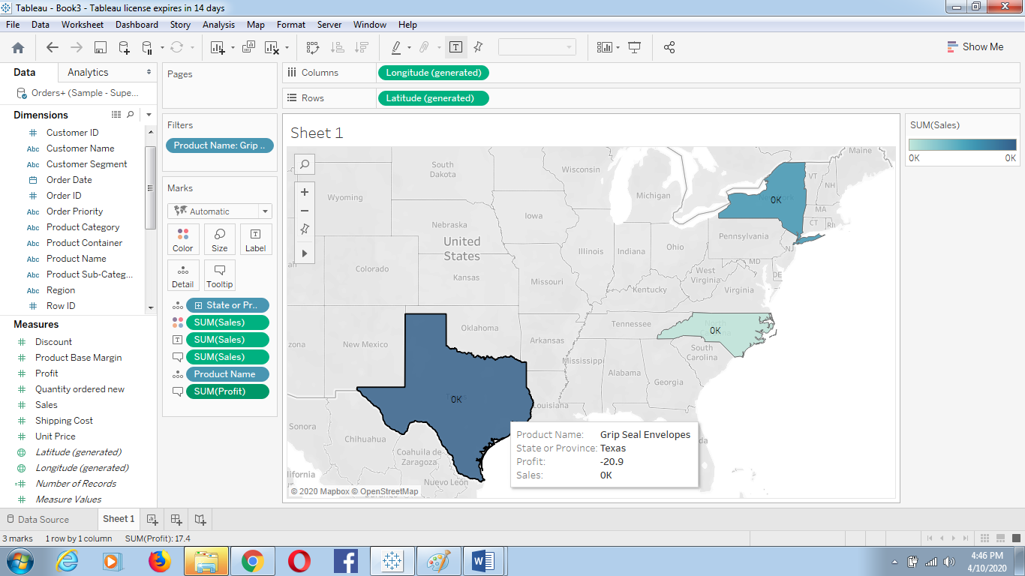

**Q 4: In the technology product category which unprofitable state is surrounded byonly profitable states.**

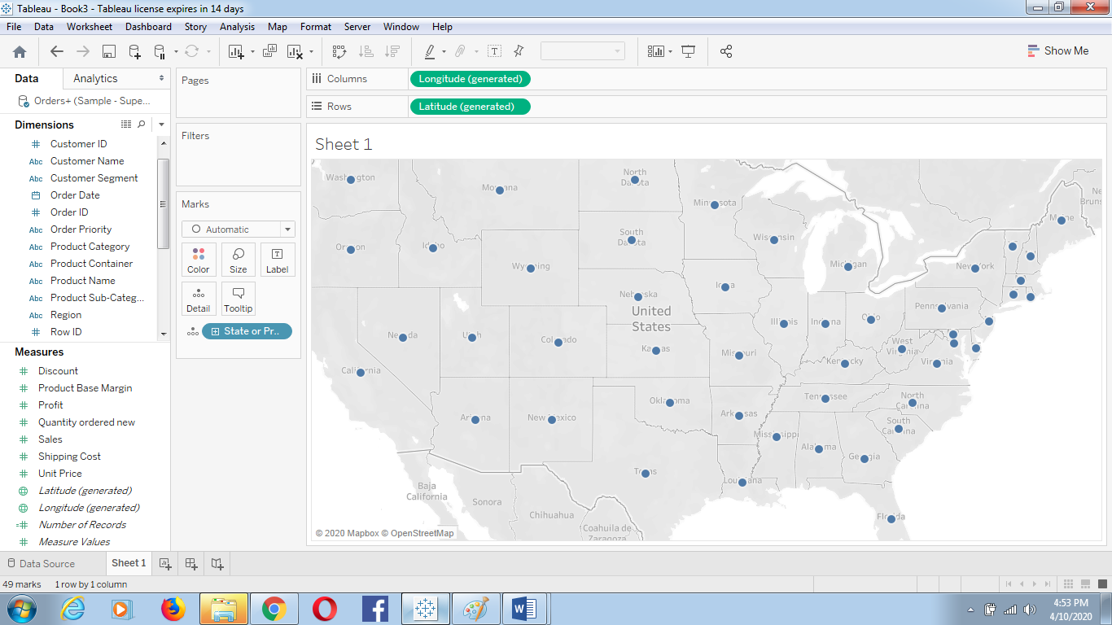

Drag the product category on the filter shelf and select technology.

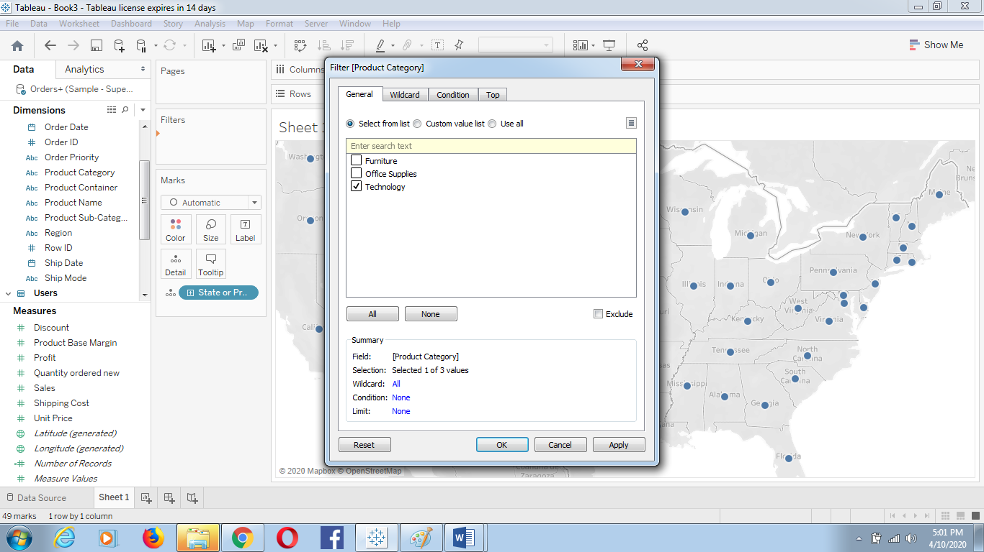

Now Drag the profit measure to color mark

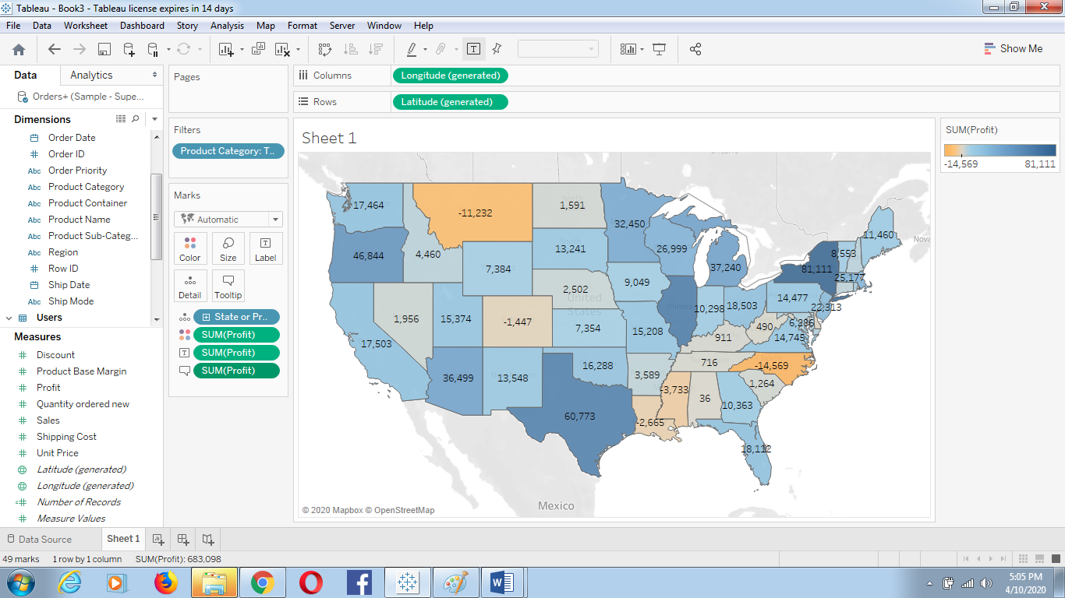

**Add profit Label.**

**Q. 5:** **Which state has the worst Gross Profit Ratio on Envelopes in the Corporate Customer Segment that were Shipped in 2013?**

Customer Segment is Corporate (Apply Filter on customer segment)

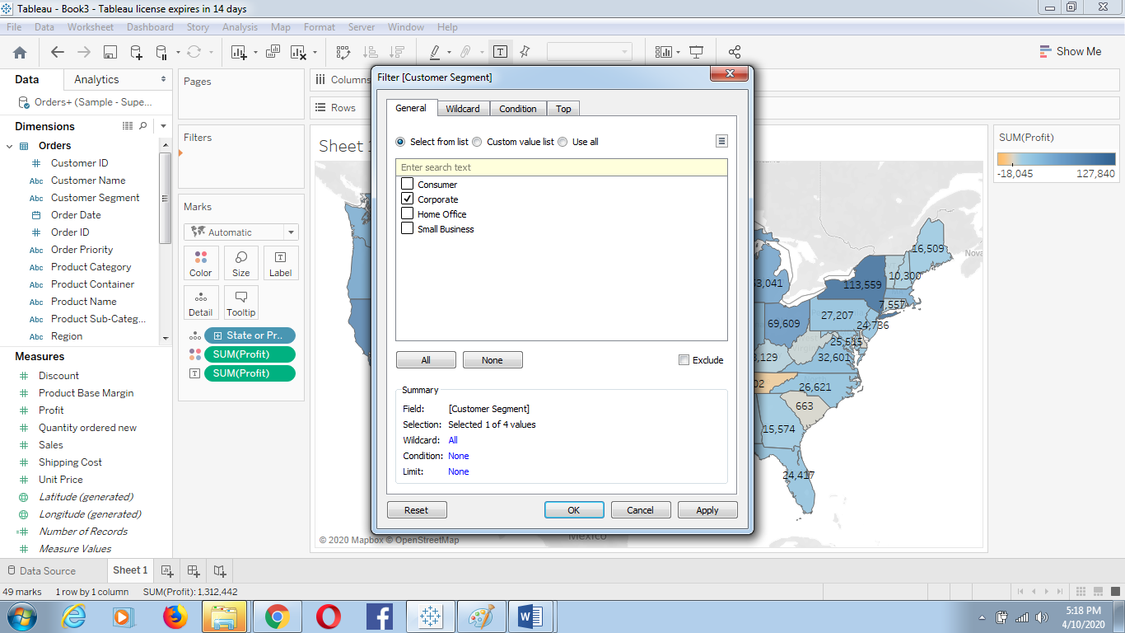

Product Sub-category is envelope (Apply filter on Product Sub-category)

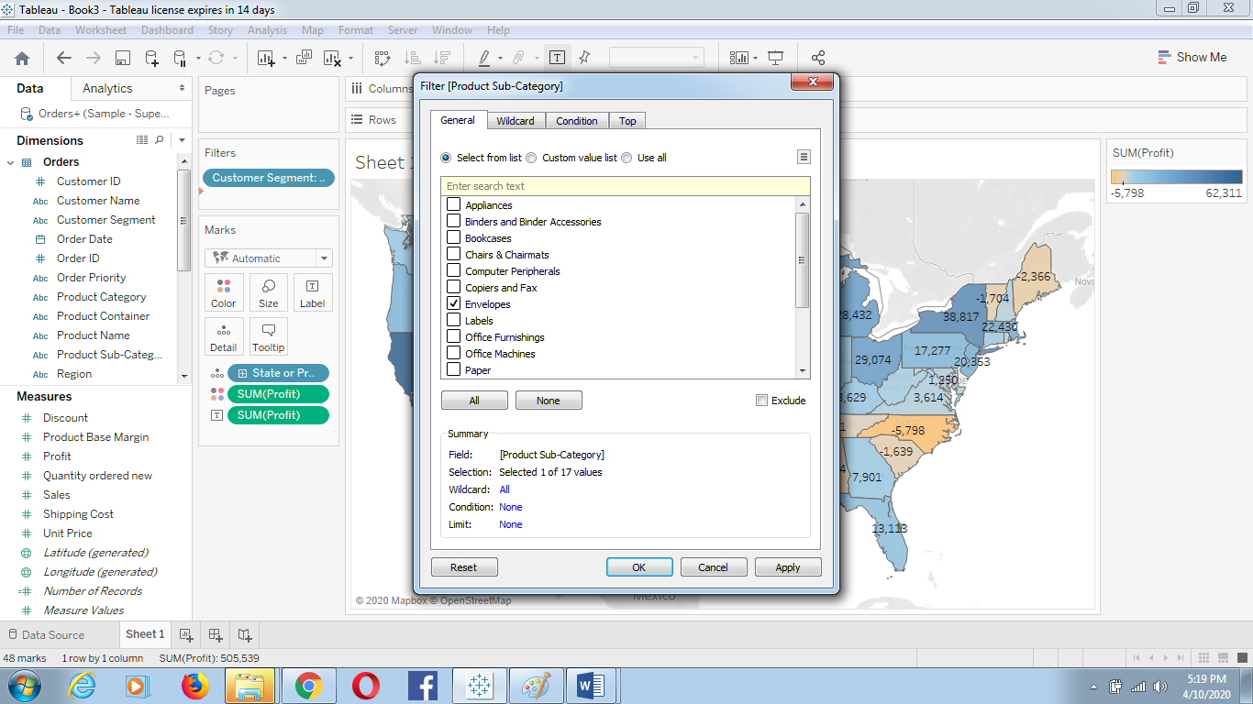

And the Shipped date year is 2013

Apply Filter on Order Date🡪 Select year

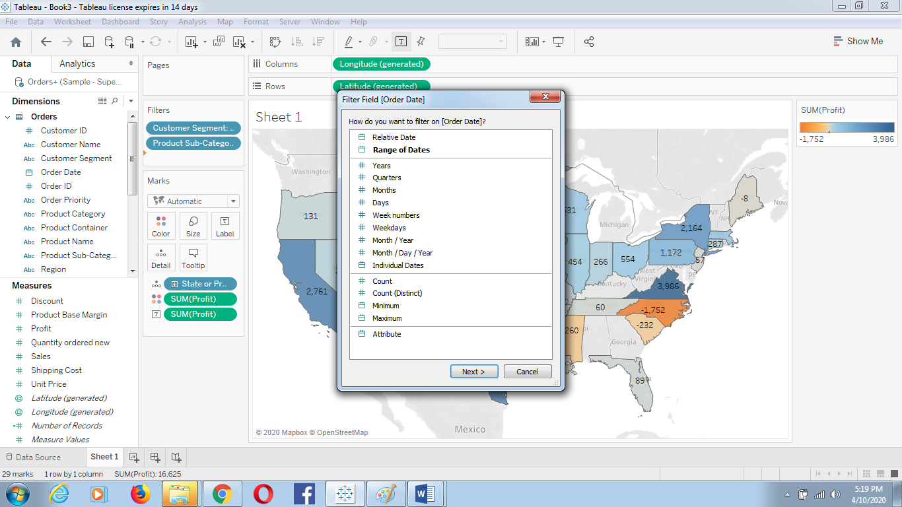

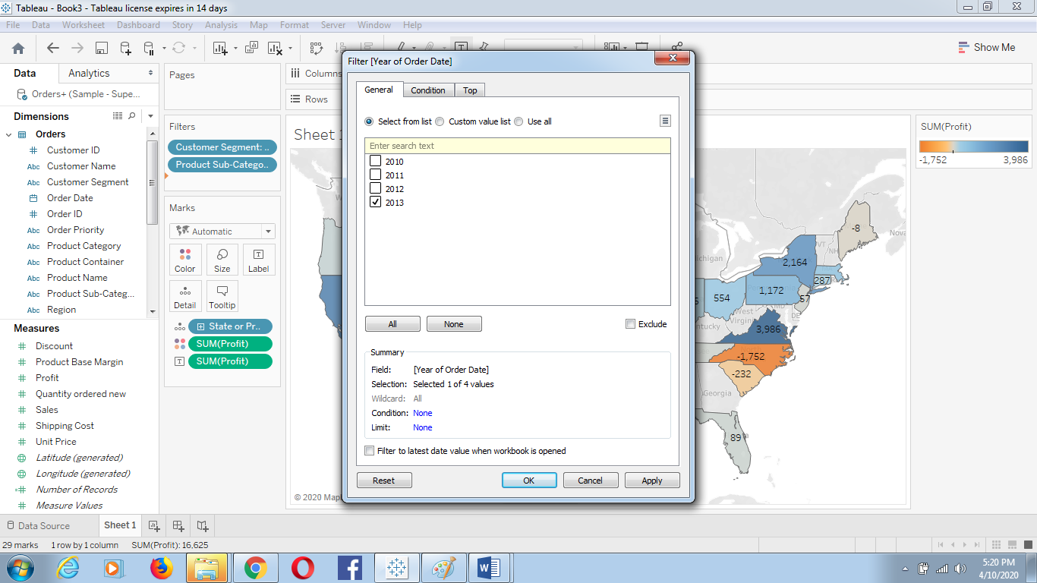

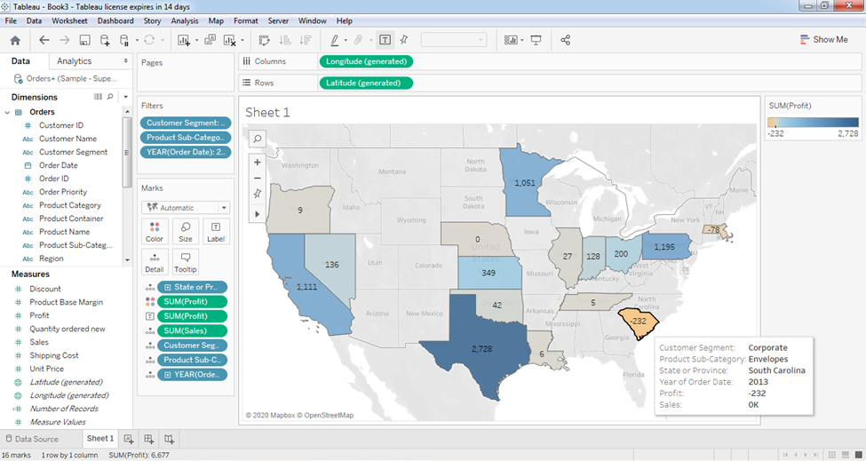

**Assignment 3: Preparing Reports**

**Data Set: Super store**

1. **Prepare a report showing product category wise sales**

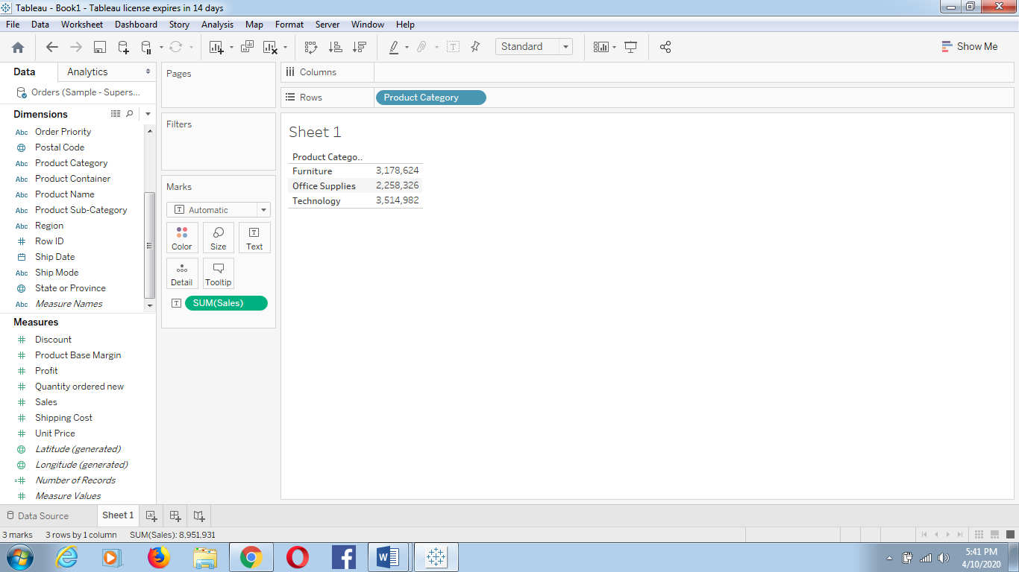

1. **Report showing region wise product wise sales**

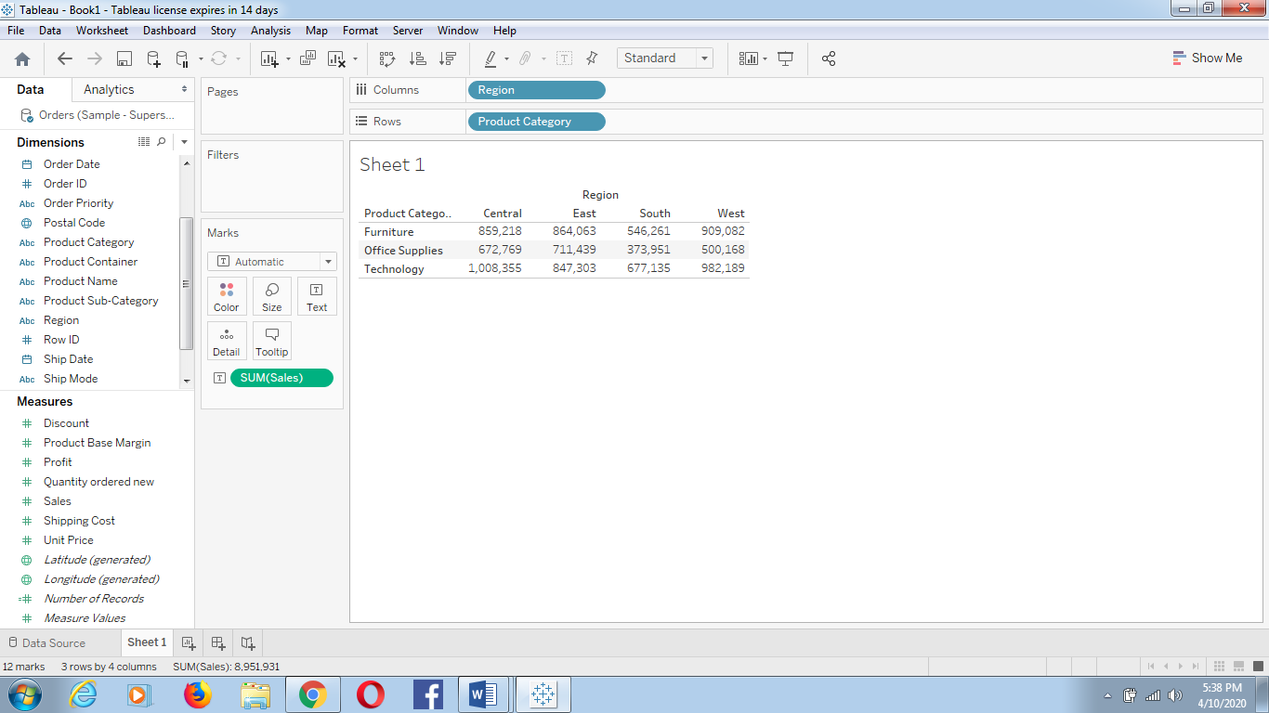

1. **Report showing state wise sales**

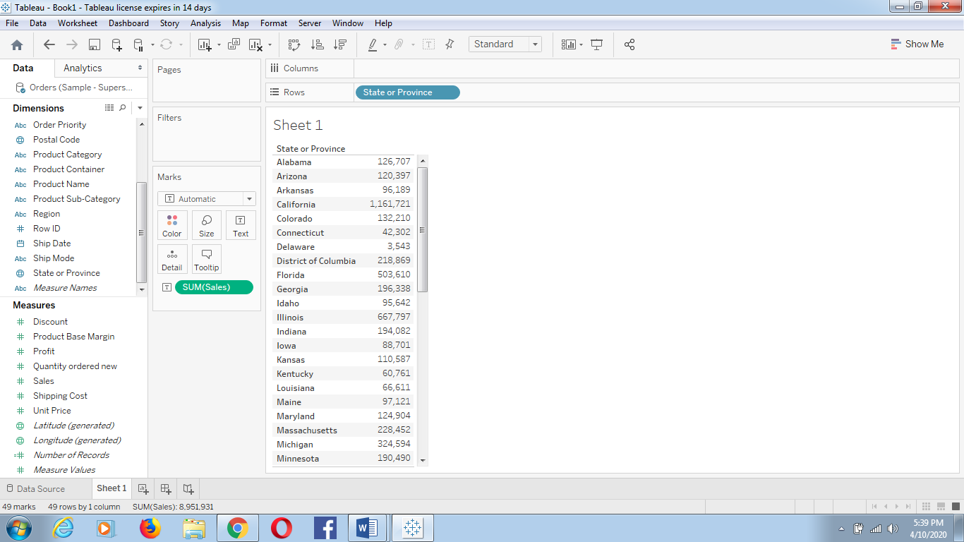

1. **What is the percent of total Sales for the ‘Home Office’ Customer Segment in July of 2014?**

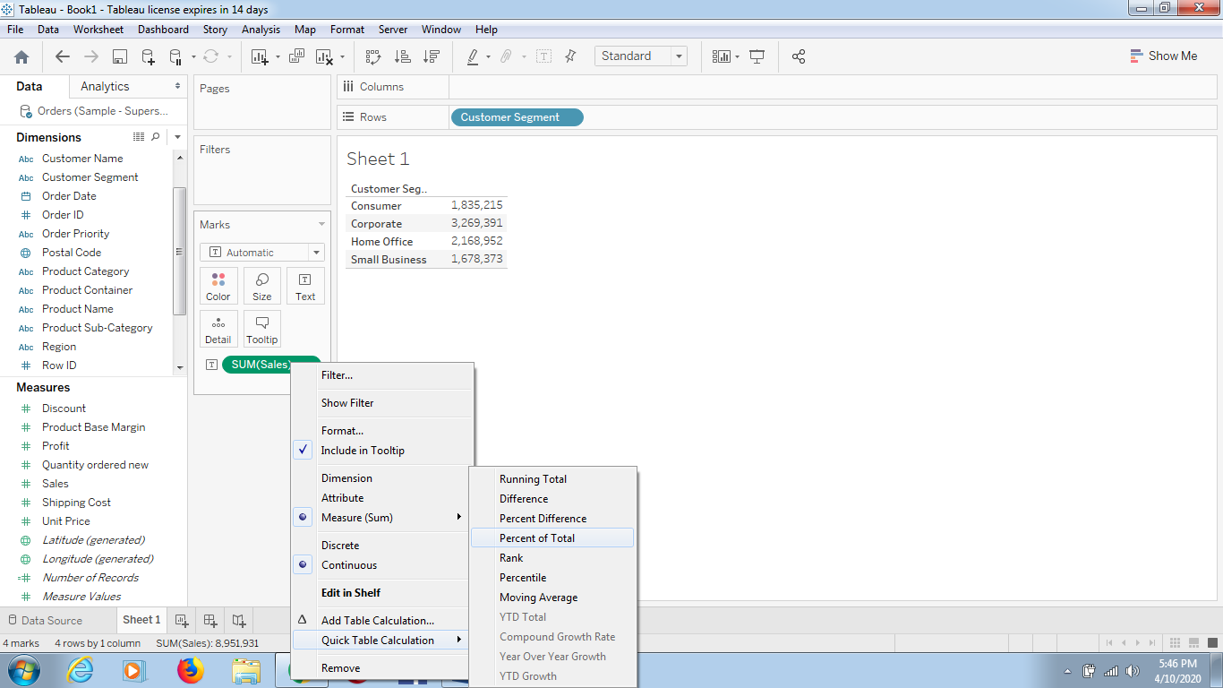

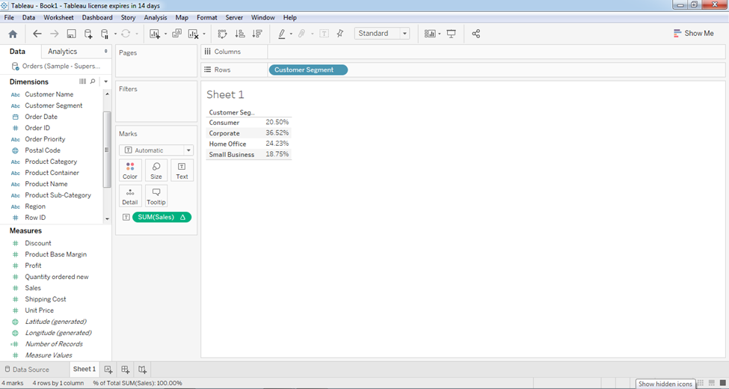

**5)Find the top 10 Product Names by Sales within each region. Which product is ranked #2 in both the Central & West regions in 2013?**

Drag “Product Name” dimension from data pane window to Row Shelf and then add an “order Date” on Filter shelf and select “Year” of Order date as 2013 (Sown in previous assignment)).After that put region on Filter shelf and select “Central” and “West” checkbox. Also, put a copy of region to the Column shelf as well.

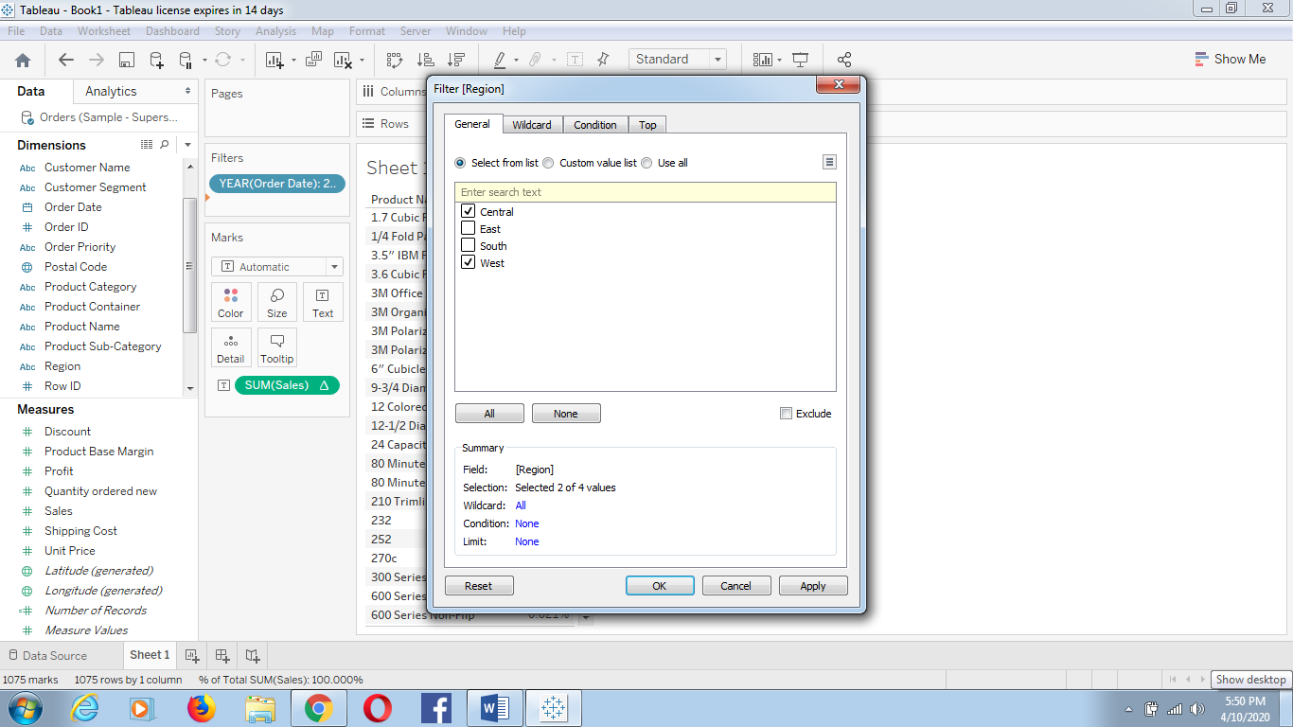

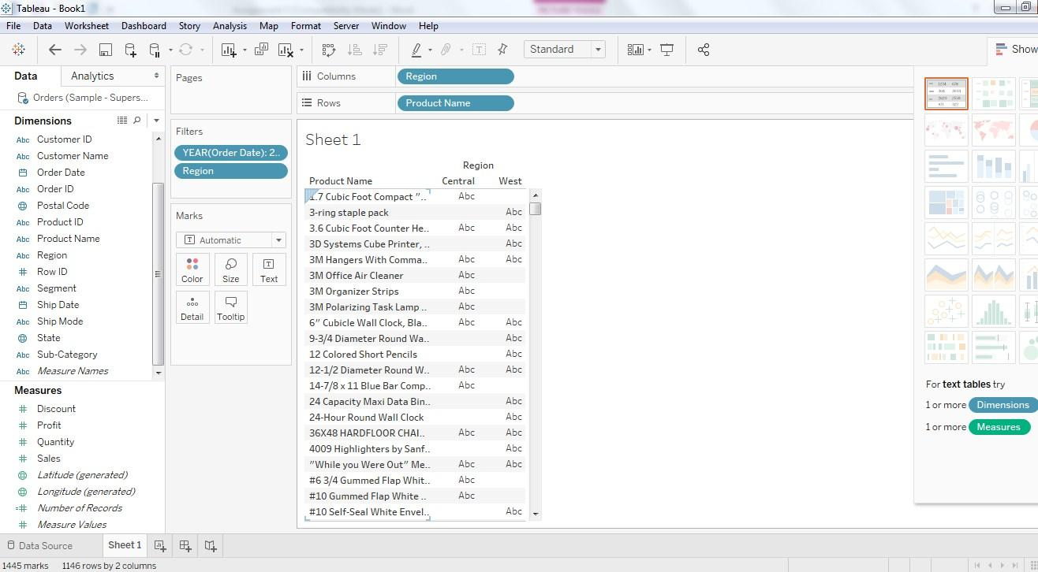

Drag a Sales measure to the text label.

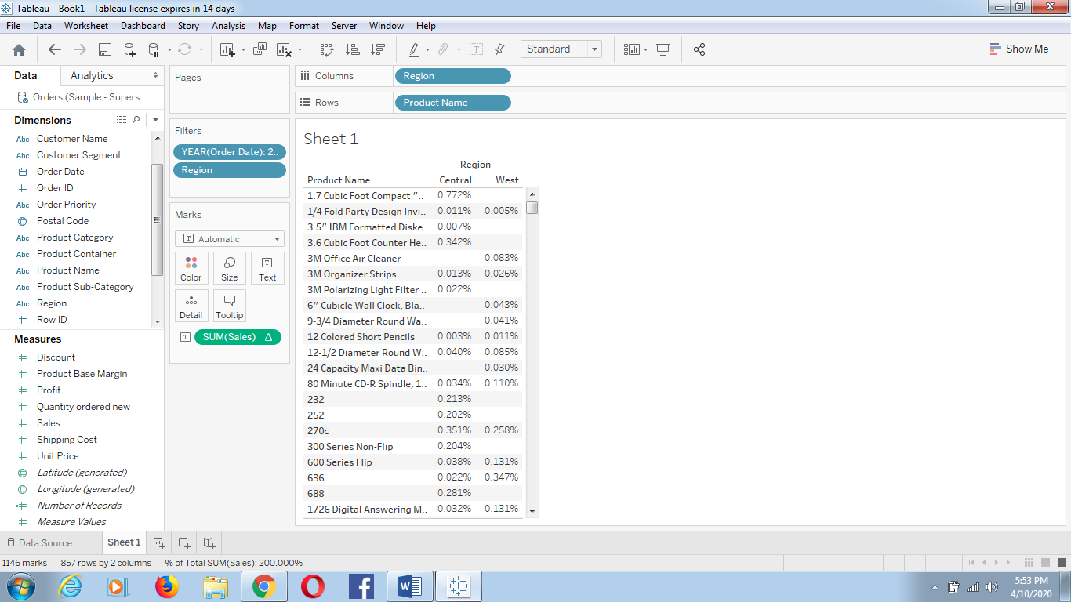

So for getting the Top 10 “product name” by sales, we need to add the “Product name” on Filter shelf.

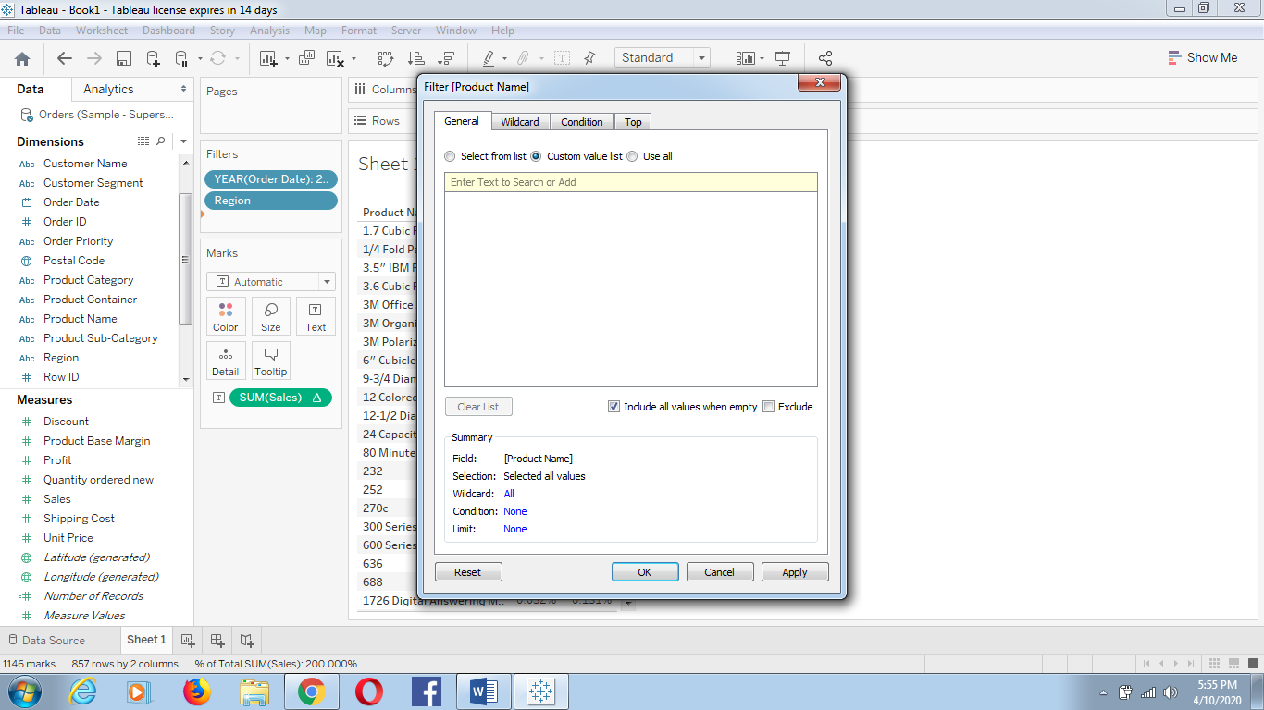

Once the Filter Pop up is open, Select **“TOP”** **tab >By Field > Top 10 by Sum (Sales).**

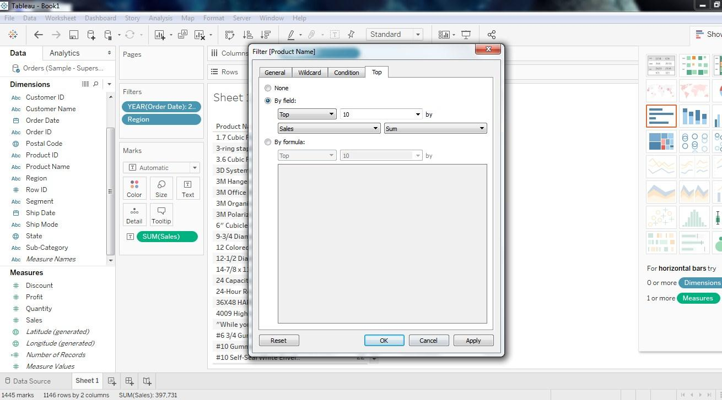

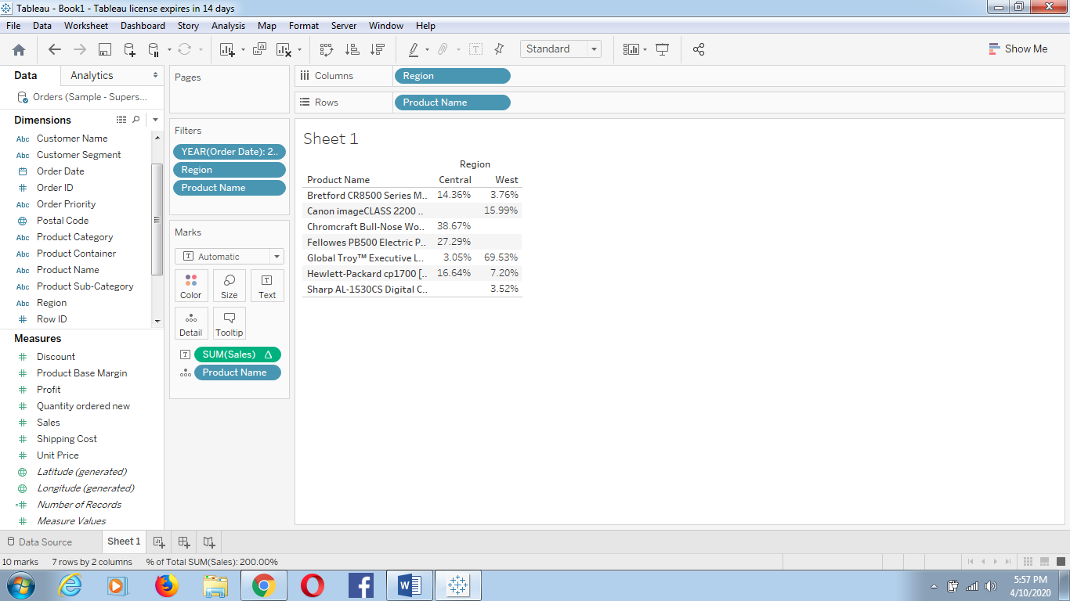

Right click on the aggregated Sales measure 🡪 select Quick Table Calculation 🡪 Rank.

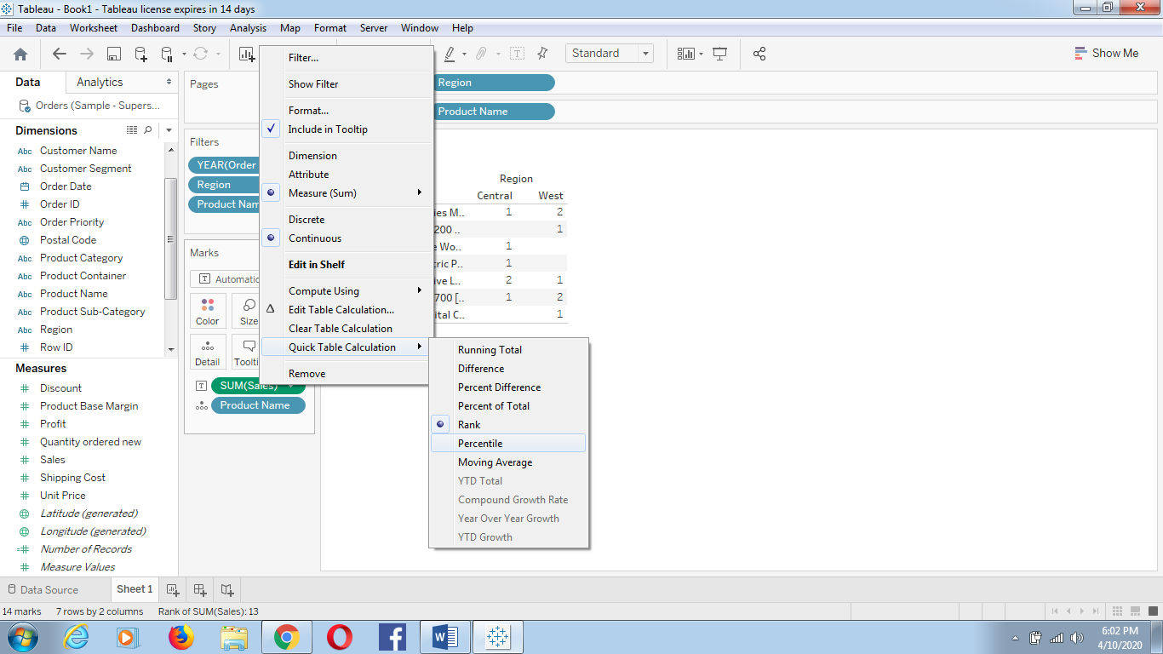

As the default addressing is Table across, please change it into Table Down

Right click on Sales Measures🡪Compute using 🡪 Table Down.

